*Biochemistry: Enzymes*

Name ______________________________ Pd. ____ Date _______________________

**ENZYMES:**

A specialized type of ____________________

**Function in our body:**

* Acts like a ________________= substance that __________________ up the rate of a

chemical reaction but it is _________ used up in the reaction.

* Enzyme(s) reduce _________________= amount of energy needed to begin a reaction
* Usually end in ______________________________.

__________________= an organic molecule ____________with the enzyme to

__________in the reaction.

* Need an active site on the enzyme
  + - 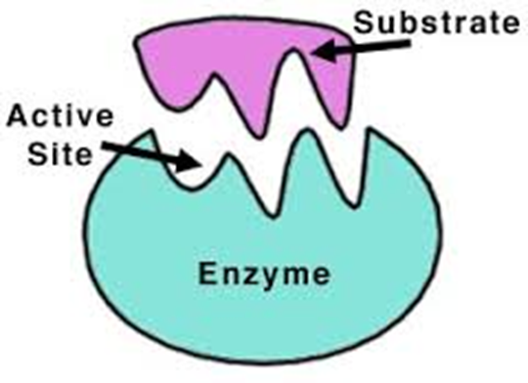__________________- attracts and holds only ______________molecules called__________________.
      * **“Lock-and-key” system**- one “key” will fit “lock”; perfect fit
      * **Induced Fit** – “lock” will mold around the “Key” if fit is close enough
    - Therefore, _______________ enable molecules called ________________to undergo a chemical change to form new substances, called______________________.

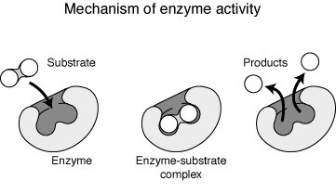

________

* Example of the ________________ of sucrose using the enzyme (________)

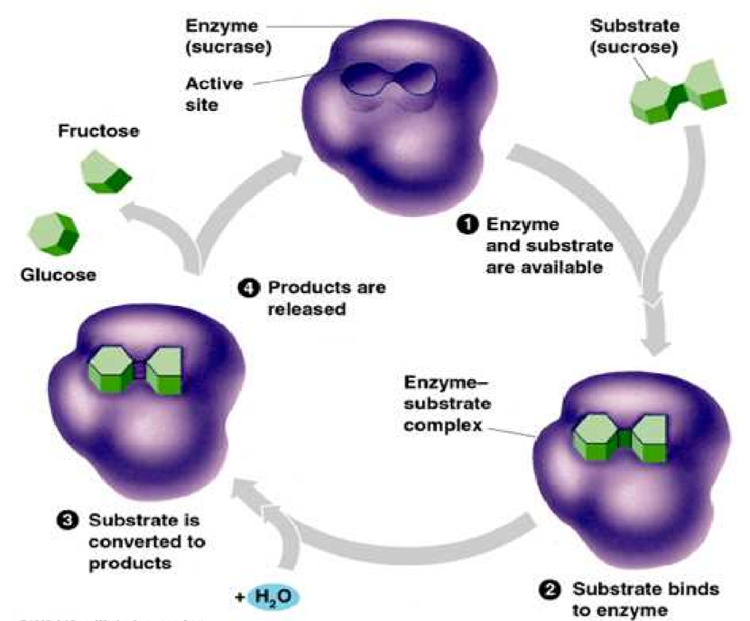

**Enzyme Inhibitors**

* ________________________ ______________________= a substance that

_____________the activity of an enzyme by entering the ______________in place of the

_________________whose structure is ______________ ____________________.

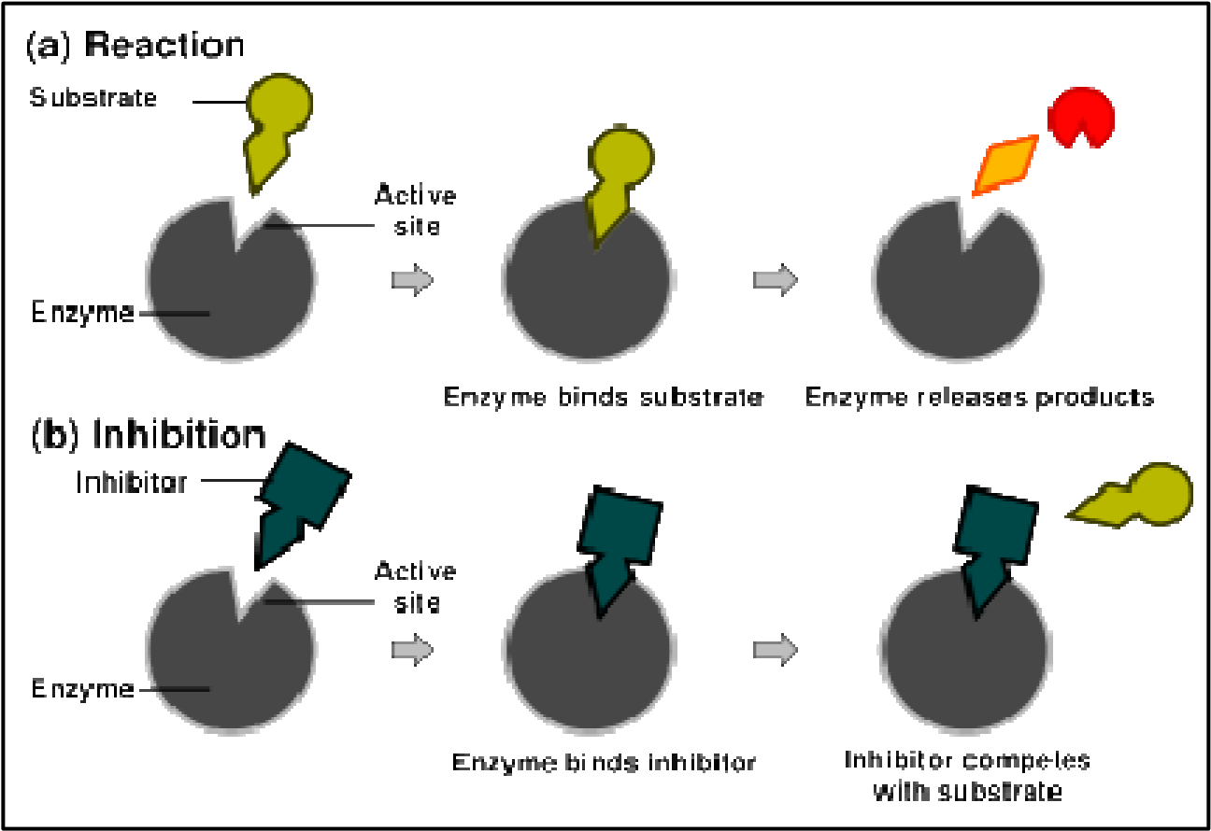

* 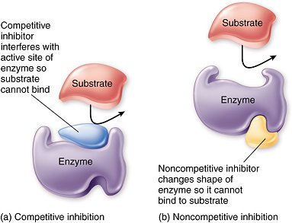___________________________ inhibitors:
  + - * Inhibitors that do not enter the **______________** **_______________**, but bind to another part of the enzyme causing the enzyme to change its **____________________**, which in turn alters the **___________________** **________________**.
* Could not ________________without enzymes! (Almost all chemical reactions in cells

require an enzyme)

* + - * **Speeds up the reactions in:**
        1. ________________________________ of food
        2. ________________________________ of molecules
        3. ___________________________________ of energy

* __________________________are named for the compound they work on.
  + - You drop the current compound ending and replace it with _________

o For example:

o Lactose’s enzyme is ______________

o Maltose's enzyme is ______________

o Sucrose's enzyme is ______________

o ______________(in your salvia) is the enzyme for starch (amylose)

**2 Factors that affect enzymes:**

* + 1. ___________________________- Too high temperatures will denature (change the shape of) the active site of the enzyme, causing the enzyme to not work properly.
    2. _____________ – every enzyme has an optimum pH in which they will work. Altering the pH will cause the enzyme to not work properly.

**Examples**

* Cat box example

Urea + urease 🡪 ___________________________ + carbon dioxide

Clean litter in cooler temps = less smell due to __________________ rate of reaction

* pH (most like 6 - 8 pH near neutral)

______________________ Juice on apple

____________________________ __________________________ (PPO) is the enzyme that reacts with oxygen to turn the apple brown

**HOW DOES OUR BODY GET ENERGY FROM THE BREAKING DOWN OF MOLECULES?**

_____________________________________________________

_____________________________________________________

**Draw a conclusion based on each graph below.**

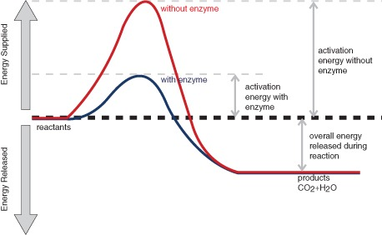

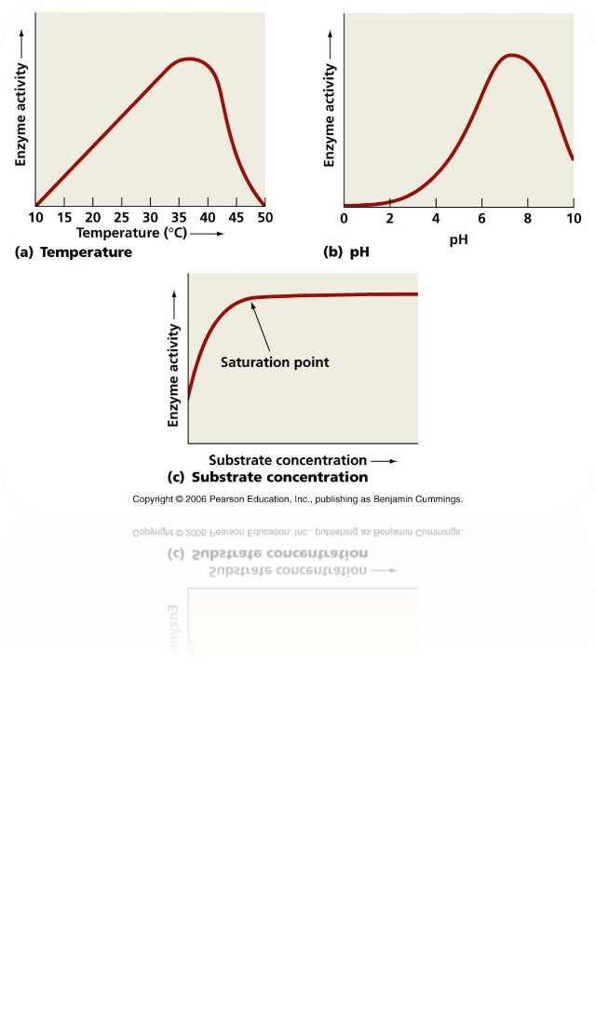

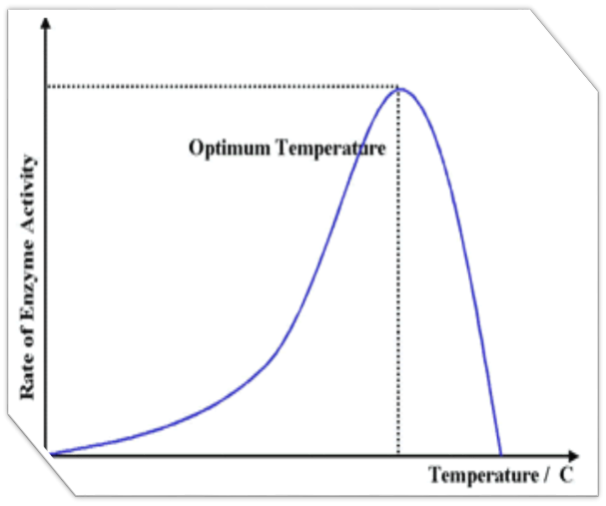

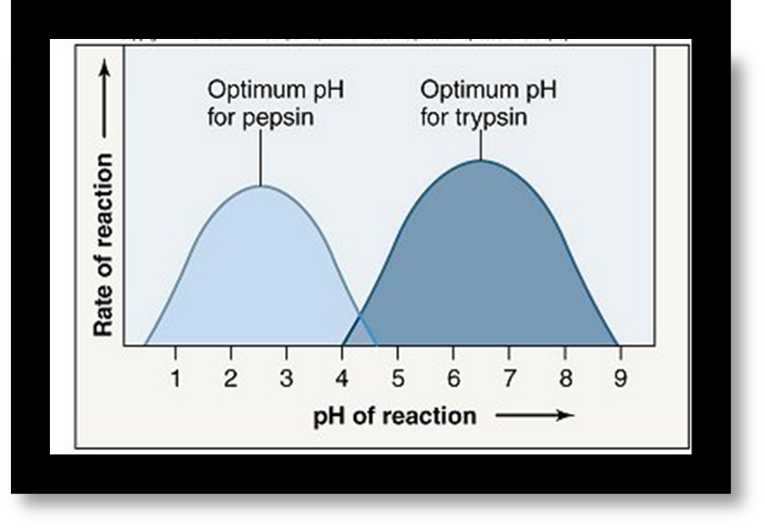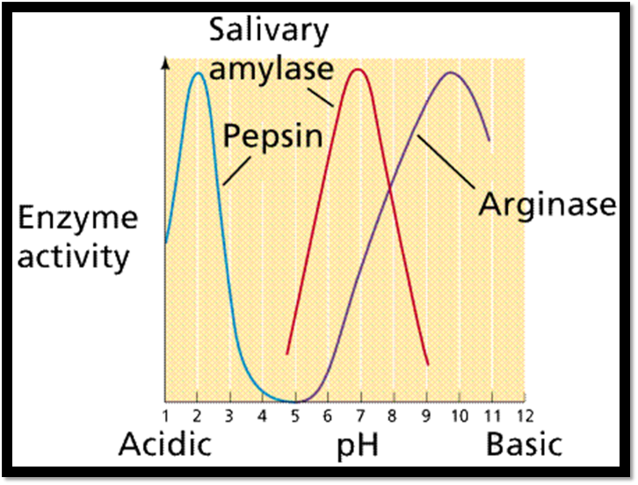

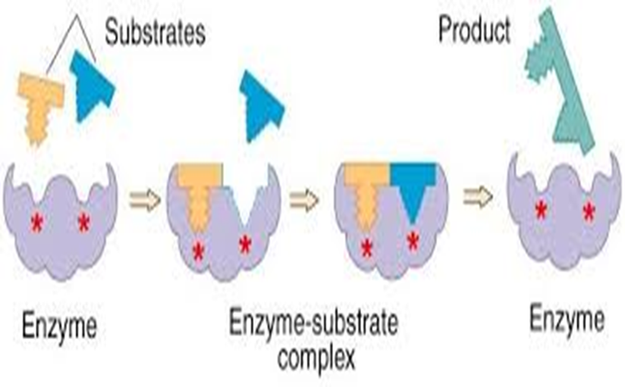

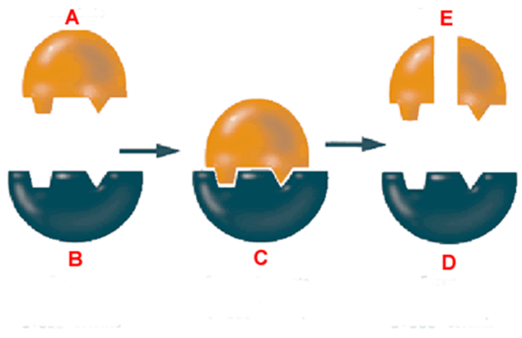**Dehydration synthesis or hydrolysis?**