

1. Log in to <http://app.studyisland.com/cfw/login>
2. Preview content
   1. 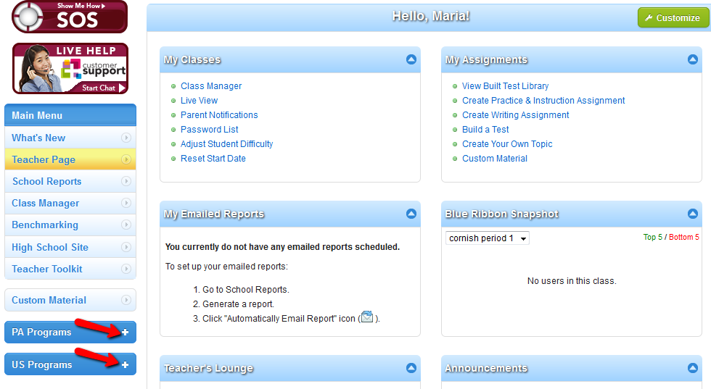Click on PA Programs or US Programs
3. Create classes using “Class Manager.”
4. Create assignments
5. Reports-track student progress
6. Teacher Toolkit
7. Custom Material

**Overview**

Study Island offers a high school interface for 9-12 students. **“The Island”** is a separate Study Island website with an interface designed specifically with our high school users in mind. Some of the key features of the high school site include new site organization and the addition of study forums, daily feeds, and a career readiness section. To access Study Island’s high school website, students will go to <https://hs.studyisland.com>

Student Username = email address

Student Password = DASD 8-digit password

Career Planning - The career readiness section will allow students to build resumes, letters of recommendation, and cover letters. In addition, there is section dedicated to interview tips and informational videos covering different aspects of interviewing for a job and/or college.

Daily Feeds - Each main subject page (English, Social Studies, Math, Science) features a daily or weekly feed such as a word of the day, poem of the day, daily quotes, weekly brain teasers, and weekly weird science facts to generate student discussion.

Passport Stamps - A passport stamp denotes topic mastery in “The Island” high school interface. The passport stamps are comparable to blue ribbons in the K-8 Study Island program. The Passport Stamps will only be seen when logged into the high school website; they will not replace the Blue Ribbons seen when logged into the Study Island website.

**Accessing Student Login and Password Information:**

1. Click on **Teacher Page**.
2. Under **My Classes**, click on **Password List**.
3. View only your class(es) by clicking on the **blue** arrow next to “Select a Class”. Choose your class.

**To Create a Class:**

1. Click “Class Manager” on the left hand side of the screen **OR** under “My Classes” on your teacher page.

2. Select **“Add New Class”.** Enter a title for your new class.

(**OPTIONAL:** Teachers may choose to “Override School Preferences” if allowed by the school admin. Here, teachers may control game features, remedial topics, and timer visibility.)

3. Click the **Blue icon with a + sign** in it by the preferred grade level, then check off the students you wish to add to the class. If you wish to add all students in a grade level, check the box next to the grade level.

4. Click “Save” at the bottom of the screen.

***Tip:*** To edit an existing class, click the “Edit Class” icon next to the class you want to edit on the Class Manager page. To **add** a student to the class, repeat steps 3 and 4. To **remove** a student from the class uncheck the box by the student’s name and click “Save.”

**To Create a Class Page:**

Once a class is created, a Class Page can be made for that class. A Class Page can only be made by the school’s admin or the owner of the class. The Class Page must be activated in order for students to access assignments.

1. Click “Class Manager” on the left side of the screen **OR** under “My Classes” on your teacher page.

2. Click the “Class Page and Assignments” icon to the right of the class name.

3. Click on “No” to change to “Yes” by Class Page Activated. There must be a note or assignment created before the Class Page can be activated.

**To Create Flash Cards:**

Flash cards are a fun and easy way for students to study. Now you can make your own flash cards using Study Island’s “Create your Own Topic” feature. Students can access your flash cards simply by logging into Study Island and going to Custom Material.

They are available in two formats:

**Printable Flash Cards:** Three flash cards will be printed per page, and include dotted lines for cutting and folding.

**Interactive Flash Cards**: Flash cards are revealed one at a time. Students can virtually flip the card, return to the previous cards or proceed to the next card.

Note: Your Study Island Admin must turn Flash Cards “ON” for students to access this feature.

1. Log in to a Teacher or Admin account.
2. Select the Teacher Page on the left.
3. Under “My Assignments” click on “Create Your Own Topic”.
4. Scroll down to the bottom to the Advanced Options and enable Flash Cards.
5. In the dialog box “Allow Flash Cards” – Do you want to provide the user with the option to view this topic in a flash card format? Click on the “No” button, and change to “Yes.”
6. Save and click Next.
7. Option to add a lesson, Next.
8. Adding New Questions - Select a question type and input a question and answer choice(s).
9. Save question and/or review question.

Note: We recommend Short Answer, but True/False and Multiple Choice are also suitable. When students work on this topic in Flash Card mode, they will only be shown correct answers. Wrong answers are only relevant if they enter the topic and work in Test, Printable Worksheet, or Game Mode.

1. Click “Add New” to input a new question or click “Finished” when you have finished adding questions.

**How to Access Flashcards:**

1. Log in as a Student, Teacher, or Admin.
2. Click “Custom Material” at the bottom left side.
3. Click the Flash Card icon by the topic.
4. Note: If the topic does not have this icon next to it, then you will need to enable the flash card option for this topic. To enable flashcards for a previously created topic, click “edit” at the right side. Then go to “Attributes”.
5. Select how many flash cards you want to view. (from up/down arrow).
6. Select “Printable Flash Cards” or interactive Flash Cards.

**To Create a Practice and Instruction Assignment:**

1. Click “Class Manager” and locate the class to which you want to add an assignment **OR** click “Create Practice & Instruction Assignment” under “My Assignments” on your teacher page   
(for this method, skip to number 5).

2. Click the “Class Page and Assignments” icon on the far right.

3. Click “Add Assignment.”

4. Select the Assignment Type.

5. Select the date assigned and the date due by clicking in the boxes for each. Note that this sets your expectations for the students, but does not automatically set your assignment to expire at the end of the time period.

6. Enter an Assignment Title.

7. Type instructions or any relevant information in the “Instructions to Students” box (optional).

8. Select “Additional Preferences” to adjust the preferences for your assignment**.** If the admin allows, teachers may choose “Override School Preferences” (optional). Make choices as desired and click “Next Assignment Options” at the bottom of the page.

9.Assigning to a Program **OR** Assigning to Individual Students:

**A. Assigning to a Programs(s):**

1. Click on the blue drop down arrow and select the class you would like to add and subject if necessary.

**B. Click “Next: Students” to assign to Individual Students:**

1. Click the box next to the class that corresponds to the student(s) you would like to add to the assignment.

2. Check the students you want to add to the assignment. Save and Exit.

➢ NOTE: If you wish to assign to only selected students, be sure the “Select All” box is unchecked.

10. Add Topics to the Assignment:

1. Choose a grade and subject under “Select Topics.”

2. Click “Get Topic List.”

3. Select the topics.

4. Select “Activated” from the drop down menu at the bottom of the screen. To keep it deactivated, select “Deactivated”. NOTE: When you keep an assignment deactivated, the students are unable to see it. This can be a great option for teachers who want to plan ahead!

5. Click “Save Assignment.”

**To Create a Writing Assignment:**

1. Click “Class Manager” and click on the class title to which you want to add an assignment.

2. Click “Add Assignment.”

3. Go to the “Writing Assignment” tab and click “Create Assignment.”

4. Enter an “Assignment Title.”

5. Select the “Assigned Date” and the “Due Date” by clicking in the boxes for each. Note: this sets your expectations for the students, but does not automatically deactivate your assignment at the end of the time period. Choose Yes/No from the “Activate Assignment button” and type instructions or any relevant information in the “Instructions to Students” box (optional).

6. Select a Graphic Organizer (optional), Select Yes/No from the “Spellcheck” slider, and choose a Writing Rubric.

7. Click “Next: Writing Prompt.”

8. Select a Category (Grade Level), a Writing Prompt, and click on “Next: Students.”

9. Assign to a class(es) and/or individual students.

a. Check the box that corresponds to the class(es) to which you wish to add the assignment.

**AND/OR**

b. Click the icon to the right of the class that corresponds to the student(s) you wish to add to the assignment. Check the box to the left of the student(s) you wish to add to the assignment.

10. Click “Save and Exit.”



**To Review/Grade a Writing Assignment:**

1. Click “Class Manager” and click on the class title to which you want to add an assignment.

2. Click the “View and Grade Assignments” icon to the right of the assignment title.

3. Click “Grade” next to the submitted composition. Here you will be able to view the submitted assignment online, leave comments, grade and/or return the compositions to students for revisions.

4. Click “Mark as Completed” when you are finished grading the assignment.

**To Delete a Composition:**

1. Click “School Reports” on the left side of the screen.

2. Choose the “Assignment Report.”

3. Select “View Report” after selecting the class and assignment.

4. To the right of the student’s name, click the number under the “# Versions” column.

5. Check off the appropriate composition and click “Remove Checked Records.”

**School Reports Page**

The School Reports page is used to generate reports on student progress. You can access this page through the “School Reports” link on the left side of the screen. Here, teachers are able to run reports on their students and also view a copy of the “Password List.”



**Emailed Report Manager**

Teachers can choose to set up Study Island reports to be automatically emailed each week.

To set up an automatic email:

1. Click “School Reports” on the left side of the screen.
2. Pull the report of your choice.
3. Click “Automatically Email Report,” if available, within the report to sign up to receive it periodically via email.

**TAB 1: Adjust Passing Goal**

The “Adjust Passing Goal” feature allows you to adjust the percentage that a student needs to achieve in order to pass the topics. *Adjusting the passing goal does not affect the difficulty level of the questions, just the percentage required to pass a topic.* You can find Study Island’s default passing percentage by choosing the grade on the left side of the page, then choosing the subject. The minimum requirements are listed under the column “Passing Goal.” The first number is the minimum number of questions that must be answered, and the second number is the minimum percentage that must be achieved.

To adjust the passing goals:

1. Select the program, then the class or grade level the student(s) is in and click “Next.”

2. Check the boxes to the left of the student(s) you want to change. Select all students at one time by checking the box in the header row.

3. In the dropdown box next to “Subject to Change,” select the subject you would like to change.

4. In the dropdown box next to “Passing Level,” select the preferred percentage.

5. Click “Submit” to save changes.

**TAB 2: Restrict Access**

With this feature, you can restrict students to lower or higher grade-level material. You can also hide the grade level of the material from the student. This is a great option for special needs students.

To restrict access:

1. Select “Adjust Student Difficulty” under My Classes.
2. Select student(s) by placing a check in the appropriate column next to their name. Select all students at one time by checking the box in the header row.
3. Click on the “Restrict Access” tab.
4. Select a class then Next.
5. In the dropdown box next to “Restrict Access To,” choose the grade level in which to restrict the student(s).
6. Optional: Check the box for “Hide Grade Level from User.”
7. Click “Submit” to save changes.

**Delete Individual Practice Sessions**

Teachers can delete individual practice sessions by going to the School Reports page and pulling an Individual Student Report. You can also delete entire topics by checking the box to the left of the topic title and then clicking “Remove Checked Records.”

1. Log in, go to the “School Reports” page, and pull an Individual Student Report.

2. Click the number of sessions that corresponds with the topic in question (under the Sessions column).

3. Check the session you wish to delete.

4. Click “Remove Checked Sessions.”

**To Find Additional Study Island Help:**

Go to the [EdTech Moodle](http://moodle.dallastown.k12.pa.us/course/view.php?id=234) and scroll down to section 12. You will find helpful links to important information regarding Study Island.

[Step by step directions](https://help.studyisland.com/web/home/?CFID=9640052&CFTOKEN=88081109) can be found online.

**Custom Material**

The Custom Material page allows teachers to create their own custom material. Student can access this material by clicking on “Custom Material” on the left side of the page.

**Create Custom Material**

1. Click “Custom Material” on the left side of the screen.
2. Click “Create New Topic” on the upper right side of the screen.
3. Give your topic a title, description, and grade level.
4. Set the Preferences (optional) for your test.
5. Click “Next” to begin.
6. Write a question-use the “Question Type” dropdown to choose type of question.
7. Click “Turn Editor On” on the right side of the screen before you begin working. Type your question in the question section and the correct answer in the answer section.
8. Click “Wrong Answers” to add wrong answers.
9. Click “Save Topic” to save the question to your test.
10. Click “Add New” to write a new questions.
11. When you are finished, click “Done Editing” to leave the editor.

*Tip*: Use the editor toolbar to chance font, add exponents, spell check, add symbols, images, etc.

**Add an Attachment or Lesson**

1. Click “Attachment” or “Lesson”
2. Choose an existing attachment from the dropdown box or click “Create New.”

**Assign Custom Material**

1. Click “Class Manager” to locate the class to which you want to add an assignment.
2. Click the Class Title.
3. Click “Add Assignment.”
4. Click “Create Assignment” on the “Practice & Instruction Assignment” tab.
5. Enter the Assignment title.
6. Select dates assigned/due.
7. Type instructions, if necessary.
8. Click “Next” at the bottom of the screen.
9. Select “Custom Material” from the dropdown box by “Select a Program.” Check the custom material topic(s) you wish to include.
10. Click “Next: Students.”
11. Assign to a class or assign to individual students
12. Click “Save and Exit.”