**Biomolecules Worksheet**

**PART 1: IDENTIFYING FUNCTIONAL GROUPS:** A functional group in a molecule gives the molecule its distinctive properties. Find the functional groups in the following structural formulas. Circle the functional group(s) and write the functional group name(s) on the first line. Then write the chemical formula on the second line.

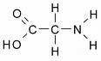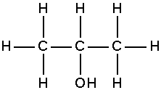

1. _________________ 2. _______________

_________________ _______________

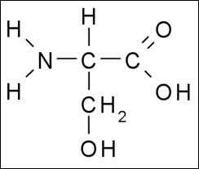



3. ___________________ 4. ________________

____________________ _________________

**PART 2: MONOMERS & POLYMERS**: Monomers are the repeating units that make up a polymer.

|  |  |  |
| --- | --- | --- |
| **POLYMERS** | **MONOMERS (building blocks)** | **Atom present** |
| **Carbohydrate** |  |  |
| **Protein** |  |  |
| **Lipid** |  |  |
| **Nucleic Acid** |  |  |

**PART 3: BUILDING A MACROMOLECULE:** All living things make large molecules, called macromolecules, from smaller molecules. Macromolecules can be made from a few repeating units, or can be composed of hundreds or thousands of smaller molecules. Each macromolecule has properties quite different from the units of which it is composed. Study the diagrams below, which show carbohydrate molecules. Beside each molecule, write whether it is a monosaccharide, a disaccharide, or a polysaccharide.

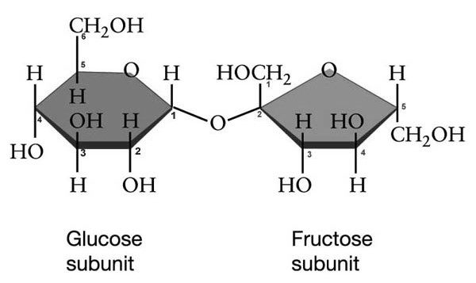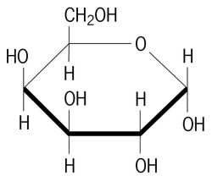

1.__ _____________________ 2._________________________

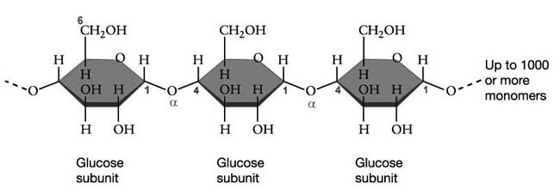

3. ____________________________

4. What is the function of #3 in our bodies?

5. After you eat carbs. and the immediate energy requirements of all your body's

tissues have been met, the excess glucose in your blood will be converted into

______________

a) If all of your glycogen stores are full and you still have excess glucose in your bloodstream, the remaining glucose will be converted to ____________.

6. What is the name of the chemical process that joined the disaccharide and the

polysaccharide? ______________________________________

**PART 4: DEGREE OF SATURATION:** Each of the following structural formulas shows a fatty acid molecule. On the line, identify the fatty acid as saturated, unsaturated, or polyunsaturated.

|  |  |  |
| --- | --- | --- |
|  | | |
|  |  | 1.______________________ |

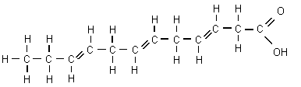

2

._____________________

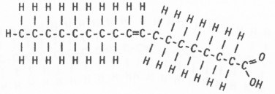

3

._____________________

1. Define a saturated fatty acid. Provide one example of a saturated fatty acid.

1. Define an unsaturated fatty acid. Provide one example of an unsaturated fatty acid.

1. Define a polyunsaturated fatty acid.

**PART 5: SYNTHESIS-ANAYLZING MACROMOLECULES: Study the diagram below and then answer the following questions.**

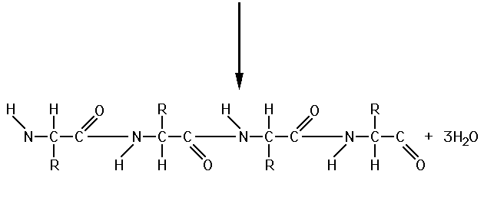

**+**

**+**

**+**

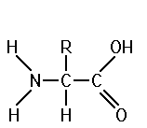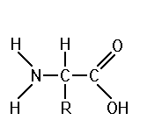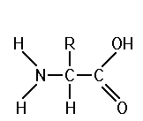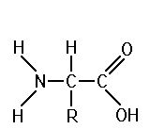

1. What are the reactants?____________________________________
2. What are the products?_____________________________________
3. What chemical process occurred in order to create this protein? _______________

a. How do you know?_______________________________________________

1. Circle the peptide bonds. How many peptide bonds are present? _____
2. How many molecules of water are produced in order to form the peptide bonds? __________

1. If a protein contained 200 peptide bonds, how many molecules of water do you suppose would be required to break it down into its components? ___________
2. What is the ratio of molecules of water to the number of peptide bonds? __________