**Notes: Ecology #4**

**Ecosystem Cycles**

* Matter cycles through an ecosystem as it is transferred between organisms and the environment
* There are many important cycles:
  + Oxygen Cycle
  + Hydrologic Cycle (water)
  + Carbon Cycle
  + Nitrogen Cycle

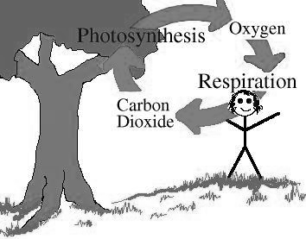**Oxygen Cycle**

* Respiration
  + Oxygen (O2 ) is consumed
  + Carbon dioxide (CO2) is released
* Photosynthesis
  + CO2 is consumed
  + O2 is released
  + Water
  + 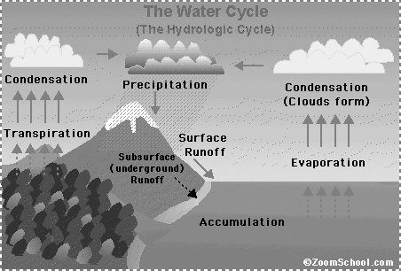Oxygen is also dissolved in water, where it can be used for respiration by aquatic creatures

**Hydrologic Cycle (Water cycle)**

* Driven by sun
* Heat turns water into vapor
  + **Evaporation**
  + **Transpiration (plants)**
* When air cools, vapor turns to clouds
  + **Condensation**
  + Clouds accumulate and drop **precipitation** (snow, rain, hail)
* Precipitation accumulates in lakes, rivers, oceans, etc.
  + **Accumulation**

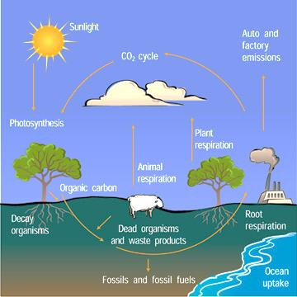

**Carbon Cycle**

* All living things and many non-living things are made out of **carbon**
* In the atmosphere, carbon is in the form of **carbon dioxide** (CO2)
  + Greenhouse gas that traps heat
* Organisms release CO2 during respiration
* When plants use CO2 in photosynthesis, the carbon becomes part of the plant
* If plants are buried when they die, they may become fossil fuels
  + Burning fossil fuels emits CO2

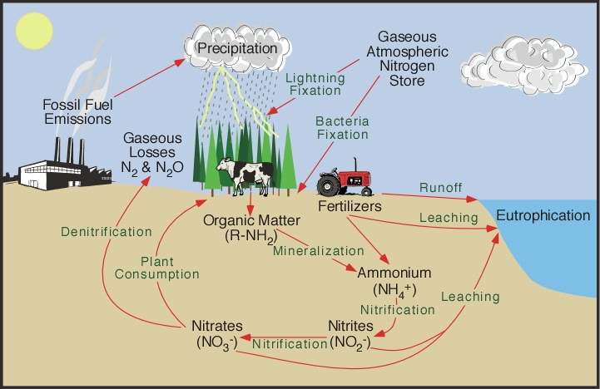

**Nitrogen Cycle**

* 78% of the air we breathe is nitrogen (N2)
* Four main processes:
  + Nitrogen Fixation
    - Breaks apart into N2 usable forms
    - Atmospheric Fixation = By lightning
    - Biological Fixation= By bacteria
    - Industrial Fixation = Fertilizers
  + Decay
    - Proteins are broken down from dead organisms and waste by bacteria into ammonia
  + Nitrification
    - Ammonia converted by bacteria and legumes into nitrates and nitrites
  + Denitrification
    - Conversion of nitrates and nitrites into N2 gas

**Phosphorus Cycle**

* 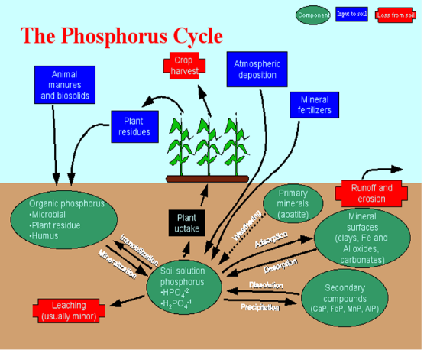Fertilizers
  + Deposit phosphorus into soil
* Plants absorb phosphorus
  + Animals eat plants
  + Absorb phosphorus
* Problem = runoff
  + Increased algae growth
  + Called eutrophication

**Succession**

* Definition:
  + Process of changes in the structure of an ecosystem over time
* An undisturbed ecosystem, if examined over a long period of time, is in a constant state of change
* Plant and animal species are replaced by new ones
* The time for succession differs between ecosystems
* Two types of succession:
  + Primary
  + Secondary
* **Primary Succession** (hundreds to thousands of years)
  + Occurs in an area where there are no living organisms
  + May have been complete destruction due to a catastrophic disaster (volcano)
  + Barren land, no soil
  + Pioneer species come from outside the area
    - Make area hospitable to other species

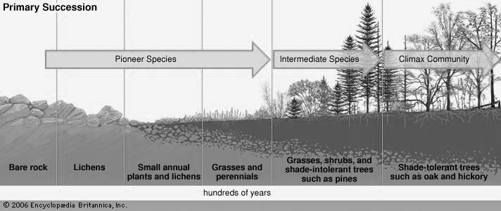

* **Secondary Succession (50-200 years)**
  + Occurs in an area where organisms formerly lived
  + Previous population has been wiped out by a natural disaster (flood, fire, drought)
  + Soil still intact, some seeds and roots still remain
    - These species establish the new population
  + After many years, the community will reach a stable state (**climax community)**

