ORGANIC MOLECULES WORKSHEET Name:___________________________________________________Period:______Date:_________

Part 1: CARBON: Answer the following questions.

1. All organic compounds contain ____________________
2. In order for a carbon atom to be considered stable it needs to form ________ covalent bonds.
3. Compounds that contain only hydrogen and carbon atoms are called __________________.
4. The following structural formulas show four different compounds of carbon and hydrogen (hydrocarbons). Below each structural formula, write the chemical formula and label any double and triple bonds.

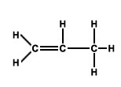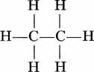

1.___________________ 2._____________________ 3.______________________



4.___________________

Part 2: CARBOHYDRATES: Answer the following questions.

1. What atoms make up carbohydrates? _______________________________________________

1. What is the ratio of hydrogen to oxygen atoms present in all carbohydrates? _________

1. What are the three types of carbohydrates?
   1. ___________________________________________________
   2. ___________________________________________________
   3. ___________________________________________________

Part 3: MONOSACCHARIDES & DISACCHARIDES: Answer the following questions.

1. What are the monomers of carbohydrates? _____________________________________

1. What is the difference between monosaccharides and disaccharides?

1. What are the three examples of monosaccharides?

* 1. ________________________________________

* 1. ________________________________________

* 1. ________________________________________

1. What are the three examples of disaccharides?

* 1. ________________________________________

* 1. ________________________________________

* 1. ________________________________________

1. Look at the structural formulas below. These three sugars all have the same chemical formula (C6H12O6).
   1. Are the structural formulas the same? __________________
   2. What do we call compounds that have the same chemical formula, but differ in their structural formulas? _______________________

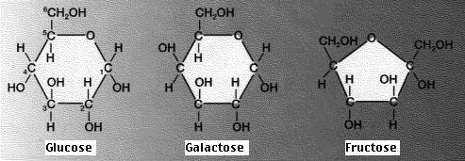

1. Monosaccharides all have the same formula: C6H12O6. How can you write this formula in the simplest form (reduced) that illustrates the proportion of elements in monosaccharides? ______________________________
2. Below is an example of dehydration synthesis. In dehydration synthesis, a hydrogen atom from one molecule joins with a hydroxyl group (-OH) from another molecule to form water, leaving two molecules bonded to the same oxygen atom. For example, when glucose and fructose combine by dehydration synthesis, they form sucrose and water.

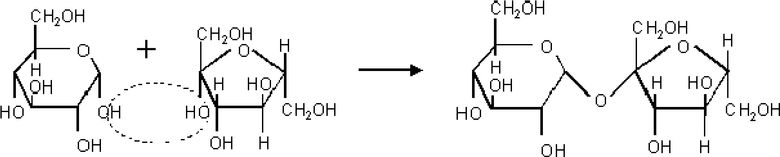 **+**  H2O

 water

1. Below is an example of hydrolysis. Complex organic molecules are broken down by the addition of the components of water – H+ and OH-.

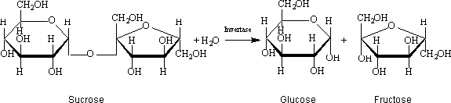

water

1. What are the products of the hydrolysis reaction? ____________________________________

1. What are the reactants of the dehydration synthesis reaction?________________________

1. How are the reactions in #7 and #8 related?_________________________________________

_________________________________________________________________________________

1. What is the chemical formula for disaccharides?__________________

1. Why is the chemical formula of disaccharides not double that of the monosaccharides?

1. In what life process does hydrolysis occur?______________________________________

1. Look at the three reactions below. Which reaction(s) is hydrolysis taking place? ______________
   1. How do you know?

1. Look at the three reactions below. Which reaction(s) is dehydration synthesis taking place? _________
   1. How do you know?

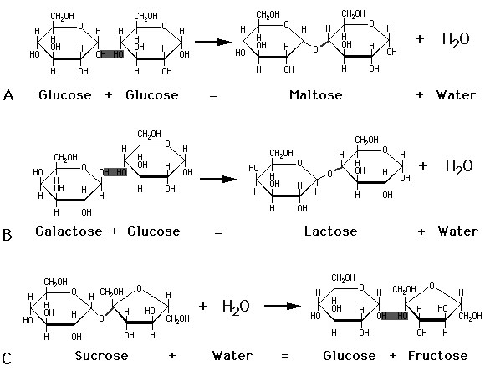

1. What are the common names for sucrose and lactose? _______________________________________
2. What are polysaccharides? ____________________________________________________________
3. What substance would the repeating unit that makes up starch, cellulose, and glycogen?

________________________________