**Johnson Administration**  
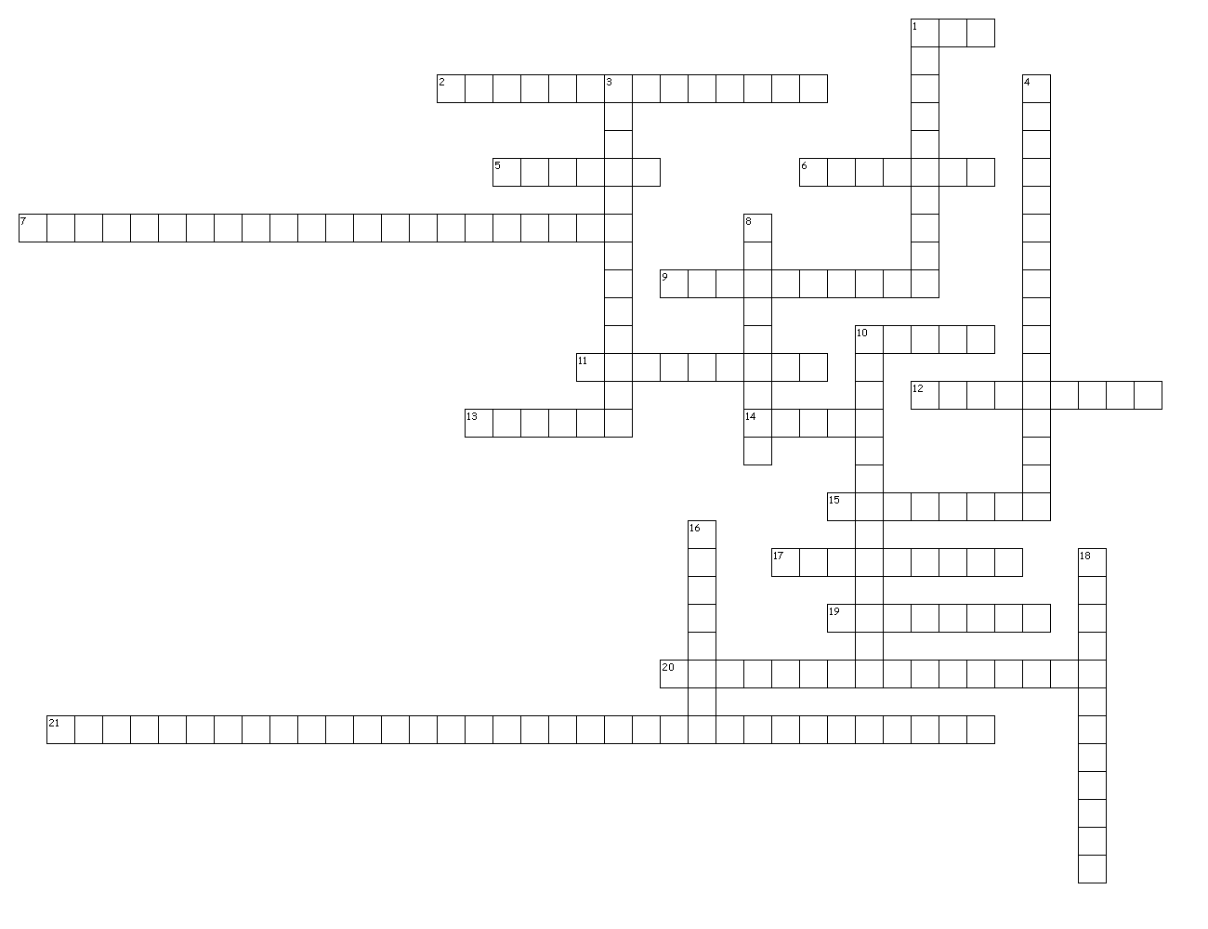

**Across**

1. Was created to develop and rehabilitate urban communities. Provided monetary assistance to the poor for housing.

2. Replaced quotas with more flexible limits.

5. Suspects in criminal cases who cannot afford an attorney have the right to free legal aid.

6. A rule which states that arresting officers must inform individuals of the rights they possess.

7. Was created to combat several causes of poverty, including illiteracy and unemployment.

9. Chief Justice of the Supreme Court during the JFK and LBJ years.

10. Sent volunteers into poor neighborhoods (rural and urban) to help improve the standard of living.

11. a preschool program for children from low income families.

12. A controversial television campaign ad which attacked LBJ's 1964 opponent.

13. As a result of this LBJ action, Unemployment fell and inflation remained in check.

14. Found religious prayer in public schools to be unconstitutional.

15. Provides hospital and low cost medical insurance to most Americans aged 65 and older.

17. Republic LBJ sent marines here to put down a rebellion and preserve a military backed government.

19. Provides low cost health insurance to poor Americans of any age who cannot afford their own private health insurance.

20. A combination of flattery and intimidation used by Johnson to persuade congressmen to vote as he wanted them to.

21. Gave federal aid to states for their schools. The aid was based upon the number of children from low-income homes.

**Down**

1. An author who argued that the federal government should have allocated even more money in the fight against poverty.

3. The distribution of seats in a legislature among electoral districts.

4. Was established by the case of Mapp v Ohio.

8. The Republican candidate in the election of 1964.

10. LBJ was frustrated in this job which he felt lacked any real power.

16. Stuck down a Conn. law which prohibited the use of birth control.

18. The term used by Johnson to describe his domestic goals.