**Notes: Ecology #3**

**Ways Organisms Reduce Competition**

* Many different behaviors/adaptations to reduce competition:
  + __________________
    - Where an organism prefers to live
    - Ex: _____________________________________________
  + ___________________
    - The role or job of an organism in the community
    - Ex: __________________________________________________
  + Patterns of activity
    - _________________________
      * Active at night
    - _________________________
      * Active during the day
    - ________________________________
      * Inactive state during the winter in response to cold
  + __________________________________________
    - Inactive stage of organisms in response to the heat and lack of water
    - Ex: _______________________________
  + __________________________________
    - Seasonal movement from harsh climate to a more favorable climate
    - Return to original habitat when conditions improve
    - Examples: ________________________

**Ecosystems**

* + Definition:
    - Interaction of all the ________________ organisms in an area (biotic factors) and the __________________ aspects of the environment (abiotic factors)
  + Biotic
    - Ex. __________________________________________
  + Abiotic
    - Ex. ____________________________________________

Ecosystem—Biotic and Abiotic Interactions:

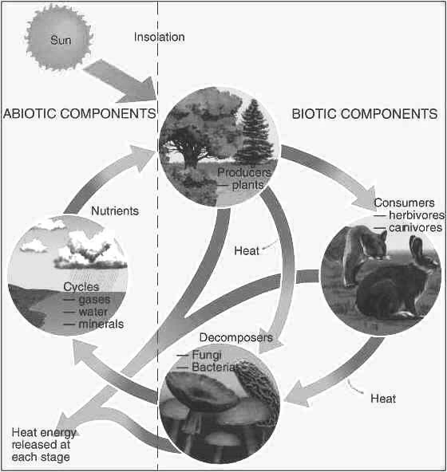

**Ecosystems**

* Ecosystems affect and are ___________________________ upon one another
* All ecosystems are dependent upon energy
* Competition is most often for __________________________.
* Why do organisms need food?
  + For ____________________________________!

**Productivity**

* Productivity
  + The amount of _____________________ an ecosystem can generate from producers
  + Producers get energy from the ______________________
* Net Productivity: Most important energy measurement
  + Energy that is ______________________ as food for consumers in the food chain
  + The higher the net productivity, the greater the amount of energy available to each trophic level

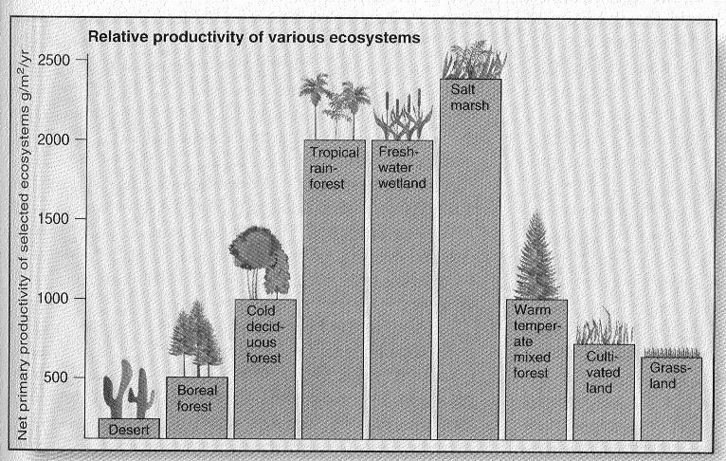

**Trophic Levels**

* In an ecosystem, energy is transferred through trophic levels in a food chain
* The transfer of energy between levels is NOT efficient
  + **Only ~____________% of energy is transferred to the next trophic level**
* Energy is used for __________________ and _______________________ , OR is lost as ____________________ or ______________________________
* The remaining 10% of energy is transferred to the next _________________________ level
* **Energy flow in a food chain:**

**Autotrophs**

**(photosynthetic organisms: plants, algae),** algae)

**Herbivores**

**(Plant eating)**

**Omnivores and Carnivores**

**(Meat-eating hunters)**

**Scavengers**

**(Carrion-eating)**

**Decomposers, detritivores**

**(Decompose organic matter)**

**Energy Transfer: Food Pyramid**

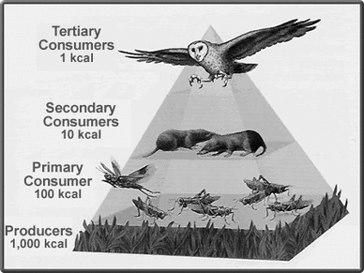

**4th trophic level: Tertiary Consumers**

* Large carnivores (top predators- owls, lions)

**3rd trophic level: Secondary Consumers**

* Small carnivores and omnivores (rats, raccoons)

**2nd trophic level: Primary Consumers**

* Herbivores (grasshoppers, grazing animals)

**1st trophic level: Producers**

* Autotrophs (plants, algae)

**Food Webs**

* Show the flow of _________________ in an ecosystem
* Often very _________________________________
* Figure: Arrows indicate the _______________________________ of energy flow

