Hip Joint

[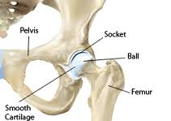](http://www.google.com/imgres?imgurl=http://www.thedenverclinic.com/services/hip/images/stories/hip_anatomy.gif&imgrefurl=http://www.thedenverclinic.com/services/hip/conditions-we-treat.html&docid=LLYac0EG8BqG2M&tbnid=Pm0F7tbWNk3aGM&w=264&h=187&ei=7V8vUfKFDoes8AT654HABw&ved=0CAcQxiAwBQ&iact=ricl)

[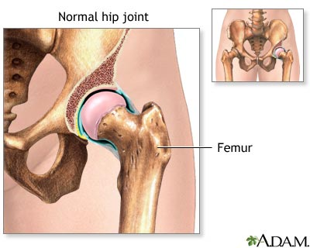](http://www.google.com/url?sa=i&source=images&cd=&docid=h2a0Ycn19FIPoM&tbnid=orV_YX6O8HBSKM:&ved=0CAgQjRwwAA&url=http://www.umm.edu/patiented/articles/hip_joint_replacement_normal_anatomy_000105.htm&ei=7V8vUfKFDoes8AT654HABw&psig=AFQjCNFVisLPSbb-pyXZl8DKVKUBhkm8Gg&ust=1362145645281548)

