**Biochemistry Review Worksheet**

**Directions:** Answer the following questions completely and concisely.

1. List a kind of food that contains these polymers.

* 1. Proteins:_______________________________________________________________
  2. Carbohydrates:_______________________________________________________________
  3. Fats:__________________________________________________________________

1. What are the elements that make up all carbohydrates?______________________________
   1. What is the specific ratio of hydrogen to oxygen?_________________

1. Monosaccharides, disaccharides, and polysaccharides are a type of what macromolecule? _________

1. What are the monomers of carbs.? __________________________________

1. What is the function of carbs.? ____________________________________________________

1. Write the formula for monosaccharides ____________________

1. Write the formula for disaccharides ____________________

1. What are the monomers of proteins?_________________________________________

1. What are the elements that make up all proteins?______________________________

1. What is the name of the bond that joins together amino acids?________________________

1. What are 2 functions of proteins?
   1. _________________________________________
   2. _________________________________________

1. What are the monomers of a lipid?____________________________________

1. What is the common name(s) given to lipids? _________________

1. What are 2 functions of lipids?
   1. ________________________________________
   2. ________________________________________

1. What is the difference between a saturated fatty acid and an unsaturated fatty acid?

1. Identify the following functional groups:
   1. – OH _____________________
   2. – NH2 ____________________
   3. – COOH ___________________

1. Define isomer.___________________________________________________________________

1. What is the difference between a hydrolysis reaction and dehydration synthesis?

1. Provide an example of a dehydration synthesis reaction below. Hint: you should have 2 reactants and 2 products and you do not have to draw the structural formulas.

1. List the 5 elements that make up most nucleic acids ___________________________________
2. What is an essential amino acid?

1. What type of polymer are enzymes?__________________________________________________

1. What are the monomers of nucleic acids?___________________________________________

1. What is the function of DNA?________________________________________________________

1. What is the function of RNA?________________________________________________________

1. A compound that consists of only hydrogen and carbon would be called a(n)________________.

1. Which macromolecule stores more energy, fats or carbohydrates? ____________.
2. What macromolecule would most likely be represented by the following formula, C57H110O6? How do you know?

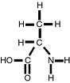

1. Below is the structural formula for an amino acid. Circle and label the 2 functional groups. Also write the chemical formula.

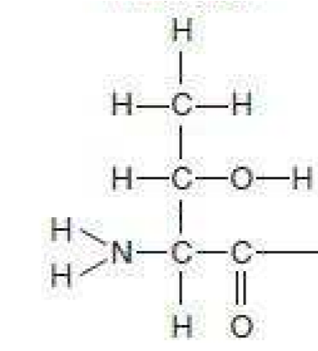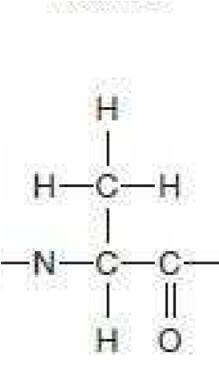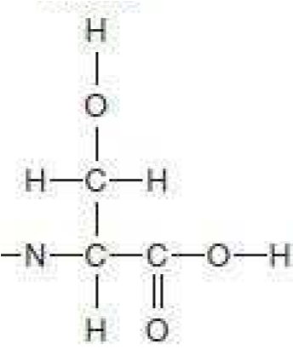

1. Circle the peptide bonds.