A Moodle 2.0 “How To” Guide

**How to View or Change your Enrollment Key**

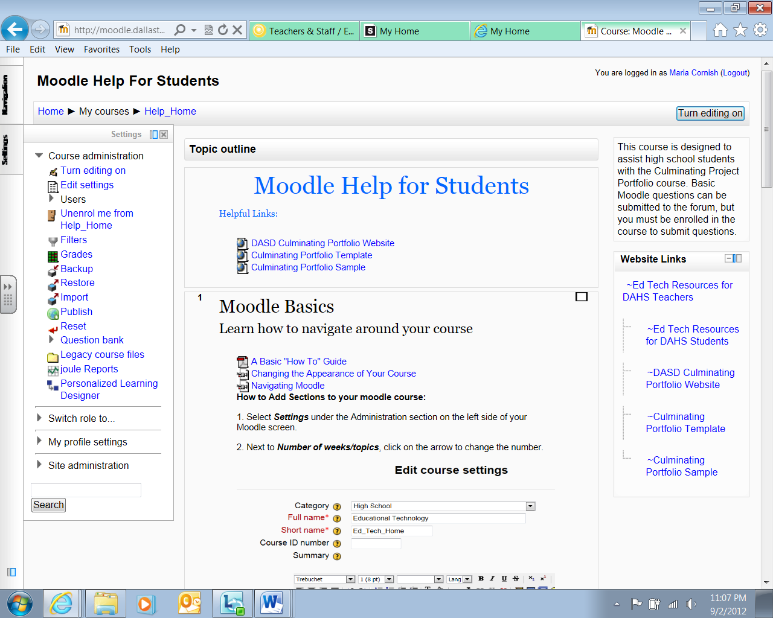

1. In the course settings block, click ***Users>Enrollment methods***
2. Make sure self-enrollment is enabled (has its eye open) and then click the edit icon on the right:

[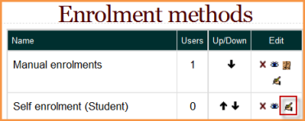](http://docs.moodle.org/20/en/File:Editselfenrolment.png)

1. Add your enrollment key in the box provided. (Click Unmask to see what you are typing.)

[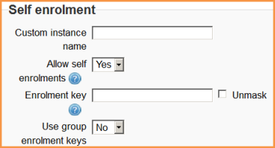](http://docs.moodle.org/20/en/File:Selfenrolmentkey.png)

1. Click ***Save changes***.



**How to upload a document to your Moodle site**

1. ***Turn editing on***.
2. Locate the section of your Moodle page where you want to put your document. Click on the ***Add a Resource drop-down box***.
3. Select ***File***.
4. ***Give the file a name*** and a description.
5. Click on ***Add***.
6. Click ***Upload a File***
7. Click ***Browse*** and navigate to where you have the file saved and select the file.
8. Select ***Upload this File***.
9. Scroll to bottom of the screen and select ***Save and return to course***.



**Inserting a Label** (this may be helpful to you in organizing your Moodle site. It creates a text label onscreen to clearly “label” and explain files that you have uploaded)

1. ***Turn your editing on***
2. Locate the section of your Moodle page where you want to insert the label. Click on the ***Add a Resource*** drop-down box.
3. Select ***Label***.
4. In the mini Word screen, type your desired text. (You can choose your font, font size, color, and any font effects here as well)
5. Click on ***Save and return to course*** when finished.

**After adding a Resource or Activity to your Moodle site, you will see the following icons:**

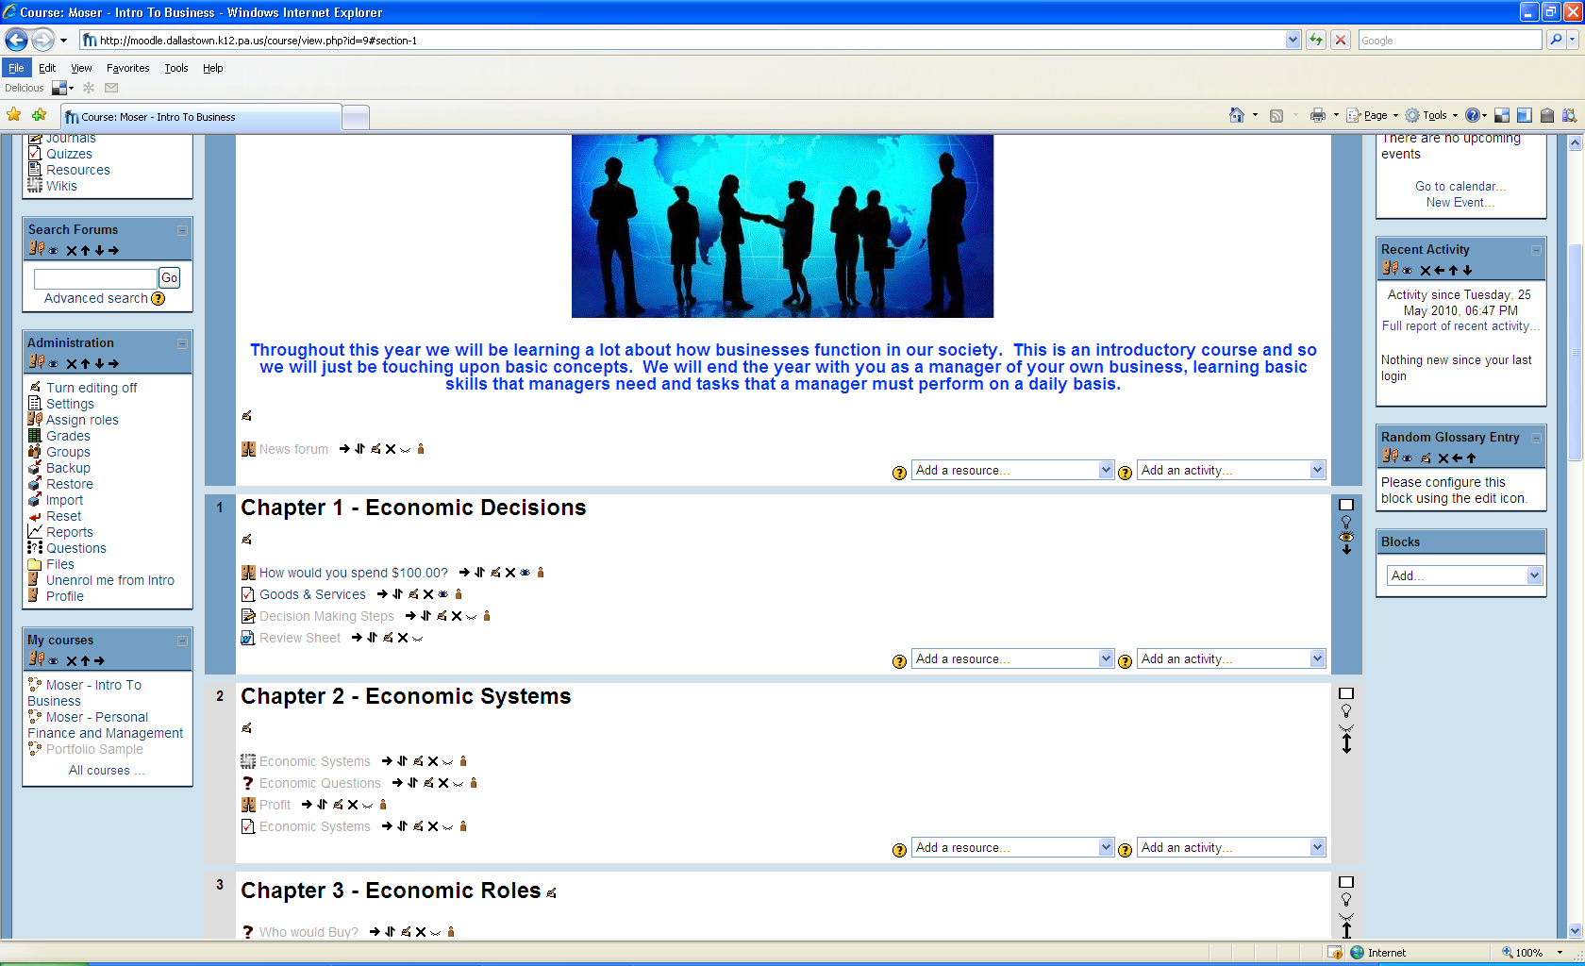

**The icons do the following: (starting at the far left)**

* + **Horizontal Alignment –** Moves the resource or activity to the right or to the left within the section
  + **Move Up or Down -** Moves the resource or activity up or down in relation to other items contained in the particular section or the whole Moodle site
  + **Update file –** Use this if you want to change a file, update information
  + **Delete -** Removes the resource or activity from the Moodle site
  + **Hide/Unhide –** This icon allows you to control what resources and activities can be seen by others you give access to your site.
  + **Groups –** Allows you to choose whether or not you will use groups for the activity.