**Basic Chemistry & Biochemistry Unit Review**

NAME: ___________________________________________________Period:_____Date:____________

**A.** *Using the vocabulary terms in the following list, fill in the blacks in the statements below.*

Element neutron compound atom hydrolysis nucleus pH nucleus

Atomic number inorganic ionic bonding polymer covalent bonding

Isotopes polysaccharide dehydration synthesis mass number proton

Acids disaccharide monosaccharide reactants electron

1. A substance that cannot be broken down into other substances by ordinary chemical means is a(n) _____________________.
2. A substance formed by the chemical combinations of two or more elements is a(n) __________________.
3. The basic unit of structure of all elements is the _________________.
4. Atoms are made up of three types of particles: __________________, __________________, and __________________.
5. The dense central portion of the atom is the ______________________.
6. The number of protons in the nucleus of an atom is the _______________________ of the element.
7. The number of protons plus the number of neutrons in the nucleus of an atom is its ____________________________________.
8. Different varieties of the same elements having different numbers of *neutrons* in their nuclei are called __________________________.
9. Chemical bonding in which there is a transfer of electrons from one atom to another is a(n) ____________________________________.
10. Chemical bonding in which there is a sharing of electrons between atoms is a(n) ________________________________________.
11. Measurement of the hydrogen ion concentration of a solution may be given in terms of _________________.
12. Glucose is a __________________________________, maltose is a __________________________, and starch is a _________________________________.
13. The type of reaction by which proteins are synthesized is __________________.
14. The type of reaction by which carbohydrates are broken down is _________________________________________________.
15. Large molecules made up of chains of repeating units are __________________.
16. ________________________________ compounds do not contain carbon.
17. _____________ are substances that fall between 0-6.9 on the pH scale.
18. Substances to the *left* of the yields arrow in a chemical equation are called _____________________.

* 1. *Place the letter of the definition in the space to the left of the term it defines.*

|  |  |
| --- | --- |
| _______1. amino acid | **A.** Type of reaction by which complex molecules are synthesized from simple molecules |
| _______2. enzymes | **B.** A substance composed of similar repeating units. |
| _______3. nucleic acids | **C.** Proteins that act as organic catalysts. |
| _______4. unsaturated fat | **D.** Digestion is accomplished by this type of reaction. |
| _______5. amino group | **E.** COOH |
| _______6. hydrolysis | **F.** RNA and DNA |
| _______7. carboxyl group | **G.** Alcohol found in lipids. |
| _______8. dehydration synthesis | **H.** Monomer of proteins |
| _______9. glycerol | **I.** A lipid containing 1 double bond between the carbon atoms. |
| _______10. polymer | **J.** NH2 |

* 1. *In the answer space for each question, write the letter of the choice that best completes the statement.*

_______1. An atom has 14 electrons. Its *third* energy level has ___________ electrons. (a) 1 (b) 2

(c) 3 (d) 4

_______2. The part of an enzyme that attracts and holds the substrate is the ___. (a) substrate site

* + 1. Coenzyme (c) active site (d) competitive inhibitor

_______3. Unlike carbohydrates and fats, proteins contain ________ atoms. (a) carbon (b) oxygen (c) phosphorus (d) nitrogen

_______4. How many electrons can a carbon atom share? (a) 1 (b) 2 (c) 3 (d) 4

_______5. The nucleus of an atom contains (a) protons & electron (b) neutrons & electrons (c) protons & neutrons (d) only neutrons

_______6. A pH of 7 indicates a (a) strong acid (b) strong base (c) neutral solution (d) weak base _______7. Organic compounds always contain (a) oxygen (b) proteins (c) nitrogen (d) carbon

_______8. Carbohydrates are composed of (a) carbon, nitrogen, and oxygen (b) nitrogen, oxygen, and

hydrogen (c) carbon, hydrogen, and oxygen (d) sulfur, nitrogen, and carbon

_______9. Glucose and fructose are both (a) monosaccharide (b) disaccharides (c) polysaccharides

(d) starches

_______10. Maltose and sucrose are both (a) monosaccharide b) disaccharides (c) polysaccharides

(d) starches

_______11. Monosaccharides join to form disaccharides by (a) hydrolysis (b) hydration (c) dehydration synthesis (d) dehydrolysis

_______12. Disaccharides are broken down into their component monosaccharides by (a) hydrolysis

(b) hydration (c) dehydration synthesis (d) dehydrolysis

_______13. Cellulose and glycogen are (a) proteins (b) fatty acids (c) polysaccharides

(d) disaccharides

_______14. Simple lipids consist of (a) three fatty acid molecules and one glycerol (b) fatty acids only

* + 1. glycerol only (d) amino acids

_______15. The bonds between amino acids in proteins are (a) peptide bonds (b) unsaturated

* + 1. hydrolytic (d) carboxylic

_______16. Enzymes are (a) carbohydrates (b) lipids (c) proteins (d) hormones

_______17. Enzymes (a) decrease reaction rates (b) increase reaction rates (c) are involved only in synthetic reactions (d) are involved only in hydrolytic reactions

_______18. Nucleic acids are composed of (a) C, H, O, N, P (b) C, H, O, N (c) C, H, O, N, S

* + 1. C, H, O

_______19. DNA (a) is the site of protein synthesis (b) contains the hereditary information

(c) is found only in the cytoplasm (d) is found only in the animal cells

_______20. RNA is involved in (a) lipid synthesis (b) carbohydrate synthesis (c) protein synthesis

* + 1. DNA synthesis

_______21. How many water molecules are present, in the following chemical equation? 2H2O **🡪**2H2 + O2

(a) one (b) two (c) three (d) none

_______22. How many hydrogen atoms are present, in the following chemical equation? 2H2O 🡪2H2 **+** O2

(a) one (b) two (c) three (d) four

_______23. _______consist of the majority of fat in an organism. (a) saturated fats b) carbohydrates

(c) triglycerides (d) unsaturated fats

* 1. 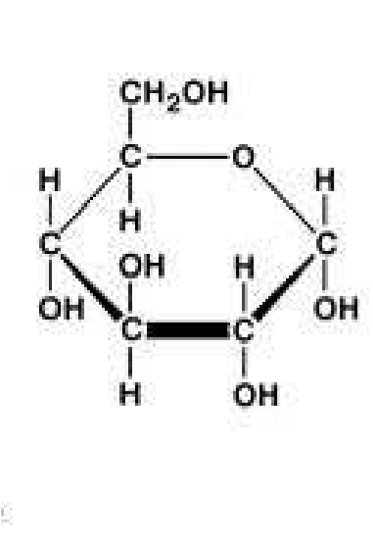*Identification: Identify each of the following types of monomers or polymers.*

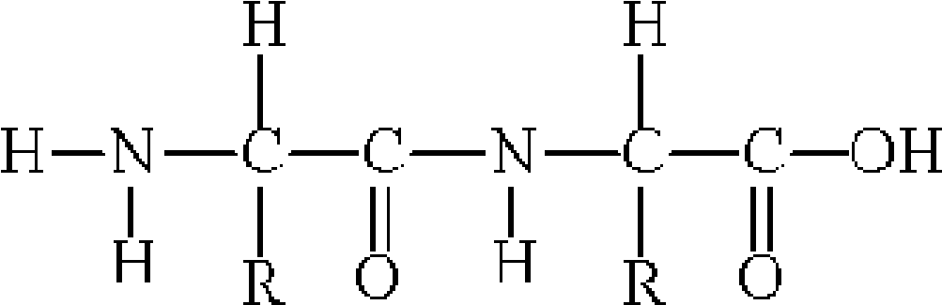

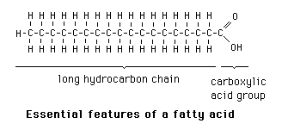

1

. _________________________________

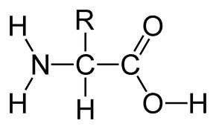

3._________________________

4. _______________________________

2.________________________________

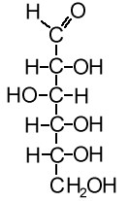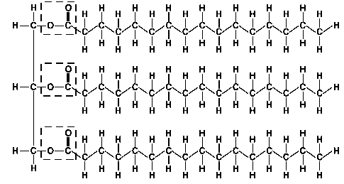

5. ___________________________ 6.____________________________________

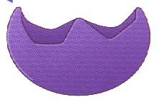 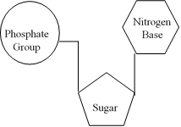

7._______________________________ 8.________________________

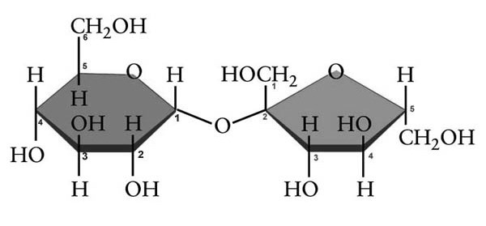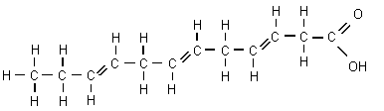

9._______________________________ 10. _______________________________

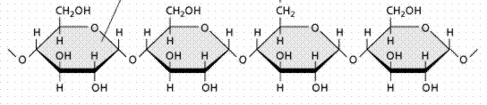

11.__________________________________