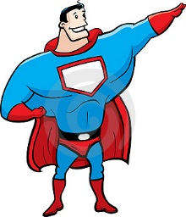
Name:
I’m a Super Hero!
Imagine you are given the power of a superhero.
- What would be your special power?
- Why would you want it?
- What would you do with this new ability?

