**CELLULAR TRANSPORT Worksheet**

Name: __________________________________________________________Period:_____

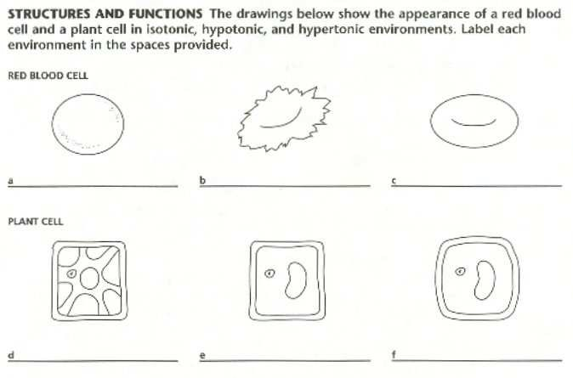

Normal red

blood cell

Normal

plant cell

Shriveling

**Directions**: Using your notes/book, answer the following questions.

___1. All forms of passive transport depend on ________________________

1. energy from the cell in the form of ATP c) carrier proteins
2. the kinetic energy of molecules d) ion channels

___2. Plasmolysis of a human red blood cell would occur if the cell were _____________

a) in an isotonic solution c) in a hypertonic solution

b) in a hypotonic solution d) None of the above

___3. A concentration difference across space is called a (n) _______________________

a) plasmolysis b) concentration gradient c) isotonic d) phagocytosis

___4. A relatively high solute concentration outside the cell is called a(n) _________ solution

a) hypertonic b) hypotonic c) isotonic d) cytolysis

___5. A type of transport in which water moves across a membrane and down its concentration gradient is

1. simple diffusion c) facilitated diffusion
2. diffusion through ion channels d) osmosis

___6. When a human red blood cell is placed in a hypotonic environment, it will _______________

1. lyse c) undergo plasmolysis
2. experience a decrease in turgor pressure d) be at equilibrium

___7. Most of the time, the environment that plant cells live in is a(n)_________ environment.

a) isotonic b) hypertonic c) hypotonic d) None of the above

___8. Diffusion is a term for the movement of molecules from _________________.

a) an area of low concentration to an area of high concentration c) an adjacent area to a gradient

b) an area of high concentration to an area of low concentration d) a nucleus to the mitochondria

___9. In a hypotonic solution, the concentration of solutes is lower than the_____________

* 1. concentration of solutes inside the cell c) concentration of solutes outside the cell
  2. concentration of osmosis in the membrane d) concentration of diffusion in the membrane

___10. When the cells in a plant have low turgor pressure, the plant __________.

a) is rigid b) dies c) wilts d) explodes

___11. Concentration of solutes inside and outside the cell are equal when _____________

a) the solution is isotonic c) the solution is hypotonic

b) the solution is hypertonic d) the solution is isometric

___12. The process of diffusion requires _______________

* 1. a cell membrane c) an aqueous solution
  2. a difference in the concentration throughout a space d) All of the above.

___13. Facilitated diffusion uses ____________________.

* 1. ions c) molecules that are too small to diffuse across the membrane
  2. carrier proteins d) molecules that are not soluble

___14. The polar phosphate heads of a phospholipid are considered ____________________.

a) hydrophobic

* 1. hydrophilic
  2. nonpolar
  3. none of the above

15. **For each of the following, identify the specific type of passive (osmosis, diffusion or facilitated diffusion) or active transport (endocytosis or exocytosis):**

1. Using cellular energy, a cell membrane encloses and takes in a droplet of fluid. _______________
2. Carrier proteins take sugar (glucose) into a cell without requiring energy input. _______________
3. Water diffuses across a cell membrane from a region of high concentration water to a region of

low water concentration. _______________________________________

1. Using cellular energy, mucus and waste products packaged by Golgi apparatus are secreted by a

cell. ________________________________

1. Using cellular energy, a cell membrane encloses and takes in food particles. __________________