**WORD AND BEYOND!**

Tips and tricks for using Microsoft Word

How to insert clipart and pictures: 2

How to add Wordart: 3

How to add tables: 4

How to create columns: 5

How to create screen shots: 6

How to track changes: 7

Other topics you don’t want to miss: 9

**How to insert clipart and pictures:**



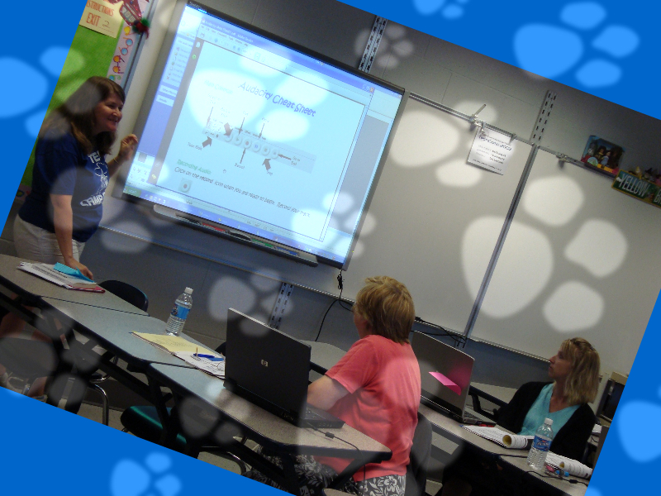****

**How to add Wordart:**

How to add tables:

**Dallastown Area School District Total Number of Staff and Students**

|  |  |  |  |  |  |  |  |  |
| --- | --- | --- | --- | --- | --- | --- | --- | --- |
|  | **LH** | **LS** | **OV** | **YT** | **DT** | **MS** | **HS** | **Total** |
| Students |  |  |  |  |  |  |  |  |
| Faculty |  |  |  |  |  |  |  |  |
| Total |  |  |  |  |  |  |  |  |

How to create columns:

The quick brown fox jumps over the lazy dog. The quick brown fox jumps over the lazy dog. The quick brown fox jumps over the lazy dog. The quick brown fox jumps over the lazy dog. The quick brown fox jumps over the lazy dog. The quick brown fox jumps over the lazy dog. The quick brown fox jumps over the lazy dog. The quick brown fox jumps over the lazy dog. The quick brown fox jumps over the lazy dog. The quick brown fox jumps over the lazy dog.

The quick brown fox jumps over the lazy dog. The quick brown fox jumps over the lazy dog. The

How to create screen shots:

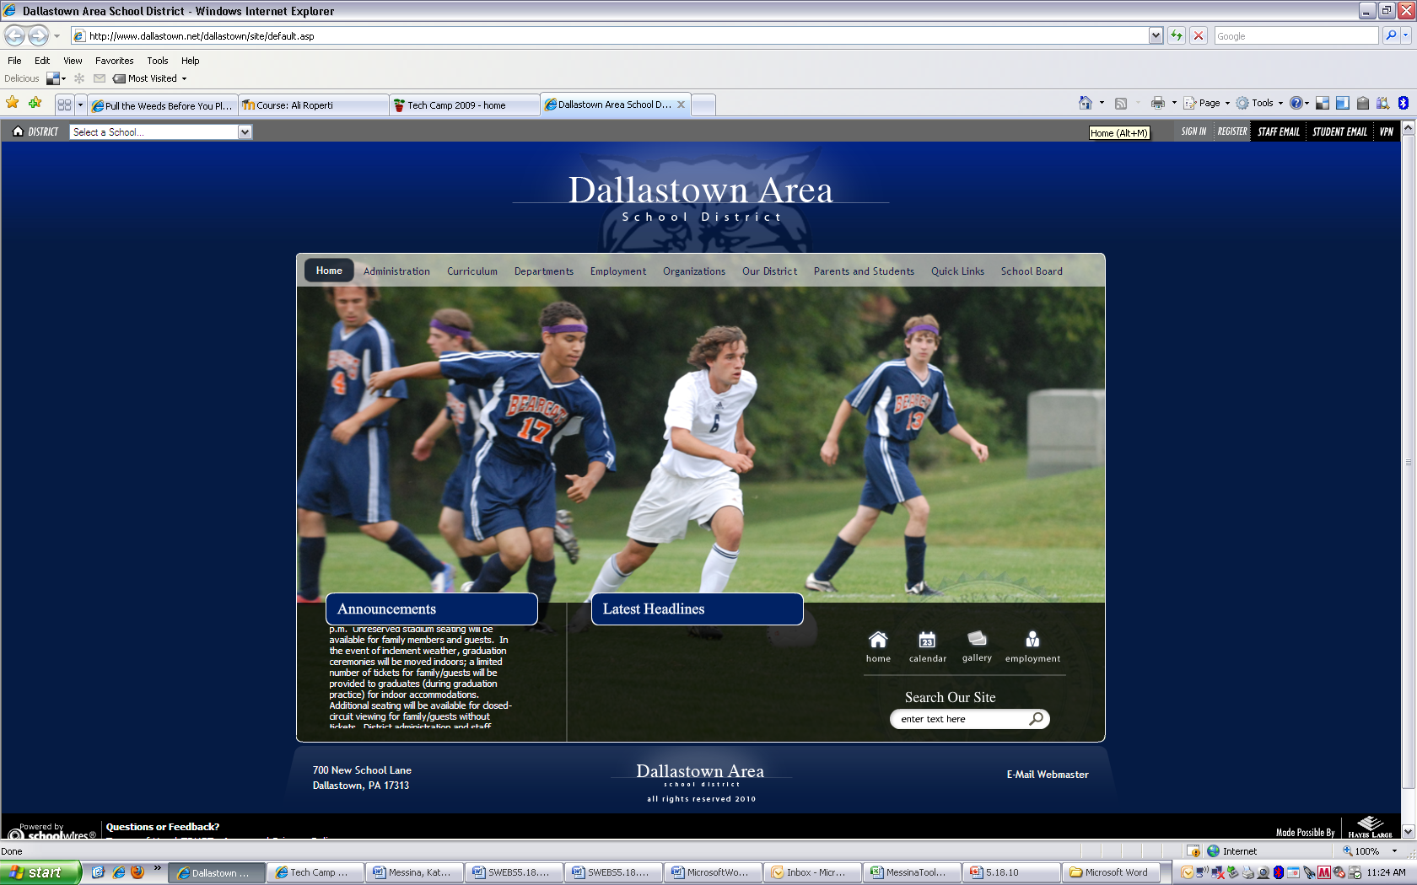

How to track changes:

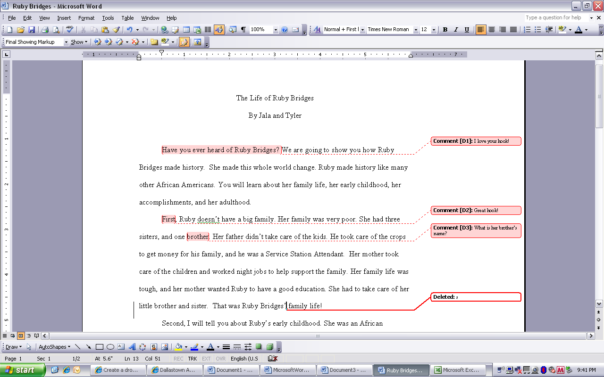

Other topics you don’t want to miss:

How to…

✔add drop caps

✔add borders, shading, and background

✔copy and paste Excel documents and make them look GOOD

✔use the table of contents template

✔use tabs

✔use shortcuts