**DHS Soccer**

The origin of soccer is in doubt. Some people think it was first used by the Chinese as battle training for their warriors; while others seem to think it was a game invented by the Romans for its Olympic games. In any event, soccer was developed by the English who, in 1860, formed an organization to consolidate rules for soccer. It was brought to the United States in the late 1860s, and the first regulation game was played between Princeton and Rutgers in 1869. With youth soccer on the rise, it may gain the importance in the U.S. that it already holds in other countries.

**SAFTEY AND EQUIPMENT RULES AND EXPECTATIONS**

**Do’s** – Play under control, play the ball – not the man, talk and be aware of the other players, use your hands for protection if the ball is kicked at your body or face, ease up if the goal tender is picking up the ball, ties your sneakers before you play, wear your scrimmage vest properly, stop playing whenever the whistle blows, and return all equipment at the end of the period.

**Don’ts** – Jump at the ball or leave your feet to make a tackle, play the man instead of the ball, dive on the ball if you are the goalie, kick the ball at someone intentionally.

**Basic Rules/ Playing Terms**

**Start of the game:** At the start of a soccer period or after a goal, there is a kick-off from the center circle.

You are allowed 11 players at time on the field.

**Other ways of restarting soccer include:   
Throw-in:** When the soccer ball has gone out of bounds, the team that last touched the ball loses possession and the opposing team gets to throw-in the ball from the point where the ball crossed out of bounds.

* When throwing the ball in at **throw-in**, the ball must be thrown from behind and over the head using both hands. When the ball leaves the thrower's hands, both of his/her feet must be touching the ground

**Corner kick:** When the defending team last touches the ball and it crosses the goal line (and not scoring a goal), the opposing team gets to kick the ball from the corner of the field.   
**Goal kick:** When the offensive team last touches the ball before it crosses the goal line, the goalie gets to kick the ball from the goal box.   
**Penalty kick:** When a foul occurs in the penalty area, the fouled team is awarded a penalty kick.

**Advantage** – situation where a foul is NOT called because the team with the ball has a possible scoring opportunity

**Dribbling** – controlling the ball with your feet as you are moving around the field

**Free kick** – awarded when a foul occurs and can be direct or indirect

**Heading** – using your head to trap, move, or pass the ball in the air

**Obstruction** – illegally blocking or screening a player from getting to the ball

**Trapping** – stopping or controlling a ball in the air or on the ground by using your head, body, or feet

**Foul** – improper play which results in a free kick or penalty kick

**Types of Fouls**

* Pushing
* Tripping
* Touching the ball with your hands

Free kicks or penalty kicks may be awarded to the opposing soccer team.

Very unsportsmanlike behavior may result in a yellow card or a red card. Players that get red cards are ejected from the game.

**Offside Rule**: The offensive player is offside if they are nearer to the opponent's goal line than both the second and last opponent and the soccer ball.   
  
**Out of Bounds**: Out of bounds occurs when the ball completely crosses over the boundary line.

**PLAYING RULES**

* Each goal in soccer is worth one point, and penalty kick are awarded for goals in the penalty area or for unsportsmanlike technical fouls.
* Eleven players make up a regulation team (forwards, halfbacks, fullbacks, and a goalie.
* The game starts with a kickoff from midfield, which also occurs after each score. The defensive team must be 10 yards away on the kickoff, and both teams must be on their half of the field.
* Direct free kick fouls (the ball can be kicked into the goal for score): tripping, holding, handball, pushing, charging in a violent or dangerous manner, or jumping at an opponent.
* Indirect free kick fouls (after the ball is kicked, it must touch another player before a score may occur): dangerous plays, obstruction, goal tender wastes time, offsides, arguing with the referee.
* A player is offsides if he doesn’t have the ball, and he/ she doesn’t have two opponents between him/ herself and the goal. There is no offsides on a goal kick, corner kick, or a throw-in.
* All of the ball must cross a line in the air or on the ground to result in the ball being out of play. A ball over the sideline results in a throw-in. A ball over the endline results in either a goal kick, corner kick, or a goal being scored.
* A foul in the penalty area, which would be a direct free kick, results in a penalty kick taken 12 yards away from the goal.
* Players are allowed to use their hands to protect their face or body in PE classes.
* Except on throw-ins, the goal tender is the only player allowed to play the ball with his hand or arms, and this may only be done in the penalty area.

**The Field and Positions:**

[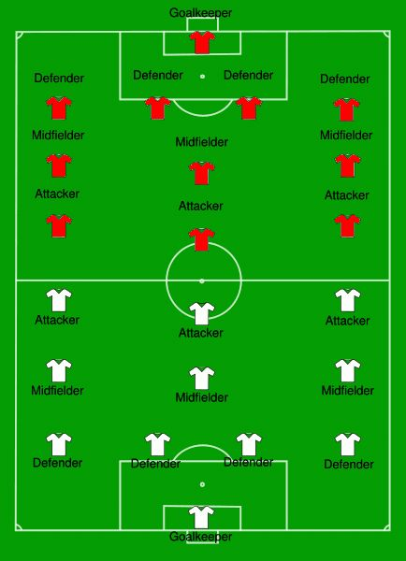](https://www.google.com/url?sa=i&rct=j&q=&esrc=s&source=images&cd=&cad=rja&uact=8&ved=0ahUKEwiV746XiefPAhXHrD4KHfmYAzMQjRwIBw&url=https://www.pinterest.com/pin/371124825516238101/&bvm=bv.135974163,d.cWw&psig=AFQjCNGkNKrAmqFAOyAzhnFzC_AVpShARQ&ust=1476973429511000)[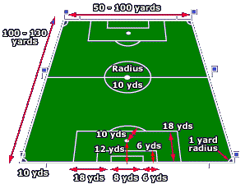](https://www.google.com/url?sa=i&rct=j&q=&esrc=s&source=images&cd=&cad=rja&uact=8&ved=0ahUKEwjrzb-viefPAhWFgj4KHX-GBicQjRwIBw&url=https://www.openplay.co.uk/blog/premiership-football-pitch-sizes-2013-2014/&bvm=bv.135974163,d.cWw&psig=AFQjCNGlPeiHgjLTnpKzDAAcylTxwaBjhQ&ust=1476973443780783)

