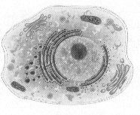**UNIT REVIEW: Cellular Structure & Function**

____1) Which molecule is found in a cell’s membrane and prevents the fatty acid tails from sticking together?

**a) keratin b) collagen c) protein d) cholesterol**

____2) Not all substances can cross the cell membrane, for this reason, the cell membrane is said to be **a) a barrier b) selectively permeable c) membrane bound d) a cell wall**

____3) Provides structure and support in plant cells:

**a) nuclear envelope b) a cell membrane c) cell wall d) ribosomes**

____4) Microfilaments and microtubules

1. **contain digestive enzymes c) are sites of protein synthesis**
2. **function in cell structure and movement d) are sites of photosynthesis**

____5) The cell organelle that processes and packages lipids and proteins is the ______________.

**a) mitochondria b) ribosomes c) Golgi apparatus d) ER**

____6) The cell organelle that digests molecules, old organelles, and foreign substances is the _______. **a) mitochondria b) smooth ER c) Golgi apparatus d) lysosome**

____7) The shape of the cell depends on its _______.

**a) location b) structure c) function d) size**

____8) A prokaryote has __________________.

**a) a nucleus b) a cell membrane c) membrane bound organelles d) All of the above**

____9) The first person to observe and describe microscopic organisms and living cells was _________. **a) Robert Hooke b) Rudolf Virchow c) Anton Leeuwenhoek d) Theodor Schwann**

____10) The movement of PARTICLES from an area of higher concentration to an area of lower concentration

is called _____________________.

**a) osmosis b) diffusion c) isotonic d) kinetic energy**

____11) The osmotic effect in plants is known as ____________________.

1. **diffusion b) plasmolysis c) capillary action d) turgor pressure**

____12) One difference between eukaryotic and prokaryotic cells is that ONLY: **a) prokaryotic cells are surrounded by a cell membrane**

**b) prokaryotic cells have a nucleus**

**c) eukaryotic cells have genetic information**

**d) eukaryotic cells have membrane bound organelles**

____13) The organelle that organizes protein synthesis is the _____________.

**a) mitochondrion b) ribosome c)centriole d) lysosome**

____14) After a protein is made by a ribosome, where will it most likely go next?

**a) rough ER, nucleus b) rough ER, smooth ER c) rough ER, Golgi d) nucleus, lysosome**

____15) The part of the cell that regulates movement of substances into and out of the cell is the _____. **a) nucleus b) cell membrane c) golgi apparatus d) mitochondrion**

____16) Cells that have high energy requirement generally have many _____________.

**a) nuclei b) flagella c) mitochondria d) microfilaments**

____17) A solution in which the concentration of dissolved substances (solutes) is *HIGHER* than the concentration inside the cell.

**a) ionic b) isotonic c) hypotonic d) hypertonic**

____18) Control center for all cell functions is called the _______________.

**a) nucleus b) nucleolus c) mitochondria d) Golgi apparatus**

____19) Cell walls are composed of ________________.

**a) protein b) cellulose c) monosaccharides d) lipids**

____20) The gelatin-like aqueous fluid that organelles are bathed in is the _________________  **a) crista b) nucleolus c) cytoplasm d) centromere**

____21) Organelle that converts sunlight, CO2 and water into sugars (photosynthesis) is called a ___.

**a) ribosome b) lysosome c) chloroplast d) vacuole**

____22) The cell organelle that transfers energy to ATP is the ________________.

**a.) mitochondrion b) smooth ER c) nucleus d) Golgi apparatus**

____23) Storage (food, water) chambers within a cell are known as _____________.

**a) microfilaments b) lysosomes c) vacuoles d) ribosomes**

____24) Which of the following is *not* a principle of the cell theory?

**a) All matter consists of at least one cell.**

1. **Cells are the basic units of life.**
2. **All cells arise from preexisting cells.**
3. **All organisms are made of one or more cells.**

____25) A cell membrane is a thin layer of lipids and ___________.

**a) monosaccharides b) proteins c) chitin d) water**

____26) Cell membranes are made of two phospholipid layers called a ______________.

**a) bilayer b) hydrophilic c) polarity d) semi layer**

____27) The cell organelle that synthesizes RNA is known as __________

**a) mitochondria b) rough ER c) ribosomes d) nucleolus**

____28) The organelles that assists other organelles to move from place to place in the cell are_____.

**a) ribosomes b) microfilaments c) vacuoles d) chloroplasts**

____29) When food is pushed out of the paramecium, (one celled protist) this process is called__.

**a) osmosis b) diffusion c) exocytosis d) endocytosis**

____30) Prokaryotes are organisms whose cells contain NO _____________.

**a) nucleus b) cell membrane c) eukaryotes d) bilayers**

____31) The movement of materials across the plasma membrane by the use of transport proteins is:

**a) osmosis b) passive diffusion c) facilitated diffusion d) transport diffusion**

____32) Unlike animals cells, plant cells have ______________.

**a) cell membranes b) mitochondria c) cell walls d) chromosomes**

____33) The loss of turgor pressure; causes plant to wilt is known as _______________

**a) osmosis b) turbulence c) plasmolysis d) dynamic equilibrium**

____34) Movement of molecules across the membrane by using their kinetic energy is called ________.

**a) concentration gradient b) passive transport c) facilitated diffusion d) active transport**

____35) Type of ER that has ribosomes attached to it:

**a) smooth ER b) rough ER c) hard ER d) soft ER**

____36) What are cells that contain a nucleus or nuclei called?

**a) eukaryotes b) prokaryotes c) ribosomes d) nucleoli**

____37) Osmosis will not occur when a cell is placed in the following solution:

**a) salt water b) hypotonic c)hypertonic d) isotonic**

____38) ________________ coined the word “cell” based on where monks lived.

**a) Anton Leeuwenhoek b) Robert Hooke c) Theodor Schwann d) Mathias Schleiden**

____39) _____ assists in the movement of chromosomes during cell division.

**a) nuclear envelope b) cytoskeleton c) spindle fibers d) centrioles**

____40) _____ are structures that carry out specific functions in the cell.

**a) cytoskeleton b) organelles c) crista d) chloroplasts**

____41) Which molecule is attached to proteins in a cell’s membrane and helps transmit chemical signals?

**a) carbohydrate b) collagen c) lipid d) cholesterol**

42) Determine if the animal cell is placed in a hypertonic, hypotonic, or isotonic solution by CIRCLING the correct answer above the box. Then draw a picture of this situation in the box provided showing the movement of WATER. **Be sure to write what would happen to an ANIMAL CELL when placed in this solution.**

a) An animal cell containing 73% water, and 27% solutes was placed in a solution containing 27% water and 73% solutes.

• **What would happen to the animal cell?** ___________________________________________

HYPERTONIC HYPOTONIC ISOTONIC

**Label the parts of these two cells:**

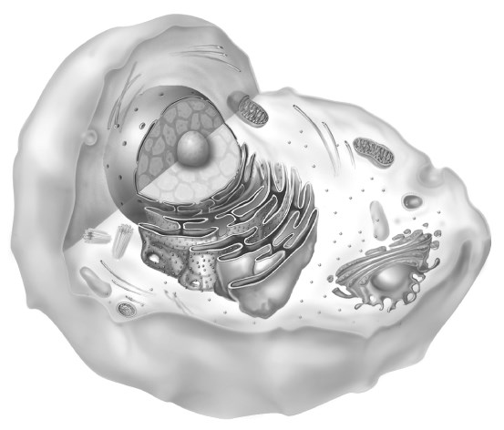

**Cell A**

**Cell B**

