Patterns of Heredity

Name:_________________________________Period:____Date:____________

_______all traits are simply inherited by dominant and recessive alleles (Mendelian Genetics). In some traits, neither allele is dominant or many alleles control the trait.

Below are different ways in which traits can be inherited from parents to

offspring.

**5 Different Modes of Inheritance:**

1. __________________________________:

* Definition:

Neither allele for a gene ___________________

Phenotype of the heterozygous offspring will be a _________of the 2 homozygous parents.

* Ex: A ___________________white flower crossed with a _________________ red flower will produce all _____________________ pink flowers.

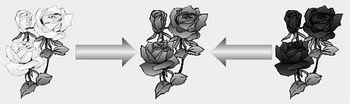

Heterozygous

OFFSPRING

Homozygous

Parent

Homozygous

Parent

* Notation:

Alleles are all capital letters because NEITHER one _________________ the other. So one of the alleles has a ____________( ‘ ) on it to represent an alternate expression of the gene.

Always make a _______to show the genotypes and the resulting phenotypes.

• Still supports Mendel’s Law of Independent Assortment

Ex. 1) In a certain species of flowers, snapdragons, the combined expression of both alleles for flower color produces a new phenotype-pink. A red snapdragon is homozygous and is crossed with a homozygous white snapdragon. What are the genotypic and phenotypic ratios of this cross?

|  |  |
| --- | --- |
|  |  |
|  |  |

P Cross = _________ x ________

**Key:**

**Genotype:**

**Phenotype:**

Ex. 2) Then cross the F1 generation and what are the genotypic and phenotypic ratios of this cross?

P Cross = _________ x ________

**Key:**

|  |  |
| --- | --- |
|  |  |
|  |  |

**Genotype**:

**Phenotype**:

1. ________________________________
   * Definition:
   * o Both ______________are expressed ____________________

* + - 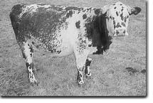Phenotypes of heterozygous offspring are showing both traits!

Ex: red cows crossed with white will generate roan cows.

___________refers to cows that have red coats with white blotches.

* + Notation:
    - 2 ________________alleles (capital letters) are used
    - Always make a _____ to show the genotypes and the resulting phenotypes

Ex. 1) In chickens, black-feathered is not wholly dominant over white-feathered, so heterozygous chickens are black and white checkered. Cross two heterozygous chickens. What would the appearance of their offspring be? P Cross = _________ x ________ **Phenotypes:**

**Key:**

|  |  |
| --- | --- |
|  |  |
|  |  |

Ex.2) In shorthorn cattle, the hybrid between red and white is called a roan. What phenotypes would result in the cross of a roan and a white?

P Cross = _________ x ________

**Key:**

**Phenotypes:**

|  |  |
| --- | --- |
|  |  |
|  |  |

1. ________________________________
   * Definition:
     + **More than _______________**for a single gene can control a trait.
   * Multiple alleles must be studies by looking at the entire population of species.
   * Each individual carries only 2 alleles for any gene (one on each homologous chromosome).
     + In this form of inheritance, a trait can have 1 gene, but ______________ for that gene.
   * Ex: The human blood group can be any combination of A, B, and O
     + The alleles are **IA**, **IB**, and **i**
     + Alleles **A** and **B** are **__________________________**
     + Alleles **i** (“O”) is **____________________________**
   * Notation:

|  |  |  |
| --- | --- | --- |
|  | **GENOTYPES** | **PHENOTYPES** |
| **Homozygous type A** | **IAIA** | type ____blood |
| **Heterozygous type A** | **IAi** | type ____blood |
| **Homozygous type B** | **IBIB** | type ____blood |
| **Heterozygous type B** | **IBi** | type ____blood |
| **Codominant type AB** | **IAIB** | type ____blood |
| **Recessive type O** | **ii** | type ____blood |

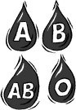 o The possible genotypes/phenotypes:

* + - NOTE: the “**i**” is dropped from the genotype of A and B when the

______________________is written. (Genotype **IAi** is type ____ blood)

o Interesting facts:

In the U. S., about 45% of the population is type O, 42% type A, 10% type B, and only 3% type AB.

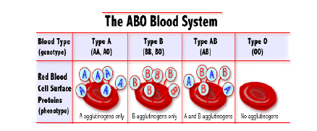

* The positive and negative of a blood type is called the __________________________, It is totally separate _________________________ with Rh+ (RR or Rr) and Rh- alleles (rr)
  + If you have the protein = Rh+
  + If you do not have the protein = Rh-
* In the US, about 85% of the population is Rh+ and 15% Rh-.
* Thus the chances of someone being O- [having both ii and rr] would be 45% × 15% = 6.75%.
* The most rare blood type would be _______**,** about 0.45% of the population.
  + - * _____is the universal donor
      * ______is the universal receiver

Ex.1) If a person of blood group AB marries one belonging to group O, what could be the possible genotypes and phenotypes of their offspring’s’ blood types?

**Genotype: Phenotype:**

P Cross = _________ x ________

|  |  |
| --- | --- |
|  |  |
|  |  |

Ex.2) If a father is homozygous blood type A and the mother is heterozygous blood type B. What could be the possible genotypes and phenotypes of their offspring’s blood types?

P Cross = _________ x ________  **Genotype: Phenotype:**

|  |  |
| --- | --- |
|  |  |
|  |  |

• **2 Types of Chromosomes:**

1. _____________________- last pair of chromosomes—23rd pair for humans

XX = _________________

XY = _________________

2. ______________________________or _____________– all other pairs of chromosomes – 1-22nd pair in humans

4.________________________**: (X-Linked)**

• Other genes besides the alleles for sex are located on sex chromosomes.

• Definit ion:

* + - * + These traits will occur _________frequently in males than females, such as color blindness and hemophilia.

**WHY?**

* + - * + Alleles for a gene may be present on the X chromosome but _______on the Y. These are called sex-linked genes.

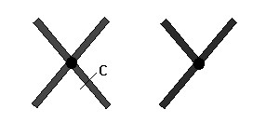

* + - * + This means that _________may inherit just ______allele for a characteristic and that allele will be expressed, whether it is dominant or recessive, because it is the ________allele present on their X chromosome.

* + - * + X-linked traits most likely will be _______________to the normal condition and the Y chromosome lacks the gene for a trait, so males have a higher chance of having the disorder.

* These traits generally do NOT show up in ______________ since females have genes on both their X chromosomes.

* Notation:
  + - The alleles for these traits are written as ____________________on the ____chromosome ONLY.
      * ____ alleles are written on the Y chromosome!

Ex: Colorblind male = Xb Y and Normal male = XB Y

* + - * _________________FEMALES are known as___________, XBXb

Ex.1) Color blindness is a sex-linked trait that is caused by a recessive allele. A colorblind man marries a woman that is homozygous for normal vision.

What possible types of vision could be found if they had **boys**? ____________________

What possible types of vision could be found if they had **girls**? ____________________

P Cross = _________ x ________

|  |  |
| --- | --- |
|  |  |
|  |  |

Ex.2) A girl of normal vision, whose father was colorblind, marries a colorblind man. What types of vision could be found in their children?

**Phenotype**

P Cross = _________ x ________

|  |  |
| --- | --- |
|  |  |
|  |  |

5. _________________________________

* Traits are determined by ____________________
* They may or may not be found on the same chromosome
* Each gene may have more than 2 alleles
* The phenotypes may vary depending on the number of dominant and recessive alleles in the genotype
* Traits that show _____________________are a result of polygenic inheritance o Ex: eye color, skin color, height, facial features

**Environment & Genes:**

* The____________________ can determine whether or not a gene is fully expressed or expressed at all.
* Internal and external environments can affect phenotypes:
  1. Influence of **internal environment:**

~ __________________based on sexes (testosterone, estrogen)

All of these can

influence the

expression of

g

enes

.

* 1. Influence of **external environment:**

~_____________________________

~_____________________________

~_____________________________

~_____________________________

~_____________________________

* **All of these can influence the expression of genes.**

**Pedigrees**

______________________ = a valuable tool for anyone working in the field of genetics.

• Used to show ___________________________ in families, and resemble a _____________________ ___________.

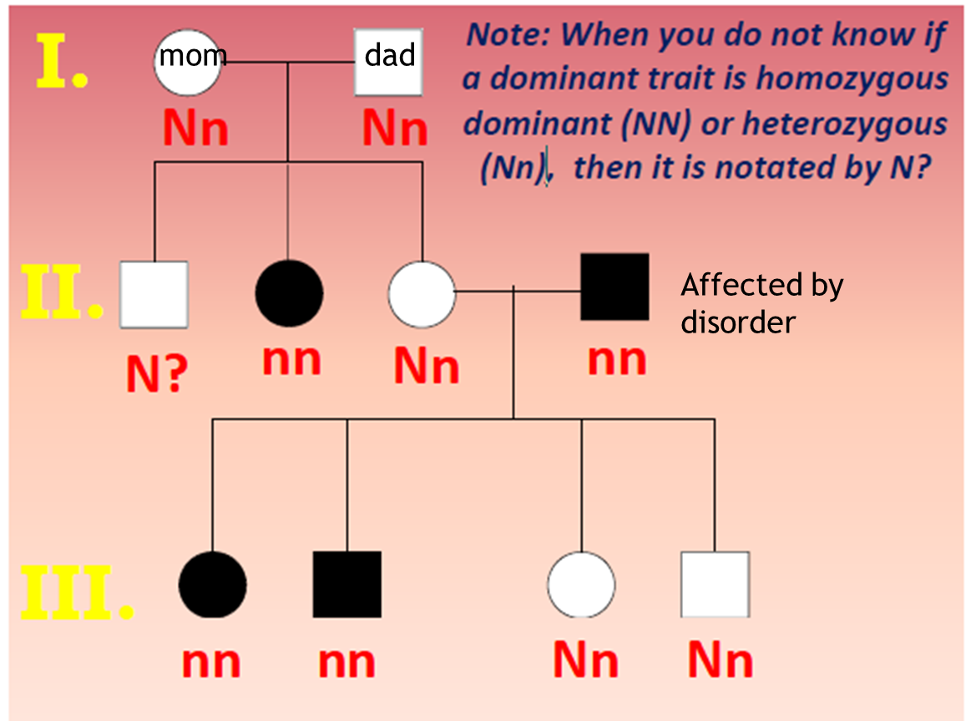

## Codominance & Incomplete Dominance Practice Problems

Name: ___________________________________Period: _____Date: _________

Directions: Use a Punnett square to answer the following problems. Show all work to receive full credit. You should include keys for your Punnett squares!

1. What is the difference between a trait that shows codominance and a trait that show incomplete dominance?

1. How do you represent a Codominance Inheritance pattern?

1. How do represent an Incomplete Dominance inheritance pattern?

1. Nose size is a trait that exhibits incomplete dominance. Larger noses are not dominant over small noses. If both parents have a medium size nose, do they have to worry about any of their children having a large nose?
   1. What are the genotypes of the parents? _______________________
   2. What are the genotypic & phenotypic ratios of the children?
   3. What % of this couple’s children will have large noses?

1. Coat color is a trait that exhibits codominance. If a roan colored cow mates with a cow with a white coat, what will the offspring look like?
   1. What does the term “roan” mean?__________________________________
   2. What are the genotypes of the parents?
   3. What are the genotypic & phenotypic ratios of the offspring?

1. Bark texture can be a co-dominant trait, producing trees with bark that is smooth, rough, or both smooth/rough. If a rough barked tree pollinates a tree that is smooth/rough, will any of the new saplings have smooth bark?
   * 1. What are the genotypes of the parent tress? _____________________
     2. What are the genotypic & phenotypic ratios of the offspring?
     3. What % of the saplings will have smooth bark? ____________________

1. A black haired female and a blonde male have four children, all of whom have brown hair.
   1. What condition makes this possible? ___________________________
   2. What are the genotypes of the parents? ________________________
   3. What are the genotypes of the offspring? ________________________
   4. Are the parents heterozygous or homozygous? _____________________
   5. Are the offspring heterozygous or homozygous? ___________________

1. A florist has a big demand for pink carnations, so he breeds pink carnations in an attempt to produce more pink carnations. However, when his new plants bloom, only 50% of the flowers are pink. (The remaining 50% are red or white).

|  |  |
| --- | --- |
|  |  |
|  |  |

* 1. How did this happen? (show the Punnett square)

* 1. What must the genotypes of the parent plants be? __________________
  2. What must the genotypes & phenotypes of the parent plants be in order for 100% of the flowers to be pink? (show the 2nd Punnett square)

|  |  |
| --- | --- |
|  |  |
|  |  |

## 

## 

 **Sex-Linked Traits** 

Name: ____________________________________________ Period:__________ Date:__________

1. Use the key to determine the genotypes of the following people.

**H** = **normal blood**

|  |  |
| --- | --- |
| **B = normal vision** b = colorblind | h = hemophilia |
| a. Female w/ normal vision ____________ | f. Female w/ normal blood _________ |
| b. Male w/ normal vision ______________ | g. Male w/ normal blood __________ |
| c. Colorblind female ____________ | h. Female w/ hemophilia _________ |
| d. Colorblind male ____________ | i. Male w/ hemophilia _________ |
| e. Carrier of colorblindness ____________ | j. Carrier of hemophilia _________ |

1. A woman who is colorblind marries a man with normal vision.
   * 1. What are the genotypes of these parents?_________________________
     2. Show the Punnett square below.

|  |  |
| --- | --- |
|  |  |
|  |  |

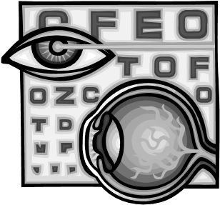

* + 1. What are the genotypes and phenotypes of the offspring?

* + 1. What % of the children will be colorblind? ______________

1. A man with hemophilia and a woman who carries the genes for the disease want to have children.
   * 1. What are the genotypes of these parents?__________________________
     2. Show the Punnett square below.

|  |  |
| --- | --- |
|  |  |
|  |  |

* + 1. What are the chances that their children could have hemophilia? _______________

1. If a carrier female for hemophilia marries a normal male:
   1. What are the genotypes of the parents?____________________________
   2. Show the Punnett square below.

|  |  |
| --- | --- |
|  |  |
|  |  |

* 1. What are the chances of the offspring having the disease hemophilia?_____________

* 1. What are the chances of their **sons** being normal?________________________

* 1. What are the chances of their **daughters** being carriers?____________________

1. If a woman’s father had hemophilia, what are the chances that she is normal? Assume that you do not know the mother’s phenotype.

1. If a woman’s mother was a carrier, what are the chances that she is normal? Assume that you do not know the father’s phenotype.

1. Are you more likely to be affected by a sex-linked disease if you are a male or a female? Explain why.

**Multiple Alleles**

A. Blood types are an example of what type of inheritance?______________________________

B. In blood, the gene for type A and the gene for type B are______________________________.

C. The gene for type O is_____________________________.

**Directions:** Using Punnett squares, determine the possible blood types of the offspring when:

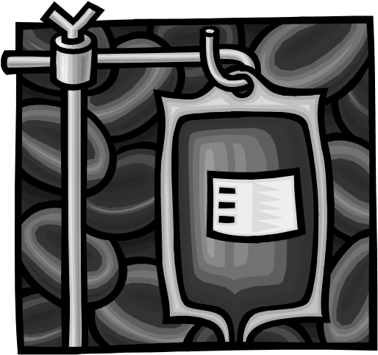

1. Father is type O, Mother is type O

|  |  |
| --- | --- |
|  |  |
|  |  |

_______ % O

_______ % A

_______ % B

_______ % AB

1. Father is type A, homozygous; Mother is type B, homozygous

|  |  |
| --- | --- |
|  |  |
|  |  |

_______ % O

________% A

________ % B

_______ % AB

1. Father is type A, heterozygous; Mother is type B, heterozygous

_______ % O

|  |  |
| --- | --- |
|  |  |
|  |  |

_______ % A

_______ % B

_______ % AB

4. Father is type O, Mother is type AB

|  |  |
| --- | --- |
|  |  |
|  |  |

_______ % O

________ % A

________ % B

________ % AB

5. Father and Mother are both type AB

_______ % O

|  |  |
| --- | --- |
|  |  |
|  |  |

_______ % A

_______ % B

_______ % AB

***Learning-Focused® Strategies Notebook* Teacher Materials** ©2004 **Learning Concepts, Inc.**

Duplication permitted exclusively for classroom use by owner of ***Learning-Focused® Strategies Notebook*.**

# **Modes of Inheritance Worm**

*Directions: Write the definition and how you would notate each type of inheritance.*

**Polygenic**

**Sex-linked**

**Codominance**

**Multiple Alleles**

**Incomplete**

**Dominance**

Different Modes of Inheritance Problems

Name:________________________________________________Period:_____Date:______________

**Directions:** *Determine the possible genotypes and phenotypes for each cross. Be sure to use the correct notation and create a genotype key when necessary.*

1. Colorblindness is a sex-linked recessive trait
   1. What type of inheritance makes this possible?________________________________

b. If a female carrier marries a male with normal vision, what are their chances of having a colorblind

|  |  |
| --- | --- |
|  |  |
|  |  |

child?

1. A cross between a homozygous red-flowered snapdragon and a homozygous white-flower snapdragon produces all pink snapdragons. Complete the Punnett square for a cross between a pink snapdragon and a white snapdragon.
   1. What type of inheritance makes this possible?________________________________

|  |  |
| --- | --- |
|  |  |
|  |  |

1. A person that has type O blood marries a man that is heterozygous for type B blood. What are the possible blood types of their children?
   1. What type of inheritance makes this possible?________________________________

|  |  |
| --- | --- |
|  |  |
|  |  |

1. A cross between a homozygous black chicken and a homozygous white chicken produces all black and white checkered chickens. Complete the Punnett square for a cross between two checkered chickens.
   1. What type of inheritance makes this possible?________________________________

**REVIEW Packet: Patterns of Heredity**

Name__________________________________ Period:______ Date: ___________

**Part 1: MATCHING:***Choose the best definition for each vocabulary term.*

|  |  |  |
| --- | --- | --- |
| _____1. A diagram that shows how a particular trait | |  |
| is shown in a family | | **A.** autosomes |
| _____2. mutation that occurs when a segment of a | | **B.** aneuploidy |
| chromosome breaks off and is reinserted backwards. | |  |
|  |  |
| _____3. abnormal number of chromosomes |  | **C.** pedigree |
| _____4. mutation that occurs when one chromosome of a pair is missing |  | **D.** polyploidy |
| _____5. More than **one gene** controlling a trait |  | **E.** mutagen |
| _____6. Anything that can cause a mutation |  | **F.** nondisjunction |
| _____7. Body chromosomes; pairs 1-22 |  | **G.** frame shift mutation |
| _____8. Error in DNA that adds or deletes a single base that causes all following amino acids |  | **H.** Gregor Mendel |
| to be affected |  | **I.** translocation |
| _____9. A chart where the chromosomes are arranged in |  |  |
| their homologous pairs |  | **J.** trisomy |
| ____10. Failure of homologous chromosomes to |  | **K.** inversion |
| separate during meiosis |  | **L.** polygenic inheritance |
| ____11. “Father of Genetics” |  |  |
| ____12. Piece of one chromosome breaks off and joins |  | **M.** karyotype |
| another chromosome |  | **N.** monosomy |

**Part 2: FILL-INS:** *Complete the following with the best word or words****.*** *You may use the words more than once.*

|  |  |
| --- | --- |
| **Polygenic Inheritance** | **Codominance** |
| **Sex-linked trait** | **Incomplete Dominance** |
| **Sex Chromosomes** | **XX** |
| **Multiple alleles** | **XY** |

1. Some genes are located on sex chromosomes. A ____________________________ is a trait controlled by these genes.
2. Traits controlled by more than TWO ALLELES are said to have ___________________________ 3. ___________________________________are chromosomes that determine the sex of an individual.
3. What are a normal male’s sex chromosomes?______________________________
4. What are a normal female’s sex chromosomes? ______________________________
5. What type of inheritance pattern would the heterozygous offspring be a blend of the two homozygous parents?___________________________________
6. When the phenotypes of hybrid offspring are showing both traits and NO blending occurs, what type of inheritance pattern would this be?____________________________
7. What type of inheritance pattern would you use a prime (‘) to notate the alternate form of an allele?________________________________

**Part 3: COMPLETION:** *Answer the following questions concisely.*

1. How do you represent sex-linked traits?

1. How do you represent co-dominant traits?

1. What trait is an example of multiple alleles?

1. What would be an internal factor that can influence gene expression? ______________________

1. What are some environmental (external) factors that can influence gene expression?

1. In sex-linked traits, how would a *carrier* genotype be written? ______________________

1. Why do sex-linked traits occur more often in males than females?

1. Describe how a karyotype is created?

**Part 4: MODES OF INHERITANCE:** *Read the following problems carefully. If need complete a Punnett square and answer the questions. Be sure to use the correct notation of genotypes.*

______1. When roan cattle are mated, 25% of the offspring are red, 50% are roan, and 25% are white. Upon examination, it can be seen that the coat of a roan cow consists of both red and white hairs. This trait is one controlled by_____________________.

* 1. Sex-linked genes C. Incomplete dominance
  2. Multiple alleles D. Codominance

______2. What type of inheritance is shown when a red-flowering plant is crossed with a whiteflowering plant and only pink-flowering plants are produced?

* 1. Inbreeding C. Incomplete dominance
  2. Polygenic inheritance D. Codominance

1. A cross between a homozygous red-flowered snapdragon and a homozygous white-flower snapdragon produces all pink snapdragons.
   1. What type of inheritance makes this possible? ________________________________

b. How do you know? _______________________________________________________________

c. Complete the Punnett square for a cross between two pink snapdragons. What are the possible genotypes and phenotypes of the offspring? Be sure to use the correct notation.

|  |  |
| --- | --- |
|  |  |
|  |  |

1. A cross between a homozygous black chicken and a homozygous white chicken produces all black and-white checkered chickens.
   1. What type of inheritance makes this possible? ________________________________

b. How do you know? _______________________________________________________________

c. Complete the Punnett square for a cross between a white and checkered chicken. What are the possible genotypes and phenotypes of the offspring? Be sure to use the correct notation.

|  |  |
| --- | --- |
|  |  |
|  |  |

1. Colorblindness is a sex-linked recessive trait (b). If a female carrier marries a colorblind male, what are their chances of having a colorblind **daughter**? Be sure to use the correct notation.

|  |  |
| --- | --- |
|  |  |
|  |  |

1. A person that has type O blood marries a man that is heterozygous for type A blood. What are the possible phenotypes of their children? Be sure to use the correct notation.
   1. What type of inheritance is human blood types an example of?____________________________

|  |  |
| --- | --- |
|  |  |
|  |  |

1. A person that has type AB blood marries a woman that is homozygous for type B blood. What are the possible phenotypes of their children? Be sure to use the correct notation.

|  |  |
| --- | --- |
|  |  |
|  |  |

1. Many genes control skin color. What type of inheritance pattern makes this possible? _____________

Patterns of Heredity Vocabulary:

1. **Incomplete dominance** = neither allele for a gene dominates *Notation:*

• Alleles are all capital letters because NEITHER one dominates the other. So one of the alleles has a prime ( ‘ ) on it to represent an alternate expression of the gene.

1. **Codominance** = both alleles are expressed equally *Notation:*

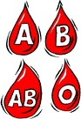• 2 different alleles (capital letters) are used

1. **Multiple alleles** = more than 2 alleles for a single gene can control a trait; example = blood types

1. **Polygenic inheritance** = traits are determined by many genes

1. **Sex-linked crosses** = traits are carried on the sex chromosomes *Notation:* 
   * The alleles for these traits are written as superscripts on the X chromosome ONLY.
   * No alleles are written on the Y chromosome!

Ex: Colorblind male = XbY and Normal male = XBY

1. **Pedigrees** = a valuable tool for anyone working in the field of genetics

1. **Carrier** = Heterozygous FEMALES; XBXb
2. **Autosomes** = chromosomes 1-22; do NOT determine sex
3. **Sex** **chromosomes** – 23 pair of chromosomes; determines sex