**Introduction to Evolution**

**What is a theory?**

* Definition:
  + “A coherent set of propositions that explain a class of phenomena that are supported by **extensive factual evidence** and that may be used for prediction of future observations.”
  + Numerous lines of evidence _________________ exist
  + Examples
* Different than a fact
  + Facts are based on direct _____________________ or _____________________
    - Examples:

**What is evolution?**

* Can be a difficult term to define:
  + Is a process that occurs over _______________________
  + Does ___________________ refer to an individual, but to a _________________
  + It is __________________ one individual changing into another
* Most simply:
  + “Evolution is a process that results in heritable changes in a population spread over many generations.”
  + Change in allele _______________________ of a gene pool over generations
  + Descent with ______________________________ (Darwin)

**History of evolution**

* Jean Baptiste Lamarck
  + ___________________ biologist
  + Noticed that species changed over time in response to the _________________________________
    - Evolution!
  + ____________ and ___________________________ Inheritance

**Lamarckism**

* Use and Disuse Inheritance (1809)
  + Traits are acquired in response to the _______________________
  + __________________________ traits can be passed on to offspring
  + **Use**:
    - Organisms will develop characteristics that are ____________________________ in a given environment.
  + **Disuse:**
    - Organisms will lose characteristics that are ________________________ in a given environment.

**Use and Disuse Inheritance is NOT supported by evidence**

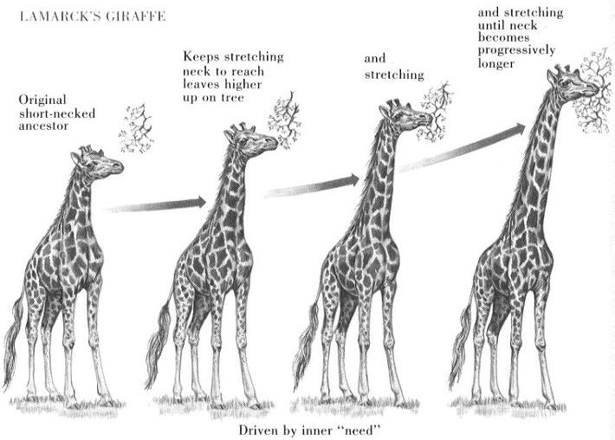

**Example of Use and Disuse:** Giraffe neck length

* Example:
  + Giraffes’ long necks enable them to reach leaves on the tops of trees.

**Charles Darwin**

* Born in 1809, to a wealthy _______________________________ family
* Educational history:
  + Enrolled in __________________ school, but dropped out and became interested in theology.
  + When he became interested in ___________________________, he took a job on the _____________ _______________________

**Aboard the Beagle**

* Purpose of the Beagle’s voyage:
  + Chart the coast of _________________ ________________________
* Darwin worked as a ___________________________
  + Studied the South American ___________________________
    - Especially on the _____________________ ________________________
  + Collected ________________________ as well as _______________________
  + Recorded detailed observations of many ____________________ organisms
* ________ year voyage

**Darwin’s Findings**

* After close analysis of his data, Darwin proposed a _________________:
* Findings were published in ______________________

  + Proposed that ______________________________________________ is the mechanism that drives evolution

***On the Origin of Species***

* The process of natural selection:
  1. Species _______________________________
     + More offspring are born than the ________________________ can sustain
  2. There is heritable _____________________ in traits within a species
  3. Certain traits were _________________ ____________________________ to the environmental conditions than others
  4. The individuals with traits best suited to the environment will have the greatest chance to ______________________ and ________________________________________
     + - Those best suited to their environment will produce the most offspring
* Result:
  + The number of individuals with a favorable trait will __________________ over time.
  + When _______________________________________________changes over time, evolution has occurred!
    - Allele frequency = Proportion of a particular allele of a gene in a population

**Gene mutations and allele frequency**

* Gene pool
  + Set of all ____________________ in a population
* __________________________ can create new alleles
  + New alleles change the composition of gene pool by changing allele frequencies
* Over time, allele frequencies will change:
  + Frequency of alleles that help survival will _____________________________
  + Frequency of alleles that are detrimental to survival will ____________________________