**The Nature of Science Notes Name __________________ period ____**

* **The Nature of Science** = Continuous process that seeks to answer **________________________** about the natural world.
* Science only deals with things that are **___________________________________**

1. Science is subject to **____________________________________**.

* Pulling medicine off shelves because researchers found out it harms people.
* Scientists thought the world was once flat
* Pluto is no longer considered a planet

2. Does not always provide **_____________________________** answers to all questions.

* What happened to the dinosaurs?
  + No one knows for sure!

3. Science demands **___________________________** – i.e. **_________________**!!!

* What certain medicines will treat

4. **_________________________________________**

* Doctors and scientists have to think on their feet; not all cases are the same for doctors
* Scientist have to be able to trouble shoot.

5. **_____________________________** and **_______________________________**

6. Scientist try to identify and AVOID **_______________________________**

**_______________________________________**-is an explanation based on many observations (hypothesis is repeatedly verified over time and through may separate experiments)

* Enable scientists to predict new facts and relationships of natural phenomenon
* Often revised as new information is gathered.
  + Ex: Cell Theory, Theory of Evolution

**Theory vs. Law vs. Principle**

* **________________________** = describes relationships under certain conditions in nature

-Ex: Law of Gravity; Law of Conservation of Matter

* **_____________________________** = A concept based on scientific laws and axioms (rules assumed to be present, true, and valid) where general agreement is present.

**The Scientific Method**

**Steps of the Scientific Method:**

1. State the **_____________________________**

-Ex: How does red light effect plant growth?

2. Gather **______________________________________**

-About the problem

3. Form a **___________________________________** (educated guess)

– A hypothesis must be:

* + - **_______________________________________**
    - Related to the **_____________________________________**
    - Written in “ **_____________________________________** ”format
      * Ex: If a plant is placed under red light, then the plant will not grow very tall.

4. Perform the **__________________________________________**

A. Make **___________________________________________**!!

B. Choose the **_________________________________**:

a) Your **___________________________________** variable is the factor that you will change in your experiment. (The factor being tested)

•NOT controlled or influenced by something else

•Ex: Red light

b) The **___________________________________** variable is what you predict will change as a result of variation in your experiment.

●Is controlled or influenced by something else (independent variable)

●Ex: Plant Growth

* Note: the **_____________________________** variable influences the **____________________________** variable!

c) A **___________________________________**

•The control is a group that serves as a standard of **________________________________**.

* It is exposed to the same conditions as the treatment groups except for the variable being tested.
* Ex: a plant placed in regular sunlight(not exposed to red light)

C. Decide the number of **___________________________________________**

* Replications are the repetition of an experiment (**_____________________**) and the same conditions are kept in the experiment.
* Provides better statistical data (**______________________________________**)

D. Specify the **______________________________________________**

* The constants in an experiment are the factors that DO NOT change. (Ex: temperature, equipment, etc.)
* What your constants will be will depend on what question you are asking.
* Ex: type of plant, amount of water, type of soil, amount of fertilizer, keeping plants at same temperature, same size pots, etc.

5. **_______________________** and **__________________________** the **_______________**

6. Draw **______________________________________________**

–Describe what happened

–Restate the hypothesis

–Explain the results using the data and research

–Propose an alternative hypothesis, if original one was incorrect) based on the data that was collected

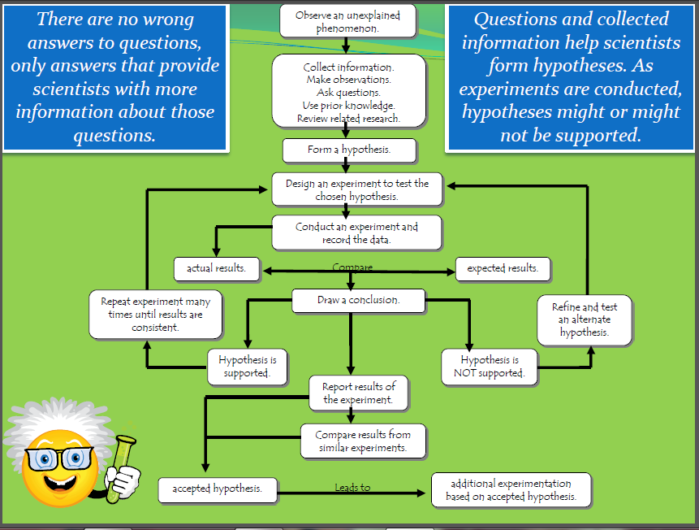

**Review of the Scientific Method**

**Part 1:** *Put the following steps of the scientific method in the proper order.*

_____ Record, organize and analyze data

_____ State a hypothesis

_____ Identify the problem

_____ State the conclusion

_____Design and carry out an experiment

_____ Gather information

**Part 2:** *Match the definition with its term.*

|  |  |
| --- | --- |
| 1. Suggested explanation to a problem based upon known information that is testable      1. A variable that is not controlled or influenced by something else.      1. Factors that are not changed during the experiment        1. Observation and measurements made during an experiment      1. Part within the experiment that is maintained without change in order to provide a comparison for what is being tested      1. Hypothesis that has been tested and supported by a great amount of evidence *over a long period* of time      1. Statement describing (but not explaining) a natural event or phenomenon      1. Logical explanations based on observations and experiences      1. A summary that explains whether or not the data supports the hypothesis | 1. **Theory _______**      1. **Law _______**      1. **Hypothesis ______**      1. **Experiment______**      1. **Constants ______**      1. **Control ______**      1. **Data ______**      1. **Conclusion ______**      1. **Inference _______**      1. **Dependent Variable_____**      1. **Independent Variable____** |

**J.** A variable that is controlled or influenced by something else

**K**. Used to test a hypothesis

Applying The Scientific Method Worksheet

Name:_______________________________________________Period:______Date:_____________

PART 1: Vocabulary: Answer the following questions completely and concisely.

1. List the 6 steps of the scientific method.
   1. ________________________________________________
   2. ________________________________________________
   3. ________________________________________________
   4. ________________________________________________
   5. ________________________________________________
   6. ________________________________________________

1. What is a hypothesis?

1. How should all hypotheses be written?

1. What is the difference between an independent variable and a dependent variable?

1. What is a control?

1. What is a constant?

1. What are three examples of constants in an experiment to see how red light affects plant growth?

PART 2: Analysis: Answer the following questions completely and concisely.

A student noticed that when a dog is cut, the dog periodically licks its wounds. Usually after a few days, the wound begins to heal without ever showing signs of infection.

The following steps outline the student’s line of reasoning:

1. I wonder why the dog’s wound doesn’t become infected.
2. If dog’s saliva is present, then the growth of infection-causing bacteria will be prevented.
3. I’ll obtain a bacterial culture and grow the same kind of bacteria in two identical culture dishes. Once the bacteria start growing, I’ll add dog saliva to ONLY one of the dishes and leave the other alone. I’ll cover both dishes. Then I’ll observe what happens each day for one week.
4. Even after adding the dog saliva to one of the dishes, the bacteria continued to grow in both dishes over the course of the week. However, the bacteria in the dish treated with saliva grew more slowly than the bacteria in the untreated dish.
5. I think I’ll try something else. I’ll start with two identical culture dishes, as before, and use the same kind of bacteria in each dish, but this time I’ll treat one dish with dog salvia BEFORE I add the bacteria. I’ll observe what happens each day for a week.

1. What part of the scientific method is illustrated in step A? ___________________________________

1. What part of the scientific method is illustrated in step B? ___________________________________

1. What part of the scientific method is illustrated in step C? ___________________________________

1. What is the independent variable in the student’s experimental design? __________________________________________________________________________

1. What is the dependent variable in the student’s experimental design?

___________________________________________________________________________

1. What is the control in the student’s experimental design? __________________________________________________________________________

1. Why were both dishes covered? _________________________________________________________________

**Scientific Method** Name __________________________

**Controls and Variables**

**SpongeBob and his Bikini Bottom pals have continued doing a little research to solve some**

**problems. Read the description for each experiment and answer the questions.**

**Krusty Krabs Breath Mints**

Mr. Krabs created a secret ingredient for a breath mint that he thinks will “cure” the bad breath people

get from eating crabby patties at the Krusty Krab. He asked 100 customers with a history of bad breath

to try his new breath mint. He had fifty customers (Group A) eat a breath mint after they finished

eating a crabby patty. The other fifty (Group B) also received a breath mint after they finished the

sandwich, however, it was just a regular breath mint and did not have the secret ingredient. Both

groups were told that they were getting the breath mint that would cure their bad breath. Two hours

after eating the crabby patties, thirty customers in Group A and ten customers in Group B reported

having better breath than they normally had after eating crabby patties.

1. Which people are in the control group?

2. What is the independent variable?

3. What is the dependent variable?

4. What should Mr. Krabs’ conclusion be?

5. Why do you think 10 people in group B reported fresher breath?

**SpongeBob Clean Pants**

SpongeBob noticed that his favorite pants were not as clean as they used to be. His friend Sandy told

him that he should try using Clean-O detergent, a new brand of laundry soap she found at Sail-Mart.

SpongeBob made sure to wash one pair of pants in plain water and another pair in water with the

Clean-O detergent. After washing both pairs of pants a total of three times, the pants washed in the

Clean-O detergent did not appear to be any cleaner than the pants washed in plain water.

6. What was the problem SpongeBob wanted to investigate?

7. What is the independent variable?

8. What is the dependent variable?

9. What should Sponge Bob’s conclusion be?

**Squidward’s Symphony**

Squidward loves playing his clarinet and believes it attracts more jellyfish than any other instrument he

has played. In order to test his hypothesis, Squidward played a song on his clarinet for a total of 5

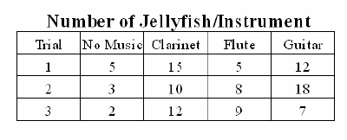minutes and counted the number of jellyfish he saw in his front yard. He played the song a total of 3 times on his clarinet and repeated the experiment using a flute and a guitar. He also recorded the number of jellyfish he observed when he was not playing an instrument. The results are shown in the chart.

10. What is the independent variable?

11. What is the dependent variable?

12. What should Squidward’s conclusion be?

13. Are the results reliable? Why or why not?

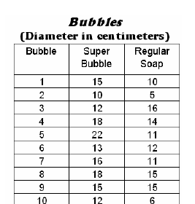**Super Bubbles**

Patrick and SpongeBob love to blow bubbles! Patrick found some Super Bubble Soap at Sail-Mart. The ads claim that Super Bubble Soap will produce bubbles that are twice as big as bubbles made with regular bubble soap. Patrick and SpongeBob made up two samples of bubble solution. One sample was made with 5 oz. of Super Bubble Soap and 5 oz. of water, while the other was made with the same amount of water and 5 oz. of regular bubble soap. Patrick and SpongeBob used their favorite bubble wands to blow 10 different bubbles and did their best to measure the diameter of each one. The results are shown in the chart.

14. What did the Super Bubble ads claim?

15. What is the independent variable?

16. What is the dependent variable?

17. Look at the results in the chart.

a. Calculate the average diameter for each bubble solution.

Super Bubble = ______ cm Regular Soap = ________ cm

b. What should their conclusion be?

18. Are the results reliable? Why or why not?

**Vocabulary**

1. **Hypothesis** = testable explanation; written in “ IF… THEN ” format

1. **Inference** = Logical explanations based on observations and experiences

1. **Independent variable** = the factor that you will change in your experiment

1. **Dependent variable** = what you predict will change as a result of variation in your experiment

1. **Control** = a group that serves as a standard of comparison

1. **Replications** = are the repetition of an experiment (trials) andthe same conditions are kept in the experiment.

1. **Constants** = the factors that DO NOT change in the experiment

1. **Theory** = is an explanation based on many observations (hypothesis is repeatedly verified over time and through many separate experiments)

1. **Law** = describes relationships under certain conditions in nature; Describes but does not explain a natural event
2. **Principle** = a concept based on scientific laws and axioms (rules assumed to be present, true, and valid) where general agreement is present
3. **Data** =any pieces if information acquired through observation or experimentation