**DHS Golf**

**NAME _____________________________________**

**DAY/S________ PERIOD_______________**

|  |  |  |  |
| --- | --- | --- | --- |
| PART/SAFETY/SOC RESP (5 points per class) /5 /5 /5 /5 /5 /5 /5 /5 /5 /5 /5 /5 | | | |
| SKILL APPLICATION | /12 | KNOWLEDGE TEST | /12 |
| STRATEGY APPLICATION | /12 |  |  |
| RULES APPLICATION | /12 | **TOTAL** |  |

**SKILL APPLICATION:**

**SKILL 1:** CHIP SHOT

* Grip: Uses the interlock or overlap grip
* Pre-Swing: Knees bent, club rest on the ground behind the ball, ball in front of back foot
* Back Swing: Club goes less than 90˚, head stays down, weight shifts from back foot to front foot
* Follow through: Club stays lower than 90˚

**SKILL 2:** FULL SWING

* Grip: Uses the interlock or overlap grip
* Pre-Swing: Knees bent, club rest on the ground behind the ball, ball in front of back foot
* Back Swing: Club goes more than 90˚, head stays down, weight shifts from back foot to front foot
* Follow through: club goes higher than 90˚

**SKILL 3**: PUTTER

* Grip: Hands are together and at top of club
* Pre-Swing: Feet shoulder width apart, club rest on the ground behind the ball, ball in middle of stance
* Back Swing: Club goes no more than 1 foot back, head stays down
* Follow through: Club goes no more than 1 foot after making contact with ball

**TOTAL SKILL APPLICATION: /12**

**GOLF SHOTS:**

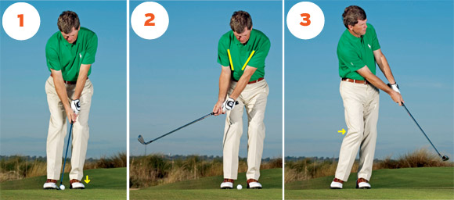 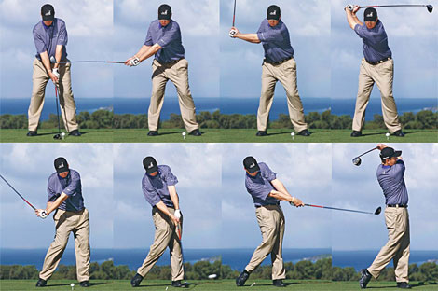 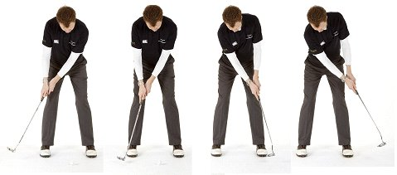

**CHIP SHOT FULL SWING**  PUTTING

**APPLICATION 2: STRATEGIES**

**4 -** Consistently demonstrates effective golf strategy.

**3** - Demonstrates some effective strategic decisions during game play.

**2 –** Inconsistently demonstrates effective golf strategy. Does not understand some of the basics of golf strategy.

**1** - Lacks the understanding and demonstration of basic golf strategy

**TOTAL STRATEGY APPLICATION: /12**

**APPLICATION 3: RULES**

**4 -** Applies all rules and terminology without hesitation or observable errors.

**3** - Applies major rules terminology for most situations.

**2 -** Demonstrates a general understanding of the game, but needs assistance from others to correctly apply rules.

**1 -** Consistently demonstrates incorrect application of rules, conventions, terminology and/or scoring. Students rely on direction from others to play correctly.

**TOTAL RULE APPLICATION: /12**

**GOLF VIOLATIONS:**

* Moving the ball to create a better lie or avoid obstructions
* Player keep count of the total number of strokes per hole.
* Take penalty strokes for hitting out of bounds, hazards, or lost ball

**GOLF ETIQUETTE:**

* Checks surrounding area to make sure it is clear to swing club
* Addresses the ball and hits ball when the course is clear in front of them.
* Replaces divots and repairs ball marks on green
* Hits ball in the correct order
  + Always let the player furthest from the hole hit first. This means in the fairway, tee box, or on the putting green.
  + The person with the best score on the previous hole tee’s off first.
* Does not step on another person putting line
* Quiet when other people are addressing the ball and swinging
* Keeps a good pace of play

**GOLF TERMINOLOGY:**

* **GREEN -**
* **FRINGE -**
* **HOOK -**
* **SLICE –**
* **CADDY-**
* **FORE –**
* **DRAW –**

**SCORING TERMINOLOGY EXAMPLE (FOR A PAR 4)**

* Eagle = 2 under par - Make the ball in the hole in two shots from the tee.
* Birdie = 1 under par - Make the ball in the hole in three shots from the tee.
* Par = The suggested number of shots it should take to make the ball in the hole. Four shots from the tee.
* Bogey = 1 over par - Make the ball in the hole in five shots from the tee.
* Double Bogey = 2 over par - Make the ball in the hole in six shots from the tee.

**CLUB SELECTION AND AVERAGE DISTANCES** (Ranges represent short hitters, mid hitters and long hitters)

|  |  |  |
| --- | --- | --- |
| **Club** | **Men** | **Women** |
| Driver | 200-230-260 | 150-175-200 |
| 3-wood | 180-215-235 | 125-150-180 |
| 5-wood | 170-195-210 | 105-135-170 |
| 2-iron | 170-195-210 | 105-135-170 |
| 3-iron | 160-180-200 | 100-125-160 |
| 4-iron | 150-170-185 | 90-120-150 |
| 5-iron | 140-160-170 | 80-110-140 |
| 6-iron | 130-150-160 | 70-100-130 |
| 7-iron | 120-140-150 | 65-90-120 |
| 8-iron | 110-130-140 | 60-80-110 |
| 9-iron | 95-115-130 | 55-70-95 |
| Pitching Wedge | 80-105-120 | 50-60-80 |
| Sand Wedge | 60-80-100 | 40-50-60 |