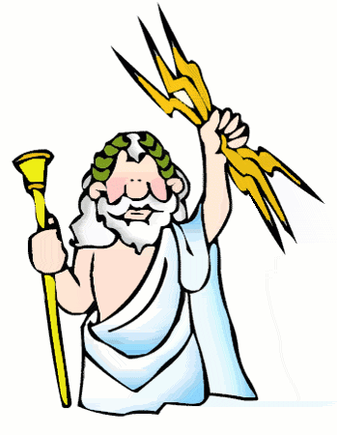 OLYMPIAN GOD/GODDESS CHART (pp.25-37)

|  |  |  |  |  |
| --- | --- | --- | --- | --- |
| **GREEK**  **NAME** | **ROMAN NAME** | **SYMBOL** | **REALM**  **and/or**  **POWER** | **MISCELLANEOUS INFORMATION** |
| Zeus |  |  |  |  |
| Hera |  |  |  |  |
| Poseidon |  |  |  |  |
| Hades |  |  |  |  |
| Athena |  |  |  |  |
| Apollo |  |  |  |  |
| Artemis |  |  |  |  |
| Aphrodite |  |  |  |  |
| Hermes |  |  |  |  |
| Ares |  |  |  |  |
| Hephaestus |  |  |  |  |
| Hestia |  |  |  |  |