Name ________________________________

Pd. ________ Date ______________________

Levels of Biological Organization

Biology is the study of all life. Living things can be organized in to different levels starting with the smallest unit of life and working up to the largest. Put the terms provided below **in order from the smallest to the largest.** Provide a specific definition for each unit and also provide one specific example of each.

Atom Community Organ Organism Cell

Biome Ecosystem Organ system Population

Biosphere Molecule Organelle Tissue

(smallest)

1. __________________________________ (definition) =

Example =

1. __________________________________ (definition) =

Example =

1. __________________________________ (definition) =

Example =

______________________________________________________________________________

1. _________________________________ (definition) =

[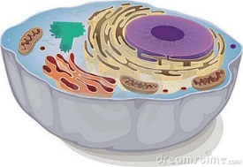](http://www.google.com/url?sa=i&rct=j&q=&source=images&cd=&cad=rja&docid=SjxjhCMBdwJ8uM&tbnid=bCXh1zPpEE2vVM:&ved=0CAUQjRw&url=http://www.dreamstime.com/stock-photography-animal-cell-image19282212&ei=E3KwUeP2GufL0wGElYDYDg&bvm=bv.47534661,d.dmQ&psig=AFQjCNF1znRzrsvTCwdug6CYvZ2WrISiAA&ust=1370604352390963)

Example =

1. __________________________________(definition) =

Example =

1. _________________________________ (definition) =

Example =

1. _________________________________ (definition) =

Example =

1. __________________________________ (definition) =

Example =

1. __________________________________ (definition) =

Example =

1. __________________________________ (definition) =

Example =

1. _________________________________ (definition) =

Example =

1. _________________________________ (definition) =

Example =

1. __________________________________ (definition) =

Example =