The Characteristics of Life

What characteristics are common to **ALL** living things?

All living things…

1. Have at Least one _______________________
   * All cells have ______________ inside as the genetic blueprint for life.
   * **Cell Types**
     1. If the DNA is **NOT** in a separate structure (_______________), the cell is ________________________.
     2. If the DNA is in a nucleus, the cell is eukaryotic.

**A Prokaryotic cell (________________ only) A Eukaryotic cell (_______________, ________________, _________________, ________________)**

Label the parts of the 2 cells below.

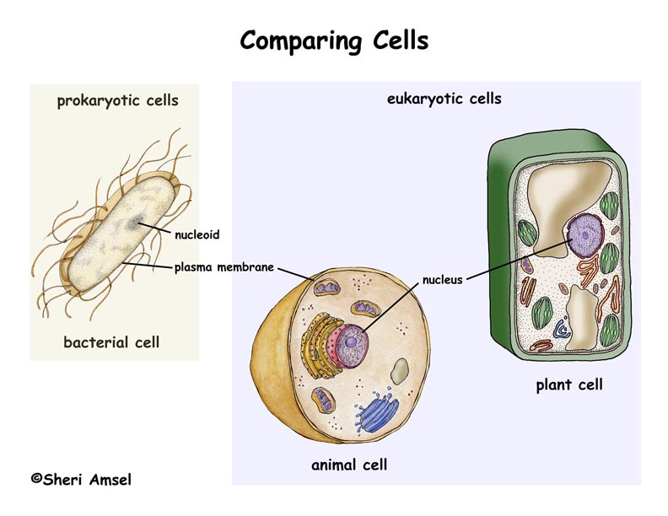

* **Cell Number**
  1. An organism that has only ________________ **cell** is said to be _________________________.
     + Examples = __________________, __________ ____________________, ____________________________(yeast)
  2. An organism that has ___________________ ______________ ____________ **cell** is said to be ________________________.
     + Examples = all _________________, all ______________________, most _____________________, and some _________________________

1. Have a ___________________________
   * ____________________ – get larger
     + In cell _________________________
     + In cell _________________________
   * ___________________________________ =
     + Into a mature organism that can ________________________________
   * __________________________________
     + Reach the end of its lifespan
2. __________________________________
   * Have the ability to create ___________________ like themselves
   * **Types of reproduction**
     1. If _______ organism creates an exact copy (clone) of itself to become 2 organisms, it is _________________________ reproduction
     2. If ______________ and _________________ unite to create a genetically different individual, it is _____________________ reproduction
        + Creates new ____________ combinations in a _______________.
3. Obtain _______________________ which is used to produce _______________________
   1. **Ways Organisms Obtain Food = __________________ it or ______________ it**
      1. ______________________________ = make food in their cells
         * Called the ____________________________________
         * Usually involves the process of ____________________________
         * Examples = ________, _________________ and some _______________________ and ________________________
      2. ________________________________ = must ______ other organisms to get food (glucose) to their cells.
         * Called the ___________________________
         * Examples = all ___________________, most ________________, some ______________________, some ____________________
4. **Produce Energy** during the process of ___________________________________
   * A __________________________ process performed by the cells of ________ _____________________ _____________________ to change ____________ energy into _______________________ that the cell can use to do ___________ and carry out ___________________ processes.
   * **Types of respiration**
     1. Respiration that uses ___________________ is called ___________________ respiration.
     2. Respiration that does _________ ________ ____________________ is called ___________________________ respiration
   * ***After obtaining food and producing/using energy, all living things produce _______________.***
5. ______________________________ to changes in the environment
   * _______________________ to stay alive = maintaining ______________________________ = balance
   * Examples = ______________________ to produce heat, ____________________ to cool off, plants _____________________ toward windows to get sunlight
6. ____________________________ to changes in the environment
   * Involves ______________________ change that occurs over generations to help a _______________________________ survive. (_______________________)
   * Examples = a new _____________________ creates a new _______________________ that is better camouflaged (__________________) in environment.