DHS Volleyball GRADING:
NAME _____________________________________
DAY/S________ PERIOD_______________

PART/SOC RESP/SAFETY /5 /5 /5 /5 /5 /5 /5 /5 /5 /5 /5 /5 /5 /5 /5 (45)
SKILL APPLICATION (12):
KNOWLEDGE TEST (20): |  | TOTAL

SKILL 1: FOREARM PASS
- Body Position: knees bent, arms straight, hands correct, eyes on ball
- Contact: between wrist and elbow, on platform, arms don’t move
- Follow through: knees extended, shoulders, hips and toes towards target
SKILL 2: SET
- Body Position: Feet SWA, athletic stance, elbows and wrists bent, shoulders to target
- Contact: body coils and uncoils with contact of the ball, contact on finger pads
- Follow Through: knees, elbows, and hands all extended upward in direction of target
SKILL 3: SERVE
- Toss: Non-dominant hand, firm wrist, ball would fall just inside of lead foot, lined with hitting shoulder
- Position: Non-dominant foot forward, dominant hand higher than ear
- Contact/Follow through: Heel of hand, no fist, hand follows ball to target
SKILL 4: HITTING/SPIKING
- Approach: Uses three step approach, 2 foot jump
- Arm Swing: Both arms upward at take-off, non-dominant spotting the ball
- Contact: slightly in front of hitting shoulder, wrist snap over top of ball
TOTAL SKILL: /12

VOLLEYBALL RULES:
- Server must serve from behind end line until after contact.
- Team rotates each time that they win the serve.
- Games are played to 25 with rally serving.
- Players rotate in a clockwise manner.
- There is a maximum of three hits per side.
- A player may not hit the ball twice in succession.
- A ball (including serve) may be played off of the net.
- A ball hitting the boundary lines are good.

VOLLEYBALL VIOLATIONS:
- Stepping on the line of a serve
- Failure to serve the ball over the net
- Hitting the ball illegally (carrying, palming, throwing, etc.)
- Touching the net with body while ball is in play
- Failure to serve in the correct order.

VOLLEYBALL SHOTS:
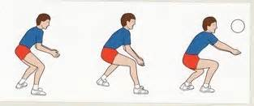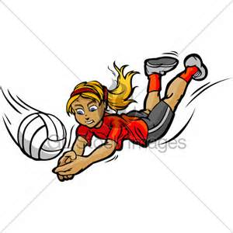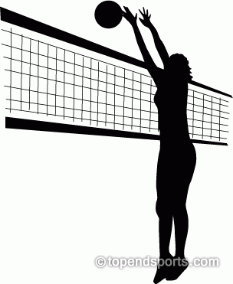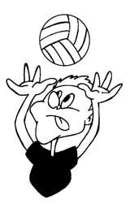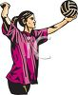
FOREARM PASS DIG BLOCK SET SERVE SPIKE

VOCABULARY:

ACE – When a ball is served to the other team and no one touches it as it lands in bounds.
SIDEOUT- When the team that served the ball makes a mistake causing the ball to go to the other team.
BLOCK – Using your hands to prevent the ball from crossing the plane of the net.
ASSIST – A ball placed in the air that is attacked for a kill.
DIG – When a player makes a save from a very difficult spike.
KILL – When a team spikes the ball and it either ends in a point or a sideout.

