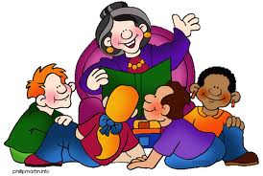
1. Interactive Read Aloud (IRA): Each IRA begins with the class sitting together on the carpet to listen to Mrs. Fourhman read. IRAs utilize meaningful, age-appropriate picture books or chapter books to model and discuss reading concepts. Students participate in IRAs by listening, talking with classmates, and sharing ideas.
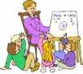
2. Shared Reading: IRAs are often followed by Shared Reading, in which all students either have or can view a short piece of text related to the day's topic. We read the text together and discuss it or participate in a related activity.
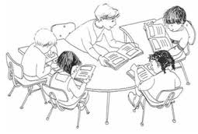
3. "Book Club" with Centers: Each month students participate in Book Club, a focused book study that allows students to work in small groups to read, investigate, and respond to a story. Each month, students are sorted into four groups. Each group reads a different book, with all books revolving around the same main themes or genres. During the 45 minute Book Club work period, students are either reading their books, responding to their books in written form, meeting with Mrs. Fourhman to discuss the book, or completing different language-based activities called Centers.

4. Independent Reading: Every day, time is set aside for students to read a book of their choice. These books can be taken from the school library, classroom library, or home. Independent Reading is a time for students to "get lost" in a great book.
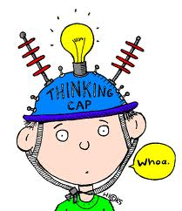
5. Writing Mini-Lesson: To transition into writing, students will participate in a brief lesson that teaches the core concepts of the day's writing topic. This lesson will prepare students to utilize new skills in their writing.
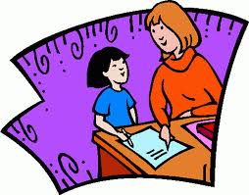
6. Writer's Workshop: Students work alone, in partners, in groups, and/or with Mrs. Fourhman to create meaningful, exciting pieces of writing. Each two month unit focuses on a different style of writing to help students blossom as authors.

