Retelling  Rating  Rubric |  |  | 
Include  All Events | 1 or 2 Events  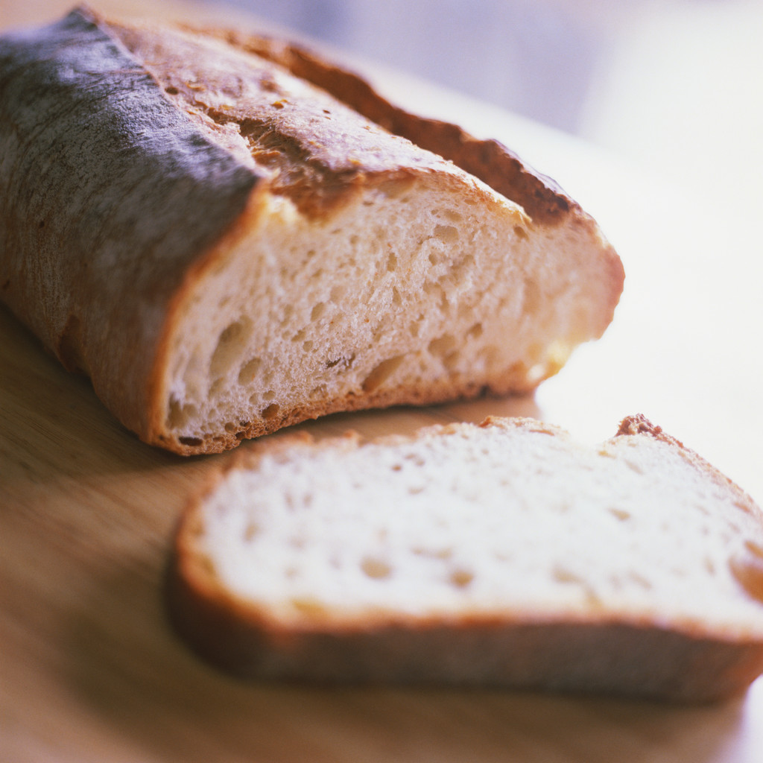 | 3 Events | All Events  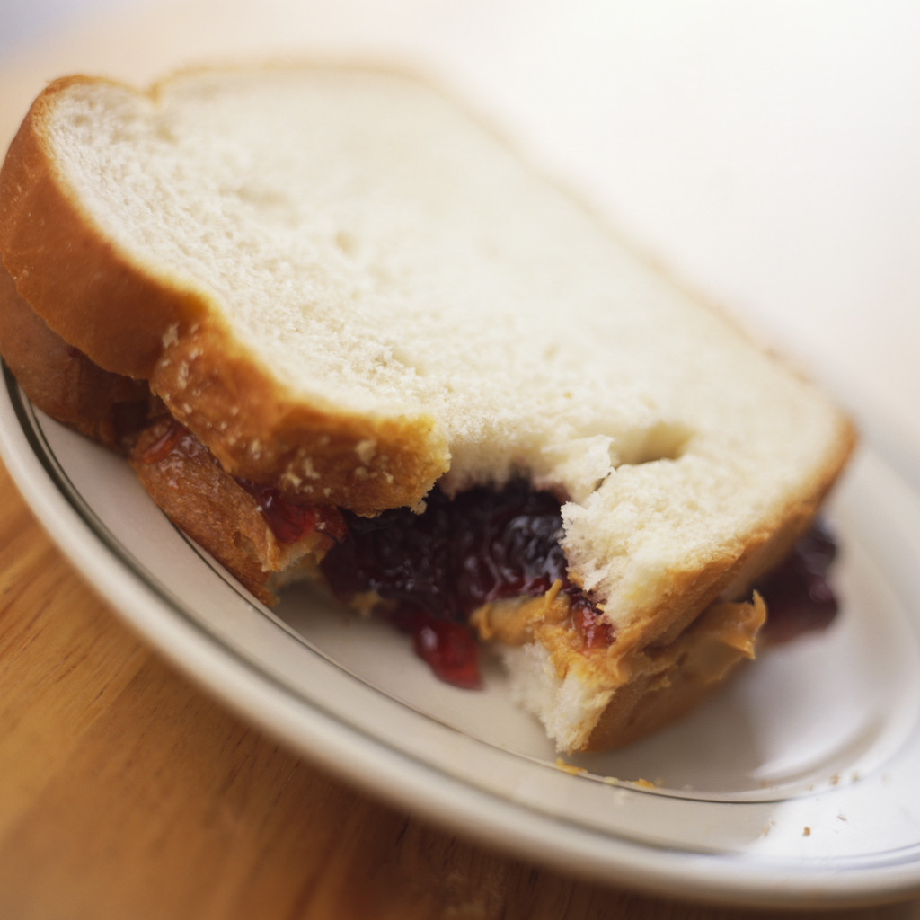
Sequence of  Events | Finally,  Then,  First,  After That  4 2 1 3 | First,  After that,  Then,  Finally  1 3 2 4 | First,  Then,  After that,  Finally  1 2 3 4
Characters | None | they it them  dog he she cat | Danny James Kate Jasper
Details | 1 Detail /Misinterpretation | Some Important Details | All Important Details
Vocabulary | None | Some | Most
Support |   4 or 5 Questions | 2 or 3 Questions | 0 or 1 Question

