Fluency Rating Rubric | 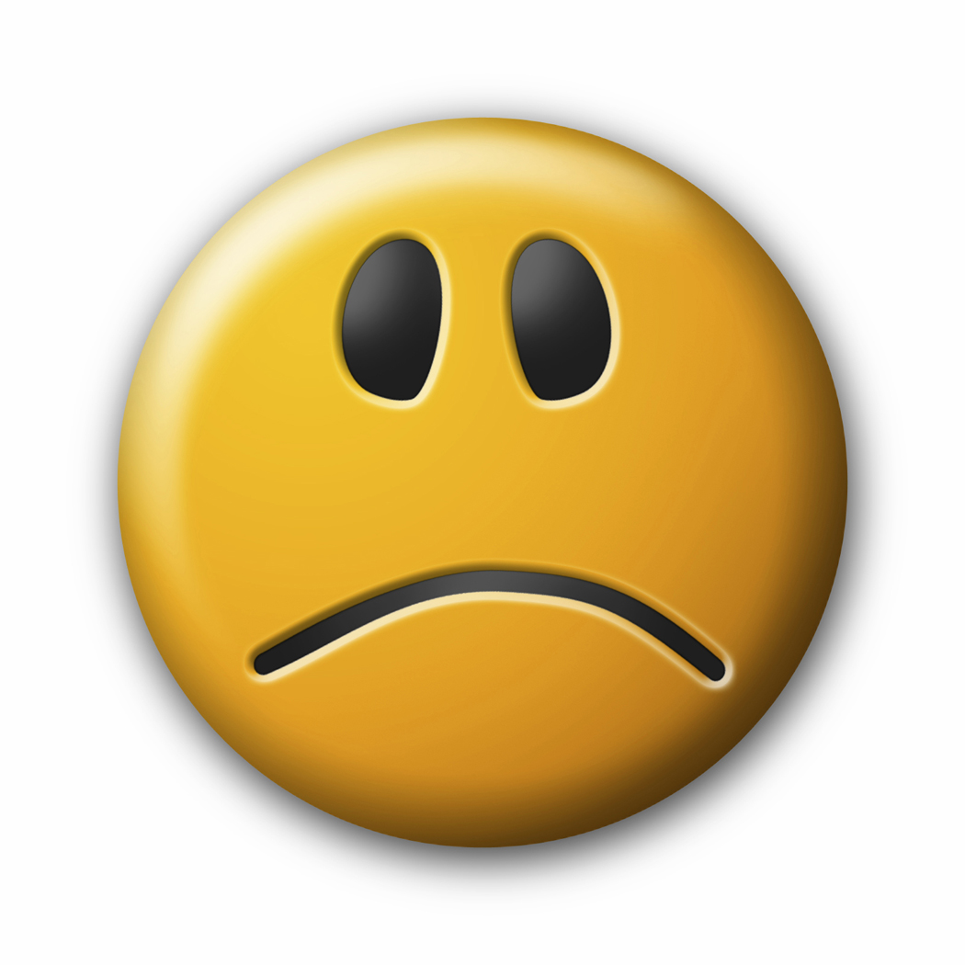 |  | 
Rate | Too Slow | Too Fast | Just Right
Expression | Did NOT sound like the characters | Sounded like SOME of the characters | Sounded like ALL of the characters
Phrasing | Read in 2 to 3  word phrases | Read in 4 to 5  word phrases | Read in long, meaningful phrases
Attending to Punctuation |   Did NOT attend to any punctuation…just kept going |   Stopped at SOME of the . ? !  Paused at SOME of the ,  And then kept going | Stopped at ALL of the . ? !  Paused at ALL of the ,

