Background to the Vietnam War
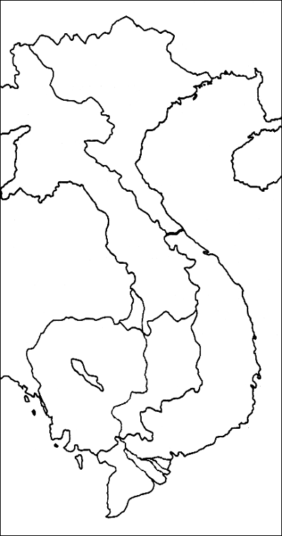

- North Vietnam
- South Vietnam
- China
- Cambodia
- Laos
- Thailand
- Burma
- Gulf of Tonkin

The Early Cold War
- U.S. involvement in Vietnam began with Harry Truman’s idea of containment.
- Domino Theory-

French Involvement
- A Vietnamese history of nationalism and resisting neighboring Chinese influence.
- 1800s France established itself as a colonial power in Vietnam.
- Ho Chi Minh and the Vietminh

A Divided Vietnam
- Geneva Accords-

- Ho Chi Minh became president of the new communist North Vietnam and Ngo Dinh Diem became leader of South Vietnam.
- 17th parallel

U.S. Support
- Following the French defeat and the division of Vietnam, the U.S. began supporting the anti-communist South Vietnam.
- The aid came in the form of military advisors to assist in the struggle against the communist north.

