Name_________________________________

Cuban Missile Crisis
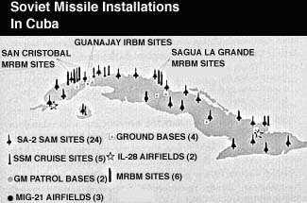
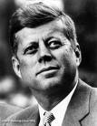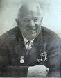

Using the following website you will answer a variety of questions which should help you to understand the events associated with the Cuban missile crisis.

http://library.thinkquest.org/11046/index.html

- What were the two contributing factors to the crisis?

a)

b)

- What factors associated with U.S.-Castro relations and Castro-Soviet friendship led to the placement of missiles in Cuba?

- Explain how the crisis materialized on October 15, 1962.

- Visit the “Recon Room”, list two facts that you learned from your visit related to the crisis.

- Define the “Executive Committee of the United States National Security Council” (EX-COMM).

- Below are listed several members of EX-COMM. Explain their most important role with respect to the crisis. (Include their title)

Dean Rusk –

Robert McNamara-

McGeorge Bundy-

Robert Kennedy-

General Maxwell Taylor-

- As early as October 16th what were the two approaches being discussed/considered by EX-COMM?

a)

b)

- Briefly describe the events of Wed, October 17 thru Sat, October 20th?

- On Sunday, October 21, what decision did Kennedy make regarding the situation in Cuba and what factors influenced his decision?

- Find JFK’s speech from the 22nd of October, 1962. Kennedy stated that he had directed several initial steps to be taken, summarize them.

- What was included within this speech that was directed to the Cuban people?

- At what distance was the original quarantine line set? Why did Kennedy decide to reduce the line to 500 miles?

- On Day 10, October 24th, Secretary of State Dean Rusk stated “We’ve been eyeball to eyeball and the other fellow just blinked”. What was he describing?

- Describe the tone of the 2nd letter received from Khrushchev. This letter was received on the evening of October 24th (Day 10).

- On Day 11, Thursday, October 25th, U.S. Ambassador Adlai Stevenson confronted the Soviets at the U.N. Describe this confrontation.

- What was the single worst day of the crisis? What three items contributed to this fact?

- Describe the elements of the compromise that ultimately brought the crisis to a conclusion?

- Who was Anatoly Dobrynin and what role did he play with respect to the crisis?

