 PINGSKILLS - RULES OF TABLE TENNIS http://www.pingskills.com/

THE TABLE:

- The surface of the table, known as the playing surface, is rectangular, 2.74m (9ft) long and 1.525m (5ft) wide, and lies in a horizontal plane 76cm (2ft 6in) from the floor. The playing surface does not include the sides of the tabletop.

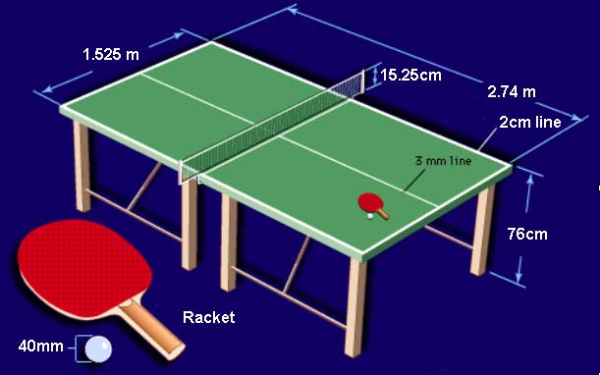
THE NET ASSEMBLY:

- The top of the net, along its whole length, is 15.25cm (6in) high.

THE BALL:

- The ball is made of celluloid or similar plastics material and can be white or orange. The diameter of the ball is 40mm. This has been changed from 38mm.

THE RACKET:

- The racket can be any size, shape or weight.
- The surface material covering the wood must be bright red on one side and black on the other.

HITTING:

- A player hits the ball if he touches it in play with his racket held in the hand, or with the racket-hand below the wrist.

THE CHOICE OF SERVING, RECEIVING AND ENDS:

- The right to choose the initial order of serving, receiving and ends is decided by lot and the winner may choose to serve or to receive first or to start at a particular end.
- When one player or pair has chosen to serve or to receive first or to start at a particular end, the other player or pair has the other choice.
- After each 2 points have been scored the receiving player or pair becomes the serving player or pair and so on until the end of the game, unless both players or pairs have scored 10 points when the sequences of serving and receiving are the same but each player serves for only 1 point in turn.

CHANGING ENDS AND CHANGING ORDER IN DOUBLES:

- Ends are changed at the conclusion of each game or when one player or pair reaches 5 points in the deciding game. In doubles at each change of ends, and in the deciding games, the order is also reversed. In the deciding game this is done by the receivers changing positions.

A GOOD SERVICE:

- At the start of service the ball must be resting freely on the stationary open palm of the server's free hand, behind the end line and above the level of the playing surface.
- The server must then throw the ball almost vertically up, without imparting spin, so that it rises at least 16cm after leaving the palm of the free hand and then falls without touching anything before being hit.
- As the ball is falling the server hits it so that it touches his court first and then, after passing over or around the net assembly, touches the receiver's court.
- The ball must be above the level of the playing surface and it shall not be hidden from the receiver during the serve.
- The ball must be hit from behind the server's end line.

A GOOD RETURN:

- The ball, after being served or returned, must be hit so that it passes over or around the net assembly and touches the opponent's court, either directly or after touching the net assembly.

DOUBLES:

- In doubles, the server must first make a good service, the receiver must then make a good return. All players must take it in turns to hit the ball.
- When serving in doubles, the ball must touch successively the right half court of server and receiver.
- In each game of a doubles match, the pair who serves first will choose which of them will do so, and in the first game of a match the receiving pair will decide which of them will receive first; in subsequent games of the match, when the first server has been chosen, the first receiver is the player who served to him in the preceding game.
- In doubles, at each change of service the previous receiver becomes the server and the partner of the previous server becomes the receiver.

A POINT:

Unless the rally is a let, a player scores a point
- if his opponent fails to make a good service;
- if his opponent fails to make a good return;
- if the ball, after he has served or returned it, touches anything other than the net assembly before being hit by his opponent;
- if the ball after his opponent has hit it, passes over his end line without having touched his court;
- if his opponent obstructs the ball ie. if he, or anything he wears or carries, touches it in play when it is above or traveling toward the playing surface, and has not passed beyond his end line, not having touched his court since last being hit by his opponent.
- if his opponent, or anything his opponent wears or carries, moves the playing surface;
- if his opponent, or anything his opponent wears or carries, touches the net assembly;
- if his opponent's free hand touches the playing surface;
- in doubles if his opponent hits the ball out of sequence.

A GAME:
A game is won by the player or pair who scores 11 points unless both players or pairs score 10 points, then the game is won by the player or pair that leads by two points
i.e. 12 – 10 or 13 - 11 etc.

A MATCH:

- A match must consist of the best of any odd number of games. For schools use 1, 3, 5.or 7 depending on time constraints.
- Play must be continuous throughout a match except that any player is entitled to claim an interval of not more than 1 minute between successive games.

