Notes: Ecology #3
Ways Organisms Reduce Competition
- Many different behaviors/adaptations to reduce competition:
  - __________________
    - Where an organism prefers to live
    - Ex: _____________________________________________
  - ___________________
    - The role or job of an organism in the community
    - Ex: __________________________________________________
  - Patterns of activity
    - _________________________
      - Active at night
    - _________________________
      - Active during the day
    - ________________________________
      - Inactive state during the winter in response to cold
  - __________________________________________
    - Inactive stage of organisms in response to the heat and lack of water
    - Ex: _______________________________
  - __________________________________
    - Seasonal movement from harsh climate to a more favorable climate
    - Return to original habitat when conditions improve
    - Examples: ________________________

Ecosystems
  - Definition:
    - Interaction of all the ________________ organisms in an area (biotic factors) and the __________________ aspects of the environment (abiotic factors)
  - Biotic
    - Ex. __________________________________________
  - Abiotic
    - Ex. ____________________________________________
Ecosystem—Biotic and Abiotic Interactions:
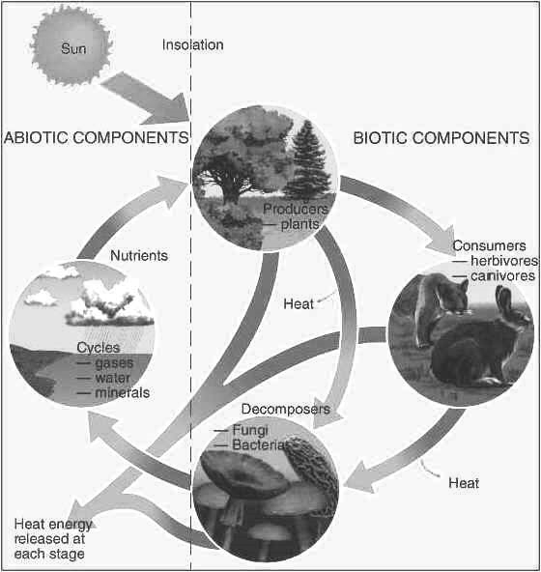

Ecosystems
- Ecosystems affect and are ___________________________ upon one another
- All ecosystems are dependent upon energy
- Competition is most often for __________________________.
- Why do organisms need food?
  - For ____________________________________!
Productivity
- Productivity
  - The amount of _____________________ an ecosystem can generate from producers
  - Producers get energy from the ______________________
- Net Productivity: Most important energy measurement
  - Energy that is ______________________ as food for consumers in the food chain
  - The higher the net productivity, the greater the amount of energy available to each trophic level
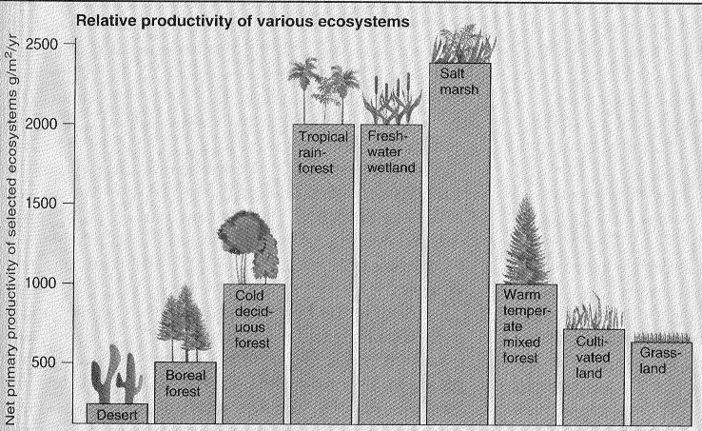

Trophic Levels
- In an ecosystem, energy is transferred through trophic levels in a food chain
- The transfer of energy between levels is NOT efficient
  - Only ~____________% of energy is transferred to the next trophic level
- Energy is used for __________________ and _______________________ , OR is lost as ____________________ or ______________________________
- The remaining 10% of energy is transferred to the next _________________________ level
- Energy flow in a food chain:
Autotrophs
(photosynthetic organisms: plants, algae), algae)
Herbivores
(Plant eating)
Omnivores and Carnivores
(Meat-eating hunters)
Scavengers
(Carrion-eating)
Decomposers, detritivores
(Decompose organic matter)

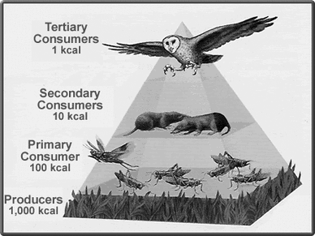
Energy Transfer: Food Pyramid
4th trophic level: Tertiary Consumers
- Large carnivores (top predators- owls, lions)
3rd trophic level: Secondary Consumers
- Small carnivores and omnivores (rats, raccoons)
2nd trophic level: Primary Consumers
- Herbivores (grasshoppers, grazing animals)
1st trophic level: Producers
- Autotrophs (plants, algae)

Food Webs
- Show the flow of _________________ in an ecosystem
- Often very _________________________________
- Figure: Arrows indicate the _______________________________ of energy flow
