Speciation/Mechanisms of Evolution
  - The formation of a new _________________________
  - When species are _____________________________ separated over long periods of time, new _________________________ can result
  - Population is split into two or more smaller groups by a ________________________ barrier
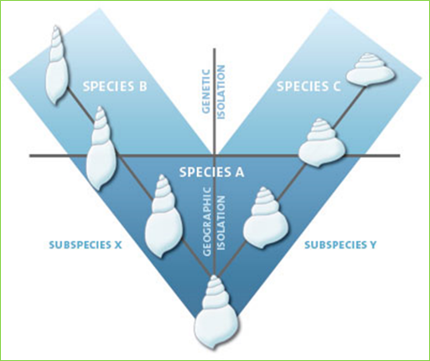
    - _________________________, streams, ____________________, desert, etc.
Geographic separation

Reproductive isolation
- Over time, geographically separated species evolve separately and become ____________________________ isolated
- Reproductive isolation:
  - Members of a species ___________________ mate and/or produce viable offspring
  - When reproductive isolation occurs:
______________________ species!
- Many reproductive isolating mechanisms:

Reproductive Isolating mechanisms
- Temporal
  - Species have different _______________________ _____________________, periods of fertility, or periods of activity (morning vs. night)
- Ecological
  - Species only mate in their ______________________ ______________________________, which is not shared by a different species
- Behavioral
  - Species have different mating ____________________________________ (calls, dances, etc.)
- Mechanical
  - _________________________, ____________________________ differences prevent mating
5. Post-mating Mechanisms
  - Mating takes place, but:
    - _______________________ does not occur (gametic isolation),
    - Zygote or embryo __________________ (hybrid inviability),
    - Or, offspring is _____________________ (hybrid sterility)
  - Examples:
    - Mule:
      - Sterile hybrid of _______________ and _________________
    - Liger:
      - Sterile hybrid of ___________________ and _____________________
Two hypotheses about how evolution occurs:
  - Gradualism
    - Genetic changes are _________________________ but steadily occurring
    - Over time, small changes add up to the formation of a new _________________________
  - Punctuated Equilibrium
    - Periods of _______________________ to ______ change, followed by a __________________________ change
    - Mutation occurs that causes a ______________________ change in a ________________________ number of individuals
      - If the change is advantageous , these individuals will have high fitness and ___________________________ the trait along
Natural Selection
- ________________________________ = any trait that aids the chances of survival and reproduction of an organism.
- Examples:
- Two Types of Adaptations : _____________________ and ________________________________
  - STRUCTURAL ADAPTATIONS arise over ________________ ____________________________.
    - Types of Structural adaptations:
    - _________________________________ = provides protection for an organism by enabling it to copy the appearance of another dangerous species.
      - Examples:
    - ________________________ = enables an organism top blend in with its surroundings
      - More likely to escape predators and survive to reproduce
      - Examples
  - PHYSIOLOGICAL ADAPTATIONS can ____________________ __________________________
    - Changes in an organism’s ______________________ __________________________
    - Ex: ________________________________ – was discovered 50 years ago as a wonder drug because it could kill many types of disease-causing bacteria
    - Now penicillin is not as effective as it used to be because many species of bacteria have evolved physiological adaptations that make them resistant to penicillin.
    - Ex: insects/ weeds have been selected for physiological resistance to chemicals used in pesticides
Mechanisms of Evolution
- Natural __________________________
  - Survival of the _____________________________
- Mutation
  - Changes _____________________________ frequency of populations
- ______________________________ drift
- ______________________-
Genetic Drift
- Definition
  - Change in allele frequency of a population due to _______________________________
  - _________________________ populations are more susceptible
- In a population, some individuals will produce _________ offspring, and pass on more of their genes
- Result:
  - Over time, only one allele for a trait may ________________________ in a population (Fixation)
    - Reduce in genetic _____________________________
Migration
- Definition:
  - Movement of individuals from ___________ population to a _______ population
- Movement of individuals between populations can ___________________ allele frequency
- Founder effect
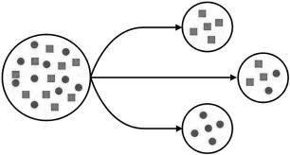
  - A colony is __________________________ by members of an existing population
  - Small colony population may have:
    - Lower genetic _______________________________
    - A ___________________________________________ collection of genes from the original population
Founder Effect in the Amish
- Live in ____________________________, PA
- Founded by 200 ___________________________________ immigrants
- These immigrants had a high proportion of the ________________________ alleles that cause _______________________________________________ syndrome
  - Symptoms:
- Closed gene pool keeps the _____________________________ alleles in the population
Population Bottleneck
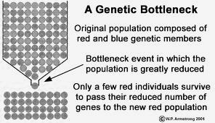
- Definition:
  - A populations size is greatly ________________________ for at least one generation
  - Genetic diversity is greatly _______________________________
  - If population increases again, the genetic diversity will be extremely ________________
Bottleneck Examples
- Elephant seals
  - Almost hunted to _______________________ in the 1890s
  - Population dwindled to _________________________ seals
  - Once the species was protected, it was able to ____________________________
  - Today, population is 30,000
- Cheetahs
  - Near extinction __________________ years ago
    - End of last __________ age
  - Population further ___________________ due to poaching
  - Today, all cheetahs have almost identical __________________________
    - Reduced ____________________, _______________________ and _________________________

