Notes: Evidence of Evolution
Evidence of Evolution
- Remember, evolution is a _________________, so there must be extensive evidence that supports it!
- Lines of evidence:

Fossil Record
- Show ______________________________ between extinct organisms and organisms living today
- Many types of ______________________
  - _______________________, imprints (footprints, leaves), ___________________, plants, _____________________, eggs, fossilized amber (insects)
- Transitional Species
  - Show link between _____________________________ of organisms
    - Example: Archaeopteryx–Link between reptiles and birds
- Shows _______________________ between living and extinct species
    - Example:
Anatomical Features
- Similarities in ________________________ suggest common descent/ancestry among organisms

Homology vs. Analogy
- Homology- traits inherited by two _______________________________ organisms from a _________________________ ancestor (forelimbs of a dog and human arm)
- Analogy- similarity due to convergent evolution __________ common ________________________ (wings of a bird and wings of a butterfly)

Convergent Evolution
- Convergent evolution
  - Two separate organisms evolve similar characteristics ________________________ of one another
  - Happens when two species are facing similar selective pressures/same _________________________________ pressures

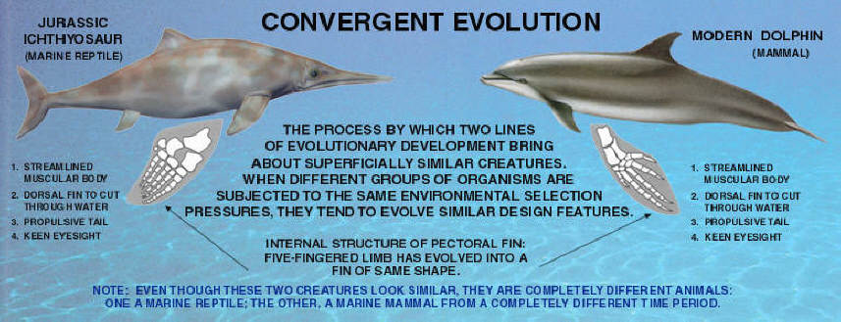
Divergent Evolution
- Divergent evolution is the accumulation of ____________________________; results in different ___________________________

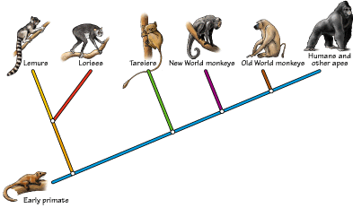

Homologous Structures
- Definition:
  - Bones or organs that appear in different organisms but share a ___________________________ ancestry
  - Same basic _________________________, but ___________________________ ____________________________
  - Example:
    - ________________________ of vertebrates:

      - These bones are very similar but have very different functions
Vestigial Structures
- Definition
  - Body structure that has been _______________________ in size and function
  - But, _______________________ a fully functional structure in another organism
- Examples
  - _____________________ (coccyx) in humans
  - _________________________ in humans
  - ______________________ in flightless birds
    - Related to wings used for _____________________
  - ________________________ fold in human eye
    - Remnant of _____________________________ membrane
  - ____________________________ in humans
    - Attempt to ________________________ _______ fur when cold
Embryology
- Embryology Definition:
  - The study of embryos and their __________________________
- Different organisms show very __________________ developmental patterns and structures
  - Suggests _________________________ ancestry between species
- Example:
  - All vertebrates have _________________ ______________________ and a ____________________ at some point during development
Biochemistry
- Nucleic acids carry ___________________________ information in all organisms
  - __________ or _______________
- _________________________________ genetic code
  - ____________________ code and _________________ acids are the same for all organisms
  - ___________ sequences
  - The more closely related organisms are, the more similar their _____________________ sequences
- Proteins
  - Vital proteins are found in ___________________ organisms
  - Example:
- ATP
  - ________________________ source for all organisms

