The Characteristics of Life
What characteristics are common to ALL living things?
All living things…
- Have at Least one _______________________
  - All cells have ______________ inside as the genetic blueprint for life.
  - Cell Types
    - If the DNA is NOT in a separate structure (_______________), the cell is ________________________.
    - If the DNA is in a nucleus, the cell is eukaryotic.
A Prokaryotic cell (________________ only) A Eukaryotic cell (_______________, ________________, _________________, ________________)
Label the parts of the 2 cells below.
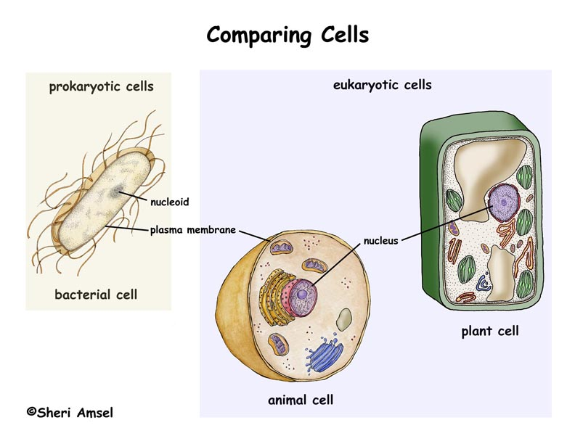

- Cell Number
  - An organism that has only ________________ cell is said to be _________________________.
    - Examples = __________________, __________ ____________________, ____________________________(yeast)
  - An organism that has ___________________ ______________ ____________ cell is said to be ________________________.
    - Examples = all _________________, all ______________________, most _____________________, and some _________________________
- Have a ___________________________
  - ____________________ – get larger
    - In cell _________________________
    - In cell _________________________
  - ___________________________________ =
    - Into a mature organism that can ________________________________
  - __________________________________
    - Reach the end of its lifespan
- __________________________________
  - Have the ability to create ___________________ like themselves
  - Types of reproduction
    - If _______ organism creates an exact copy (clone) of itself to become 2 organisms, it is _________________________ reproduction
    - If ______________ and _________________ unite to create a genetically different individual, it is _____________________ reproduction
      - Creates new ____________ combinations in a _______________.
- Obtain _______________________ which is used to produce _______________________
  - Ways Organisms Obtain Food = __________________ it or ______________ it
    - ______________________________ = make food in their cells
      - Called the ____________________________________
      - Usually involves the process of ____________________________
      - Examples = ________, _________________ and some _______________________ and ________________________
    - ________________________________ = must ______ other organisms to get food (glucose) to their cells.
      - Called the ___________________________
      - Examples = all ___________________, most ________________, some ______________________, some ____________________
- Produce Energy during the process of ___________________________________
  - A __________________________ process performed by the cells of ________ _____________________ _____________________ to change ____________ energy into _______________________ that the cell can use to do ___________ and carry out ___________________ processes.
  - Types of respiration
    - Respiration that uses ___________________ is called ___________________ respiration.
    - Respiration that does _________ ________ ____________________ is called ___________________________ respiration
  - ***After obtaining food and producing/using energy, all living things produce _______________.***
- ______________________________ to changes in the environment
  - _______________________ to stay alive = maintaining ______________________________ = balance
  - Examples = ______________________ to produce heat, ____________________ to cool off, plants _____________________ toward windows to get sunlight
- ____________________________ to changes in the environment
  - Involves ______________________ change that occurs over generations to help a _______________________________ survive. (_______________________)
  - Examples = a new _____________________ creates a new _______________________ that is better camouflaged (__________________) in environment.

