Quentin Aanenson

April 21, 1921 - December 28, 2008

9th Air Force, U.S. Army Air Corps
Luverne, MN

Aanenson flew the P-47 Thunderbolt in the Normandy D-Day invasion and subsequent European campaign.

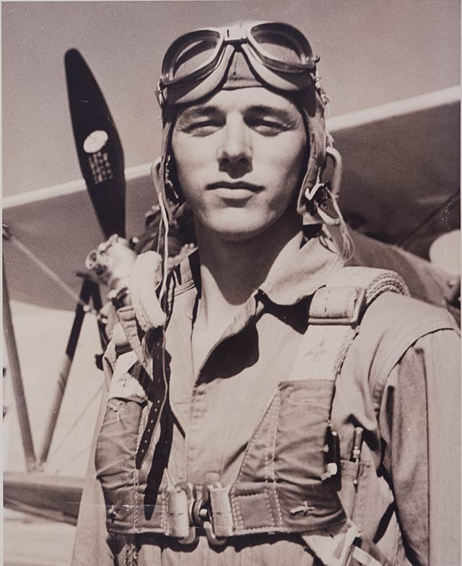
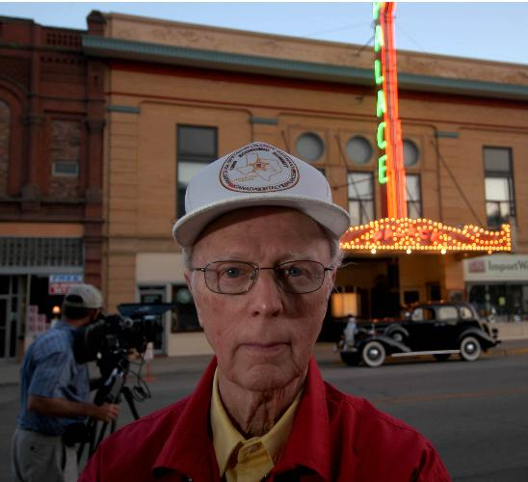

Hannah Bressi & Ryan Leader
America’s past is filled with many stories and many people. A hero is a man of distinguished courage or ability, admired for his brave deeds and noble qualities. Our navy, army, and air force are made up of extraordinary people, heroes. Quentin Aanenson is just one of many soldiers that experienced D-Day and battles that our society today forgets about. He was the fifth of six children living on a farm in the 1920’s. Many of his accomplishments are admirable, and many of his services should be remembered always.
Quentin Aanenson was born on April 21, 1921 on a 160 acre farm five miles from Luverne. His grandparents had come from Norway, and his parents were fluent Norwegian speakers at his home. After graduating high school he attended the University of Minnesota for two years. He later attended the University of Washington while working a job at Beoing. Aanenson was colorblind and therefore unable to become a pilot, his dream job. He took the eye test so many times that he memorized it. After he passed, he was accepted into the Army Air Corps in February 1943. This is the beginning of Quentin Aanenson’s heroic life.
Aanenson’s whole life was one to admire. Between his frequent letters to Jacqueline Freer, his love, he was in combat on D-Day. Flying over the English Channel and dropping bombs on the Germans’ is just a snap shot of what he contributed. On July 25, 1944 he was among the 3,000 planes that was a part of Operation Cobra. His crazy story about a flight over Vire, France is just one of the many stories of his life. On August 3, 1944 on his mission over Vire his plane was hit by flak and caught fire. He tried to bail out but found it impossible. His next decision was to crash the plane as quickly as possible. The change in air pressure extinguished the cockpit fire, and he managed to fly the plane back to his base and crash-land. He suffered a concussion, dislocated shoulder, and burns.
Aanenson was also part of many cockpit fires, intense combat, crash landings, and even the Battle of the Bulge. Quentin Aanenson was promoted captain in 1945. That same year he went home and married his love Jackie Greer. After the war was over he attended the Louisiana State University and had a career in insurance business. With three children and eight grandchildren his stories fill the hearts of many. On December 28, 2008 Aanenson passed away. His story will live through Americans for years to come.

“I have purposely not told you much about my world over here, because I thought it might upset you. Perhaps that has been a mistake, so let me correct that right now. I still doubt if you will be able to comprehend it. I don’t think anyone can who has not been through it ... I live in a world of death ...”

Letter from Quentin Aanenson to his girl friend shortly after he was told he would be coming home.

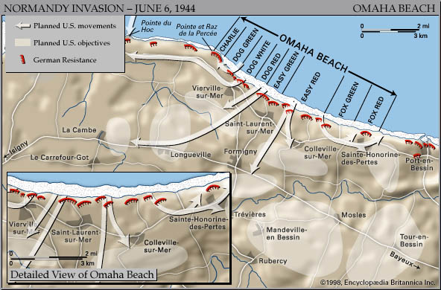

This is a picture of the area on D-Day that Aanenson flew over at Pointe du Hoc at the top left of the map.
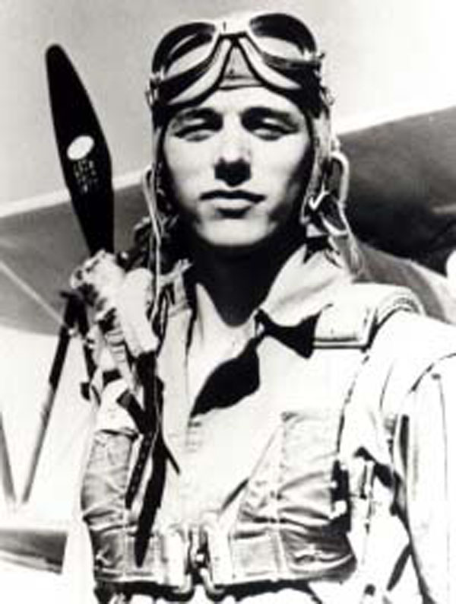

This is a picture of Aanenson while he was in the Military during WWII

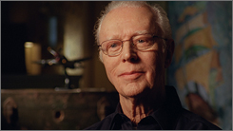

This is a picture of Aanenson shortly before his death in 2008

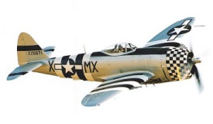

This is a picture of a plane that he would have flew in during WWII

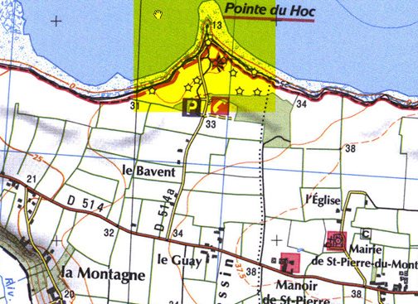

This is a more in depth look at Pointe du Hoc where Aanenson flew over on D-Day.

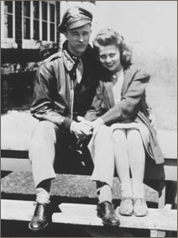

This is a picture of Aanenson with his wife Jacqueline G. Aanenson

VIDEO LINKS:

Soldiers are sent into combat expected to kill as many opponents as they possibly can. To society, we don’t think twice about what goes through the minds of these soldiers as they do this. In this clip Aanenson tells his thoughts about his actions. Could you live with murdering someone for the sake of your family, friends, and country?

http://www.pbs.org/thewar/detail_5378.htm

Could you imagine living in a place where you don’t feel safe walking down the street? Where the rest of the world is at war all around you and you are unable to control any of it. Many Americans’ were so far away from the combat action that they didn’t experience the fear that many Germans had. This video shares the experiences of the small town American during the war. The Aanenson family lived on a farm at this time, where Quentin dreamed of flying air planes all day long.

http://www.pbs.org/thewar/detail_5404.htm

