Mendelian Genetics Packet
Name:___________________________________Period:______Date:__________

GENETIC FACTS & FALLACIES PRE-QUIZ
T F 1. Certain acquired characteristics, such as mechanical or mathematical skill, may be inherited.

T F 2. Identical twins are always of the same sex.

T F 3. Fraternal twins are more closely related to each other than to other children in a family.

T F 4. The father determines the sex of a child.

T F 5. Each parent contributes half of a child’s genetic makeup.

T F 6. Certain drugs or alcohol can cause birth defects in the fetus.

T F 7. Colorblindness is more common in males than in females.

T F 8. A person may transmit characteristics to offspring, which he, himself does not show.

T F 9. Identical twins are more closely related than fraternal twins.

T F 10. Certain inherited traits may be altered by the stars, moon, or planets early in development.

T F 11. Humans have 23 chromosomes.

T F 12. The tendency to produce twins may run in families.

T F 13. A craving for a food such as strawberries may cause a birthmark on an unborn child.

T F 14. Many of a person’s inherited traits are not apparent.

T F 15. The parent with the stronger “will-power” will contribute more to a child’s inheritance than the other parent.

T F 16. If a person loses a limb in an accident, it is likely that he or she will have a child with a missing limb.

T F 17. Gregor Mendel was a monk and is known as the “Father of Genetics” based on his experiments with pea plant.

T F 18. Children born to older parents may have a higher change of birth defects than younger parents.

T F 19. The total number of male births exceeds female births each year.

T F 20. If a male “mutt” dog mates with a pedigree (show quality) female dog, all future litters that the female would have (even with other dogs) can have traits from the “mutt” dog.
GENETIC TERMINOLOGY:
- ________________= any characteristic that can be passed from parent to offspring
- _______________________= passing of traits from parent to offspring
- ______________________= study of heredity
- __________________= two forms of a gene (dominant & recessive)
- __________________________= stronger of two genes expressed in the hybrid; represented by a capital letter (R)
- __________________________= gene that shows up less often in a cross; represented by a lowercase letter (r)
- _______________________= gene combination for a trait (ex: RR, Rr, rr)
- ______________________= the physical feature resulting from a genotype (e.g. tall, short)
- _________________________________= gene combination involving 2 dominant or
2 recessive genes (ex: RR or rr); also called ___________
- ________________________________= gene combination of one dominant & one recessive allele (ex: Rr); also called ________________
- __________________________ = cross involving a single trait
- ___________________________= cross involving two traits
- ___________________________= used to solve genetics problems. (based on probability)
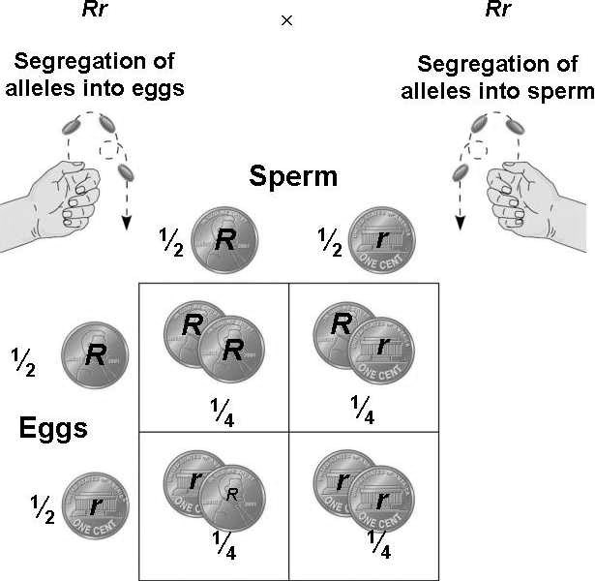

FUNDAMENTALS OF GENETICS

- ________________________= The passing of traits from ________________to__________________.
- Transmitted by means of information stored in molecules of__________.

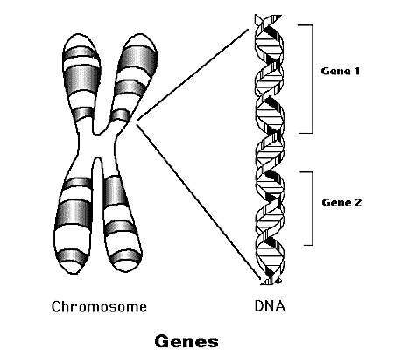
- _____________________= Scientific study of _______
Based on knowledge that traits are transmitted by________________________.
    - Our _____________ are made up of our __________, which are pieces of _______ that code for certain _____________.
    - Humans have ______ chromosomes in all your somatic (body) cells.
_______chromosomes from your mom and ______chromosomes from your dad.

- ___________________________= All the outside forces that act on an organism.
Affects the development, later life, and the expression of hereditary traits of an organism.

WHAT MAKES YOU WHO YOU ARE TODAY?
  - _________________________________--are the two great influences, acting together all through your life.
  - Genetic messages determine what organisms _______become.
  - The interaction of messages and the environment determines what organisms ______become.
  - Organisms inherit_______________________, not traits!
  - Traits develop when genetic messages interact with the environment.

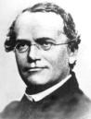
- GREGOR MENDEL -“________________________” – (1865)
Austrian monk
His research with __________________led to the discovery of the basic principles of heredity.
Did a statistical study of traits in garden peas over an eight year period.
Garden peas were a good choice for experimentation because:
  - They can be_____________________________.
  - They display __________________in one of two contrasting forms:
    - Height—tall/short
    - Seed color—yellow/green
3. They are normally ____________________plants and are very easy to cross- pollinate.
Mendel used logical____________________ methods and kept careful_______________.
He used his math principles of ____________________to interpret results.
Mendel studied pea traits, each of which had a dominant & a recessive form ______________
The ___________________(shows up most often) gene or allele is represented with a________________, & the ______________________with a ______________________of that same letter (ex: B, b).
Mendel's traits included:
    - Seed shape --- Round (R) or Wrinkled (r)
    - Seed Color ---- Yellow (Y) or Green (y)
    - Pod Shape --- Smooth (S) or wrinkled (s)
    - Pod Color --- Green (G) or Yellow (g)
    - Seed Coat Color --- Gray (G) or White (g)
    - Plant Height --- Tall (T) or Short (t)
    - Flower color --- Purple (P) or white (p)

MENDELIAN GENETICS OVERVIEW
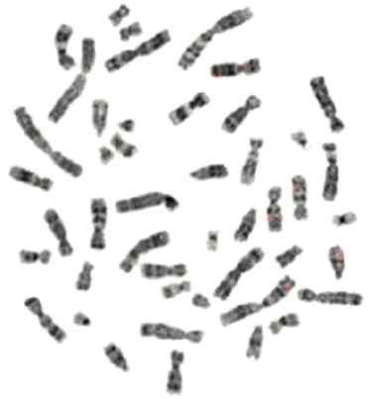
Humans each have two sets of_____ chromosomes in their somatic (body) cells and about 30,000 genes.
- The different forms or types of a specific gene are called _________.
For example, a GENE for eye color might have a blue_____________, a brown____________, and a green____________.
- Because our chromosomes are in _________sets, we have two copies of each gene, _______from our _______and _______from our______.
- If both of our parents gave us the ________________of gene – the same allele – then we are:
_____________________ or pure (on both sets of our chromosomes, on both sets of genes; the allele is the________).

- If one parent gave us one type of gene and the other parent gave us a different type, then we are:
__________________________ or hybrid – we have two different alleles.

- With MENDELIAN traits (the type of traits that Mendel studied), heterozygotes DO NOT have a _________of the two alleles.
Instead, one type of allele dominates –
o We show the characteristics of this allele only – it is the ________________trait.
o The other version of the trait is still there on half of our chromosomes (so we might still pass it on to our children, depending on meiosis) BUT it DOES NOT affect us right now—it is the _____________trait.

- Whether we are heterozygous, homozygous with the dominant trait, or homozygous with the recessive trait it is called our _________________ (type of genes that we have).

- Which trait we ____________________show is our __________________(the type of allele that is expressed).
For example, if the __________________of the eye color gene is brown and the ________________of the eye color gene is blue, then the person could have the following possibilities:
    - Two blue alleles, bb (one from_________, one from_________).
Genotype would be __________________________
Phenotype would be_________________________
    - Two brown alleles, BB (one from mom, one from dad).
Genotype would be _________________________________ Phenotype would be _________________________________
    - One brown and one blue allele, Bb (one from mom, one from dad). Genotype would be _________________________________
Phenotype would be ________________________________

o When only _________trait is being studied in a genetic cross, it is called a_____________________.
When parent organisms, called the_____________________, are crossed, the resulting offspring are the first filial, or_____________________________.
When organisms of the F1 generation are crossed, their offspring make up the second filial or,____________________________.

MENDEL’S EXPERIMENTS:
- Mendel produced pure strains by allowing the plants to self-pollinate for several generations.
- These strains were called the ______________generation or P₁ strain.
- Mendel cross-pollinated two strains and tracked each trait through two generations.
(ex: TT x tt )
- ______________= plant height
- _______________= T (tall), t (short)

P₁ cross = ________________

F₁ Genotypic ratio = ______________

F 1 Phenotypic ratio = _____________
- The offspring of this cross were all
__________________showing ONLY the __________________ & were called the _____________________generation.
- Mendel then crossed two of his F₁ plants and tracked their traits; known as an
_______________________
- Trait = plant height
- Alleles = T (tall), t (short)
F₁ cross = _______________

F₂ Genotypic ratio = _____________________

F₂ Phenotypic ratio = ____________________

- When 2 hybrids were crossed, 75% (3/4) of the offspring showed the dominant trait & 25% (1/4) showed the recessive trait
- Two hybrids ALWAYS create _________________________________________.
- The offspring of this cross were called the_____________________________.
RESULTS OF MENDEL’S EXPERIMENTS:
- Inheritable _____________________are responsible for all heritable characteristics.
- _____________________is based on ______________________
- __________________is based on_____________________, one from the mother and the other from the father.
- True-breeding individuals are homozygous (both alleles) are the same.
- Formulated 3 laws of heredity in the early 1860's.

MENDEL’S 3 LAWS OF HEREDITY:
Trait: Pod Color
Genotypes: | Phenotype:
GG | Green Pod  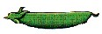
Gg | Green Pod
gg | Yellow Pod  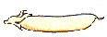
- _______________________states that when different alleles for a characteristic are inherited (heterozygous), the trait of only one (the dominant one) will be expressed. The recessive trait's phenotype only appears in true-breeding (homozygous) individuals.

- ____________________________= states that each
genetic trait is produced by a pair of alleles which separate (segregate) during reproduction.
Rr

R r
• Explains the disappearance of a specific trait in the F₁ generation and its reappearance in the F₂ generation.
3. __________________________________________= states that each factor (gene) is distributed (assorted) randomly and independently of one another in the formation of ________________(egg or sperm).
RrYy
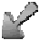 | 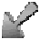 | 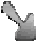 | 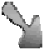
RY | Ry | rY | ry
• Explains that different traits are inherited_______________________, if on different chromosomes
- Ex: wrinkled seeds do not have to be yellow. They can be green.
- Ex: A gamete with RrYy
  - R and r – separate into different gametes
  - Y and y – Separate into different gametes
  - They can then recombine 4 ways to form gametes: RY Ry rY ry
Hitch-hiker’s thumb

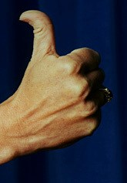
INHERITANCE OF HUMAN TRAITS: DOMINANT/ RECESSIVE
No cleft in chin / Cleft in chin recessive
Straight thumb / Hitch-hiker’s thumb
Hair on back of hand / no hair on back of hand
Inability to fold tongue/ ability to fold tongue
Tongue roller/ Non-roller
Dark hair/ Light hair
Non-red hair/ Red hair
Widows peak/ Straight or curved hairline
White forelock/ Normal hair
Freckles/ Normal
Dimples/ No dimples
Brown eyes/ Blue eyes
Normal eyesight/ Nearsighted
Almond shaped eyes/ Round eyes
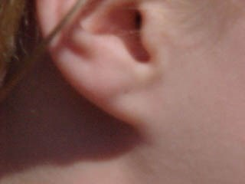
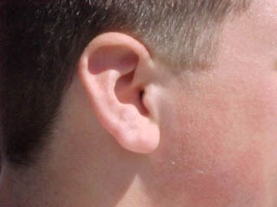
Long eyelashes/ Short eyelashes
Unattached earlobe
Attached earlobe
Broad nostrils/ Narrow nostrils
Roman nose/ Straight nose
Free ear lobe/ Attached ear lobe
Bent little fingers/ Parallel little fingers
Left over right thumb/ Right over left thumb
A or B blood/ O blood
RH+ blood/ RH- blood
Normal clotting/ Hemophilia
Normal / Allergy

HUMAN GENETICS

Fraternal vs. Identical Twins:
- __________________develop from a __________fertilized egg that splits shortly after fertilization
- Since they developed from the _________egg they have exactly the same __________________
- ___________________develop from ______eggs that are fertilized by
_____________sperms
  - They are _______________different people
By studying identical twins, geneticists have learned that __________seem to have a ________________influence than the ________________on such traits as height, weight, blood pressure, speech patterns, and gestures.
  - They have also discovered that _______play a role in some _______________problems once thought to be caused only by environmental factors.
o For instance, genes can cause a susceptibility to _____________ such as diabetes and certain types of cancer.
Inherited Diseases:
- ______________and _____________________ MAY be _________________ o Ex: Aids (HIV) can be passed onto offspring
o Ex: Common cold (rhino virus) can’t be passed onto the offspring
- Disorders resulting from abnormal structure or function of body organs are _______ likely to be based on genes
- Some disorders that are associated with genes are:
-diabetes – respiratory allergies – colorblindness– down syndrome – farsightedness - sickle cell anemia- etc..
- - We will learn more about genetic disorders in a couple of units

_{Sex Determination:} ?
OR

- ______________________________= determine the sex of an individual The X chromosomes (XX) produce a ____________________
An X chromosome paired with a Y chromosome (XY) produces a ___________
Since only a male can produce a gamete bearing a Y chromosome, the
__________________determines the _________of the child
Note: the X chromosome contains additional genetic information that the Y chromosome does not have, therefore a male child actually inherits more genetic information from his _____________than his father (a
very tiny amount)

Sex-Linked Traits:
- Traits that occur __________frequently in one sex than another (usually males)
  - Males -color blindness and hemophilia
- Occurs because other genes besides the alleles for sex are also located on the sex chromosomes
They are ______________to the normal condition and the Y chromosomes appear to lack genes for these traits
These traits generally do not show up in ________________

Punnett Squares:
- Punnett Square = used to solve genetics problems. (based on probability)
- Ex: Crossing two heterozygous genotypes (Rr x Rr)

- Remember the letters of a genotype (R, r’s) represent possible ______________ (egg/sperm) combinations.
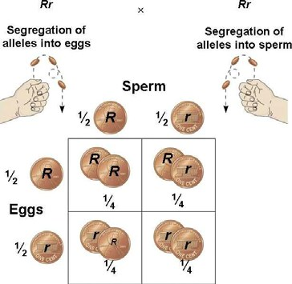
Test Cross Punnett Square:
- You cannot tell by looking at an organism that shows the _________________trait whether it is heterozygous (Rr) or homozygous(RR) for that trait
- To determine the genotype of an organism showing the dominant trait a ___________ would be done.
- ________________= the organism of unknown dominant genotype is crossed with a _________________________________(rr) organism.

IN CLASS PRACTICE PROBLEMS – MONOHYBRIDS (one trait)

Black coat color in guinea pigs is dominant over white coat color. Look at the “Example 1” cross below. This cross shows a hybrid black guinea pig with pure white guinea pig.
P₁ cross: ___________ X ____________
F₁ genotypes:

F₁ phenotypes:

Then try solving “Example 2”.

EXAMPLE 2:
Cross a hybrid black and a hybrid black guinea pig.
Black Trait – _______
White Trait - ______
Hybrid black - ______
Hybrid black -_______
P₁ cross: __ __ x __ __

F₁ genotypes:

F₁ phenotypes:

NOW YOU TRY SOME:

1.) In pigs, the white color (W) is dominant; the black color (w) is recessive. Using Punnett squares, show the expected results of the following crosses.

a) A pure (homozygous) white pig is mated with a black pig.

P₁ cross: __ __ x __ __

F₁ G= _____________________

F₁ P= _____________________

b) Show a cross between two of the F₁ offspring from number 1a. Determine the genotypes and phenotypes of the offspring in the F₂ generations.

F₁ cross: __ __ x __ __

F₂ G= _____________________

F₂ P= _____________________

MONOHYBRID PRACTICE

1. Crossing Guinea Pigs. In Guinea pigs black hair dominates over white. Thus a pure black is represented by BB, a hybrid by Bb, and a white by bb. It should be noted that whenever the recessive trait appears it must be pure. Try working out the following crosses in guinea pigs using the Punnett square method. Determine the genotypes and phenotypes in each
cross.

- homozygous black x homozygous black P cross: __ __ x __ __

- pure white x pure white P cross: __ __ x __ __

- pure black x pure white P cross: __ __ x __ __

- hybrid black x homozygous black P cross: __ __ x __ __

- heterozygous black x heterozygous black P cross: __ __ x __ __

Bikini Bottom Genetics
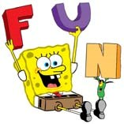
Name __________________________________________ Period: _______ Date: __________ Scientists at Bikini Bottoms have been investigating the genetic makeup of the organisms in this community. Use the information provided and your knowledge of genetics to answer each question.

- For each genotype below, indicate whether it is a heterozygous (He) OR homozygous (Ho).

TT _____ Bb _____ DD _____ Ff _____ tt _____ dd _____

Dd _____ ff _____ Tt _____ bb _____ BB _____ FF _____

  - Which of the genotypes in #1 would be considered purebred? _____________________________

  - Which of the genotypes in #1 would be hybrids? _______________________________________

- Determine the phenotype for each genotype using the information provided about SpongeBob.
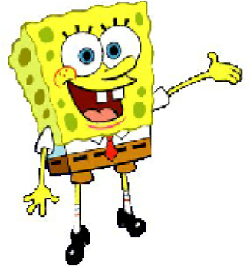
  - Yellow body color is dominant to blue.
YY _________________ Yy _________________ yy _________________
  - Square shape is dominant to round.
SS _________________ Ss _________________ ss _________________
- For each phenotype, give the genotypes that are possible for Patrick.
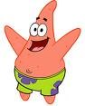
  - A tall head (T) is dominant to short (t).
Tall = ________________________ Short = __________________________
  - Pink body color (P) is dominant to yellow (p).
Pink body = ___________________ Yellow body = _____________________
- SpongeBob SquarePants recently met SpongeSusie Roundpants at a dance. SpongeBob is heterozygous for his square shape, but SpongeSusie is round. Create a Punnett square to show the possibilities that would result if SpongeBob and SpongeSusie had children. HINT: Read question #2!
  - List the genotypes for SpongeBob and SpongeSusie._____________________

  - What are the chances of a child with a square shape? _______ out of _______ or ______%

  - What are the chances of a child with a round shape? _______ out of _______ or _______%

- Patrick met Patti at the dance. Both of them are heterozygous for their pink body color, which is dominant over a yellow body color. Create a Punnett square to show the possibilities that would result if Patrick and Patti had children. HINT: Read question #3!
- List the genotypes of Patrick and Patti _________________________.
- What are the chances of a child with a pink body? _____ out of ____or ______%
- What are the chances of a child with a yellow body? ____out of ______or _______%

6. Everyone in Squidward’s family has light blue skin, which is the dominant trait for body color in his hometown of Squid Valley. His family brags that they are a “purebred” line. He recently married a nice girl who has light green skin, which is a recessive trait.
Create a Punnett square to show the possibilities that would result if Squidward and his new bride had children. Use “B” to represent the dominant gene and “b” to represent the recessive gene.
- List the genotypes of Squidward and Squidward’s new wife. ______________.
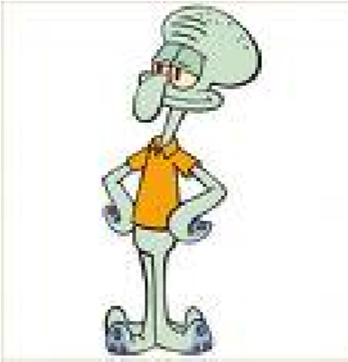
- What are the chances of a child with light blue skin? _______%
- What are the chances of a child with light green skin? ________%
- Would Squidward’s children still be considered purebreds? Explain!

- Assume that one of Squidward’s sons, who is heterozygous for the light blue body color, married a girl that was also heterozygous. Create a Punnett square to show the possibilities that would result if they had children.
    - List the genotypes of Squidward’s son and his wife. _______________________
    - What are the chances of a child with light blue skin? ________%
    - What are the chances of a child with light green skin? _______%

- Mr. Krabs and his wife recently had a Lil’ Krabby, but it has not been a happy occasion for them. Mrs. Krabs has been upset since she first saw her new baby who had short eyeballs. She claims that the hospital goofed and mixed up her baby with someone else’s baby. Mr. Krabs is homozygous for his tall eyeballs, while his wife is heterozygous for her tall eyeballs. Some members of her family have short eyes, which is the recessive trait. Create a Punnett square using “T” for the dominant gene and “t” for the recessive one.
  - List the genotypes of Mr. and Mrs. Krabs. _________________
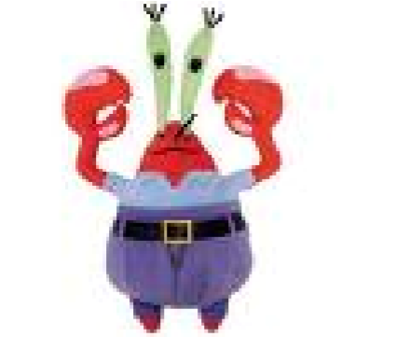
  - Did the hospital make a mistake? Explain your answer

Bikini Bottom Genetics Worksheet #2
Name _________________________________________________ Period: _____ Date: ________
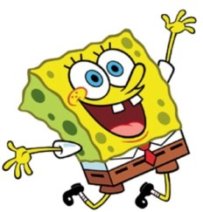
Directions: Use your knowledge of genetics to complete this worksheet.

- Use the information for SpongeBob’s traits to write the phenotype (physical appearance) for each item.

Trait | DOMINANT  Gene |  | RECESSIVE Gene
Body shape
Body shape | Squarepants (S) |  | Roundpants (s)
Body color | Yellow (Y) |  | Blue (y)
Eye shape | Round (R) |  | Oval (r)
Nose style | Long (L) |  | Stubby (l)
        - LL-_____________ e) Rr-_________
        - yy-______________ f) ll- _________
        - Ss-_____________ g) ss- _________
        - RR - ___________ h) Yy -__________

- Use the information in the chart above to write the genotype or genotypes for each trait below.

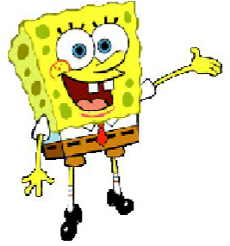
      - Yellow body - ___________ e) Stubby nose - ___________
      - Roundpants - ___________ f) Round eyes - ____________
      - Oval eyes - ______________ g) Squarepants - ___________
d) Long nose - _____________ h) Blue body - ____________
- Using the information in the chart above, determine the genotypes for each of the following:

    - Heterozygous round eyes -_____ c) Homozygous long nose - ______
    - Purebred squarepants - ______ d) Hybrid yellow body - ______
- One of SpongeBob’s cousins, SpongeBillyBob, recently met a cute squarepants gal, SpongeGerdy, at a local dance and fell in love. Use your knowledge of genetics to answer the questions below.

  - If SpongeGerdy’s father is a heterozygous squarepants and her mother is a roundpants, what is her genotype? Complete the punnett square to show the possible genotypes that would result to help you determine Gerdy’s genotype.
  - List the genotypes for SpongeGerdy’s father and SpongeGerdy’s mother. _____________________

c) What is Gerdy’s genotype? _________________________________

d) SpongeBillyBob is heterozygous for his squarepants shape. What is his genotype? ________

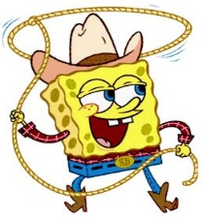
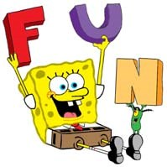

- Complete the punnett square to show the possibilities that would result if SpongeBillyBob & SpongeGerdy had children.
  - List the genotypes for SpongeBillyBob and SpongeGerdy._______________
  - List the possible genotypes and phenotypes for the kids.
G:______________________________________________________
P: ______________________________________________________
  - What is the probability of kids with squarepants? _________ %
  - What is the probability of kids with roundpants? _________ %

DIHYBRIDS (two traits)

Because each parent and offspring are using ______traits, each one should have 4 alleles, _______ for each___________.
Each gamete produced by the P₁ generations will contain 2 alleles, one for each trait.

Example: A plant that is heterozygous for being tall and having green seeds is crossed with a homozygous yellow and short
o Traits = seed color and plant height
o Alleles G =green T = tall
g = yellow t = short

Cross: ____________________

Determine the gametes produced by each parent by using the FOIL method.
-TtGg produces 4 different gametes:______, ______, ______, _______
-ttgg produces only 1 gamete: _______

Phenotypes:

Genotypes:

MENDELIAN GENETICS REVIEW QUESTIONS

Lesson 1 Questions: Introduction to Genetics

- What are two factors that affect who you are?
  - ______________________________________
  - ______________________________________

- __________________________ is the passing of traits from parent to offspring.
- ____________________ is the “Father of Genetics”.
- What organism did Mendel use to conduct his research? ______________________ 5) __________________________ are two forms of a gene (dominant & recessive)
- What is the difference between a phenotype and a genotype?

- How would you write a homozygous dominant genotype (use the first letter of the alphabet ☺) _____
- How would you write a homozygous recessive genotype (use the first letter of the alphabet ☺) _____
- How would you write a heterozygous genotype (use the first letter of the alphabet ☺) _____
- A homozygous genotype can also be called _____________
- A heterozygous genotype can also be called a _____________
- What is the difference between the P generation and the F₁ generation?

- _______________________________ is the study of heredity
- How many chromosomes would a human have in their skin cells? ___________
- How many chromosomes did you inherit from your mom?___________ from your dad? ___________

Lesson 2 Questions: Mendel’s Law’s

- A cross between two hybrids will ALWAYS create what phenotypic ratio?

- The ________________________ is based on the genotype.

- What are Mendel’s three laws?
  - _____________________________________
  - _____________________________________
  - _____________________________________

- ______________________________________ law states that each factor (gene) is distributed (assorted) randomly and independently of one another in the formation of gametes (egg or sperm).
- _____________________________________ law states that when different alleles for a characteristic are inherited (heterozygous), the trait of only one (the dominant one) will be expressed.
- _____________________________________ law states that each genetic trait is produced by a pair of alleles which separate during reproduction.

Lesson 3 Questions: Human Genetics & Punnett Squares

- Are fraternal twins or identical twins more closely related? _________________________________ a. How do you know?

- What sex chromosomes are present for a male? _______________ a female?______________

- Which parent determines the sex of the child? __________________
a. Why?

- In guinea pigs black (B) hair dominates over white. Cross a homozygous black guinea pig with a white guinea pig. What are the genotypic and phenotypic ratios for the F₁ generation and the F₂ generation?

F₁ genotypic ratio:___________________________

F₁ phenotypic ratio:__________________________

F₂ genotypic ratio:___________________________

F₂ phenotypic ratio:__________________________

- How could a guinea pig breeder determine if a black guinea pig is homozygous dominant or heterozygous?

- Suppose that black hair (B) is dominant over blonde hair (b) and brown eyes (E) are dominant over blue (e).
What percent of offspring could be expected to have black hair and blue eyes if the father has black hair (homozygous) and brown eyes (heterozygous) and the mother has blonde hair and blue eyes.

  - Father’s genotype = ______________________________

  - Mom’s genotype = _______________________________

________% black hair & blue eyes

20

DIHYBRID (2 traits) HOMEWORK SET
In a dihybrid cross, when two traits are considered, the number of possible combinations of the offspring increases. Suppose that black hair (B) is dominant over blonde hair (b) and brown eyes (E) are dominant over blue (e).
What percent of offspring could be expected to have blonde hair and blue eyes if:

- The father has black hair (heterozygous) and brown eyes (heterozygous) and the mother has blonde hair and blue eyes.
Genotype of father = BbEe
Genotype of mother = bbee
Complete the cross using the Punnett square. Determine what percent of offspring will have blonde hair and blue eyes.

________% blonde hair & blue eyes

- Both parents have black hair (heterozygous) and brown eyes (heterozygous).
Genotype of father = ________
Genotype of mother = ________
Complete the Punnett square below. Determine what percent of offspring will have blonde hair and blue eyes.

______% blonde hair & blue eyes

DIHYBRID (2 traits) HOMEWORK SET

1. Mendel found yellow seed color was dominant (Y) trait over green (y) in garden peas. He found white seed coat was the recessive (w) trait and black was the dominant (W) trait. What would the F₁
genotype and phenotype be from crossing parents that were pure yellow seed color and black seed coat with pure green seed color and white seed coat?

P cross = ___________ X ____________
F1 Genotype:

F₁ Phenotype:

2. In guinea pigs rough coated (R) is dominant over smooth coated (r) and black color (B) is dominant over white color (b). A rough coated and black guinea pig, whose mother was smooth and white is mated with a smooth, white animal. What are the genotypes and phenotypes of the offspring?

P cross = ___________ X ____________
F₁ Genotype:

Phenotype: F1

3. In squash the color white (W) is dominant over yellow and disk shape (D) is dominant over sphere shape. a) When crossing two homozygous squashes, one white, sphere and the other yellow, disk. Determine the genotypes and phenotypes of the F₁ generation. b) Then determine the phenotypic ratio of the F₂ generation (obtained by crossing the F₁ plants).

P cross = ___________ X ____________
F₁ Genotype:

F₁ Phenotype:

P cross = ___________ X ____________

F₂ Phenotype:

4. Determine the genotype and phenotypes of the offspring, if one of the F₁ plants in #3 is crossed with a yellow, homozygous disk plant.

P cross = ___________ X ____________
Genotype:

Phenotype:

5. In garden peas, a yellow (Y) seed with smooth (S) coat dominates green(y) and wrinkled (s) seeds. Determine the genotypes and phenotypes of the offspring in the following crosses:
a. A plant that is heterozygous for yellow seed color and homozygous for a wrinkled coat is crossed with a plant that is green and homozygous for a smooth coat.
P cross = ___________ X ____________
Genotype:

Phenotype:

P cross = ___________ X ____________
Genotype:

- A plant that is heterozygous for yellow seed color and heterozygous for a smooth coat is crossed with a plant that is green and homozygous for a smooth coat.

Phenotype:

- A plant that is heterozygous for yellow seed color and has a wrinkled coat is crossed with a plant that is green and has a wrinkled coat.
P cross = ___________ X ____________
Genotype:

Phenotype:

MORE GENETICS REVIEW QUESTIONS:

- Any characteristic that can be passed from parent to offspring:__________________________
- The study of heredity:_______________________________________
- The physical feature resulting from a genotype:_____________________________________
- A cross that only involves a single trait:_____________________________________________
- A tool used to solve genetic problems based on probability:_________________________________
- The passing of traits from parent to offspring: _______________________________
- A gene combination for a trait:______________________________________________
- States that each factor (gene) is distributed (assorted) randomly and independently of one another in the formation of gametes (egg or sperm): _______________________________________________

- The father of modern genetics:________________________________________
- A cross involving two traits:___________________________________
- Two forms of a gene (dominant & recessive): ______________________________________
- A combination of genes with one dominant & one recessive allele: ___________________________
- The resulting offspring of the parent organisms or P₁: __________
- When different alleles are inherited(hybrid), only the dominant one will be
expressed:________________________________________________________
- Gene that shows up less often in a cross; represented by a lowercase letter:____________________
- A factor that can affect how genes are expressed: ________________________________________
- Parent organisms are referred to as the: ________
- Determines the sex of the child: _____________________________________
- Each genetic trait is produced by a pair of alleles which separate during reproduction:
_____________________________________________________________________

Mendelian Genetics Vocabulary:

- Trait = any characteristic that can be passed from parent to offspring

- Heredity = passing of traits from parent to offspring

- Genetics = study of heredity

- Gregor Mendel = Father of Genetics; experimented using pea plants

- Alleles = two forms of a gene (dominant & recessive)

- Dominant = stronger of two genes expressed in the hybrid; represented by a capital letter (R)

- Recessive = gene that shows up less often in a cross; represented by a lowercase letter (r)

- Genotype = gene combination for a trait (ex: RR, Rr, rr)

- Phenotype = the physical feature resulting from a genotype (e.g. tall, short)

- Homozygous genotype = gene combination involving 2 dominant or 2 recessive genes (ex: RR or rr); also called pure

- Heterozygous genotype = gene combination of one dominant & one recessive allele (ex: Rr); also called hybrid

- Law of Dominance = states that when different alleles for a characteristic are inherited (heterozygous), the trait of only one (the dominant one) will be expressed. The recessive trait's phenotype only appears in true-breeding (homozygous) individuals

- Law of Segregation = states that each genetic trait is produced by a pair of alleles which separate (segregate) during reproduction

- Law of Independent Assortment = states that each factor (gene) is distributed (assorted) randomly and independently of one another in the formation of gametes (egg or sperm)
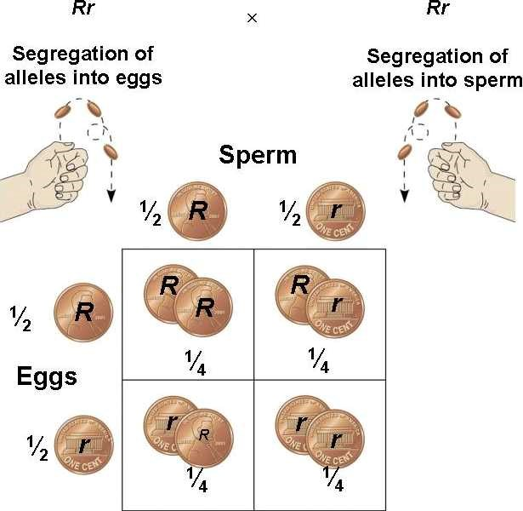
- Sex-linked traits = traits that occur more frequently in one sex than the other because the genes are on the sex chromosomes

- Monohybrid cross = cross involving a single trait

- Dihybrid cross = cross involving two traits

- Punnett Square = tool used to solve genetics problems; based on probability

