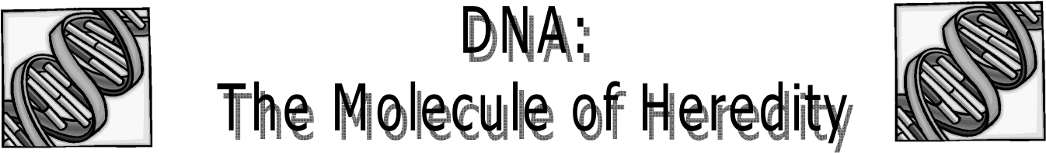
Name: _____________________________________________Period:______Date:__________
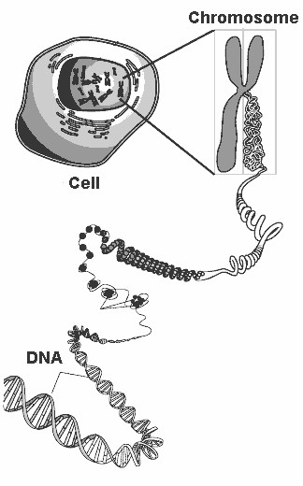
Gene
__________________= passing on of characteristics from parents to offspring
• How?__________________________________!
I. DNA, Chromosomes, Chromatin, and Genes
  - _________= blueprint of life (has the instructions for making an organism)
  - _____________________= uncoiled DNA
  - _____________________= coiled DNA
  - You have 46 chromosomes or 23 pairs in the ________________of each body cell.
o 23 from mom and 23 from dad
• ___________= a segment of DNA that codes for a protein, which in turn codes for a trait (skin tone, eye color, etc); a gene is a stretch of DNA.
o There is a gene for every protein your body has to make.

DNA
- Deoxyribonucleic Acid
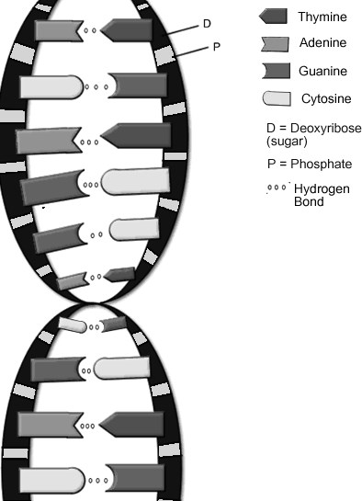
- Located in the _____________of the cell
- Codes for your __________
- ___________________- discovered DNA in 1928
- SHAPE & STRUCTURE:
o Made from ___________________
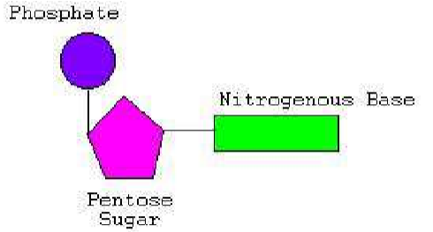
- DNA nucleotide components:
      - ______________________ (simple sugar)
      - _____________________________
      - ____________________________
    - Shaped similar to a twisted ladder…aka______________________!
    - The uprights of this ladder are composed of
_________________and
____________________________
o The rungs are composed of 2 bases (a purine and pyrimidine) joined at the center by weak ___________________bonds.
- _______________________= adenine (A) and guanine (G)
- _______________________= thymine (T) and cytosine (C)
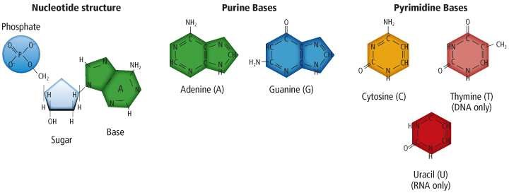

  - Direction of the two DNA strands:
    - ________= orientation of the sugar has carbon on the left
    - ________= orientation of the sugar has carbon on the right
    - Ex: (look at pic. below) the __________stand is oriented 5’-3’ and the ___________________strand is opposite 3’-5’
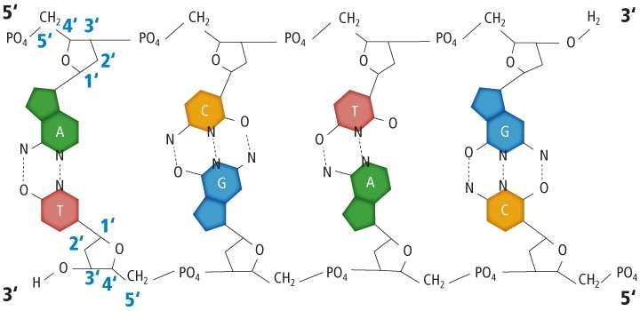

- BASE PAIRING:
    - 1962: _________________and ______________________discovered that A always bonds with T and C bonds with G
    - ____________________and ___________________are complementary. They both require _______ hydrogen bonds.
    - __________________and _________________are complementary. They both require _______ hydrogen bonds.
    - ___________________of bases determines the genetic information and is unique to each organism
    - If the organisms are closely related the more _________the DNA nucleotide sequence would be
    - The rungs of the ladder can occur in any order (as long as the _______________ is followed)

If the order of base pairs in a DNA molecule is changed, what might occur?
            - __________________________
    - DNA is made of ______________strand of nucleotides.
    - The DNA from each side is ______________________to the other side.
    - If you know the sequence of one side you can determine the sequence of the other side.
    - Ex: What is the complementary strand to this DNA molecule?
A A T C G T A C C G A T
_____________________

- 2 FUNCTIONS OF DNA:
    - To direct and control ______________________
    - __________________________= reproducing an exact copy of DNA so that the information can be passed on during cellular division

- DNA REPLICATION:
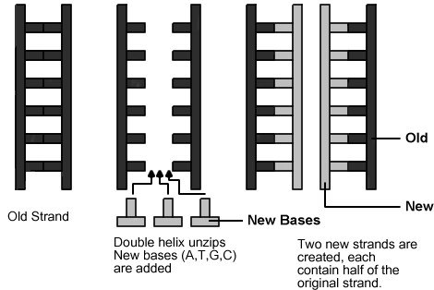
    - ______________________is the process where DNA makes a copy of itself
    - ____________________________________________ _________= parental strands of DNA separate, serve as a template, and produce DNA molecules that have one strand of parental DNA and one strand of new DNA.
      - Helps_____________________the number of copying errors
      - 3 stages: _________________________, base pairing, and joining
o Why does DNA need to replicate?
- Cells divide for an organism to grow or reproduce; every new cell needs a copy of the DNA or instructions to know how to be a cell.
- DNA replicates right before a cell divides (______________).
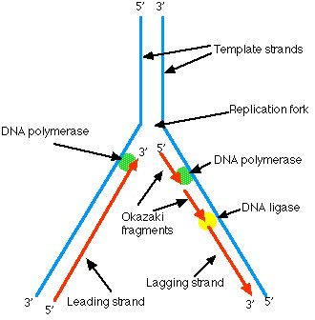
- REPLICATION STEPS:
  - Unwinding: DNA helicase (an ___________) unwinds and unzips the double helix and begins to break the H bonds between the nitrogen bases.
  - Base pairing: ________________________(an enzyme) runs along the parent chain of DNA in the 3’5’ direction and bonds free floating nucleotides to the parent (original) chain-- based on base pairing rules.

- The newly assembled strand is called a _____________________________of nucleotides and reforms the double helix.
- Each new strand is a ____________________________of parent strand.
  - Because DNA synthesis can only occur 5' to 3', a second type of
_______________________________ binds to the other template strand as the double helix opens.
      - DNA polymerase synthesizes discontinuous segments of nucleotides (called _____________________________________).
  - Joining: Another enzyme, _______________________ then bonds these Okazaki fragments together into the ________________________________.
  - Therefore, the result is the formation of ______ DNA molecules, each of which is identical to the original DNA molecule.

- What makes up our characteristics?
  - If you have brown hair, what makes it brown, as opposed to blonde, or red?
    - A pigment called______________, a_____________, is what you see as “brown” in the hair.
  - What makes you tall or short?
    - The lengths of your bones are made up of a framework of__________________.
  - So, if heredity material controls your traits, and your traits are made of proteins, then shouldn’t heredity material control the making of proteins?
    - This is exactly what _________ does!!

    - The order of __________________ (A, T, C, G) determines the type of _____________that is assembled.

    - If the order of bases is accidentally changed, then ____________________occur which can change the proteins that need to be made!

- THE LINK BETWEEN DNA & PROTEINS:
  - In the _________________of each cell, there are tiny organelles where proteins are assembled. What are they called?
o __________________
  - If a hair cell needs to make melanin. How do the instructions to synthesize this protein get from the DNA to the ribosome?
o Something must carry these instructions from the nucleus to the ribosomes in the cytoplasm. This “messenger” molecule is___________!!

A. RNA (Ribonucleic acid):

  - Comparing the STRUCTURE of DNA to RNA:
STRUCTURE: | DNA | RNA
Strands of nucleotides
Sugars
Nitrogen Bases
  - 3 kinds of RNA:

    - __________– messenger RNA (see picture below)
        - Structure: _______________
        - Function: Carries the __________message from the nucleus to the ribosomes
o ___________= set of three nitrogen bases representing an amino acid

    - __________– transfer RNA (see picture below)
        - Structure: has an _________________that is a complement to the
__________________at one end and an _____________at the other end
        - ___________________________ shaped
        - Function: Carries the _______________to the ribosomes for protein production.

    - _________– ribosomal RNA
        - Structure: A part of ribosome
        - Function: Creates the ____________________between the amino acids during protein production.
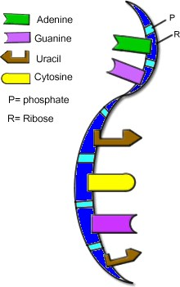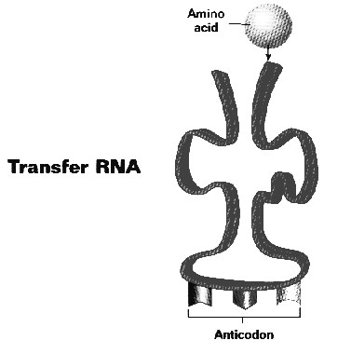

mRNA
- PROTEIN SYNTHESIS Overview:
  - The _______________created is determined by the base arrangement in DNA (code sentence)
  - ________transfers this information to__________, which carries the code to the ribosome where tRNA decodes it. ________ anticodons pair with mRNA’s codons. Then _________forms peptide bonds between _______________to form a _______________

  - The process of protein synthesis is broken down into two sub-processes: transcription and translation.
      - _____________________= is the process through which _________transfers the code to _________
Takes place in the ______________
      - _____________________= is the process through which _________is decoded and forms a ________________
Takes place at a ________________

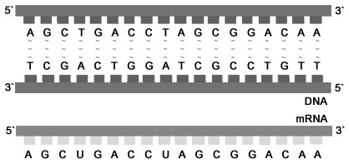
          - __________________________ (enzyme) attaches at a specific location on DNA
A.
TRANSCRIPTION- From DNA to mRNA:

          - The enzyme then causes the DNA strands to separate from one another and allow one of the DNA strands to be
________________
          - mRNA nucleotides are floating around in the
nucleus find their complement on the DNA stand and _______________together. This
is possible due to the base-pairing rules.

          - Once the DNA segment has been copied by the mRNA bases, the mRNA strand separates from the DNA

          - The mRNA (messenger RNA) leaves _________________through a nuclear pore & enters the _________________ goes to _________________for protein synthesis
          - DNA zips up again to create the original double helix.

WHY is TRANSCRIPTION Important?
  - It is needed to get the __________________out of the _____________so the ribosomes know what ________________to make!
  - Without transcription, the ribosome would have no idea what proteins the body needed and would not make any.

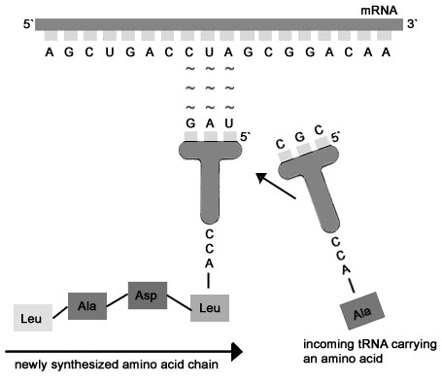
  - You could ________replace the hair that we lose every day; could NOT grow long fingernails; be able to fight off diseases; cells would fall apart because the proteins were not being_______________________!!

B. TRANSLATION (Protein Synthesis)-From RNA to Protein:

- First codon of mRNA attaches to ________________.
- ______ (transfer RNA)- each carries a specific amino acid; the tRNA anti-codon will pair up with its complementary mRNA codon.
- When the 1st and 2nd amino acid is in place, the rRNA joins them by forming a____________________. As the process continues, the amino acid chain is formed until a stop codon comes along.
- The tRNA is ________________________ to find another of the same amino acid so the process can occur again and again.
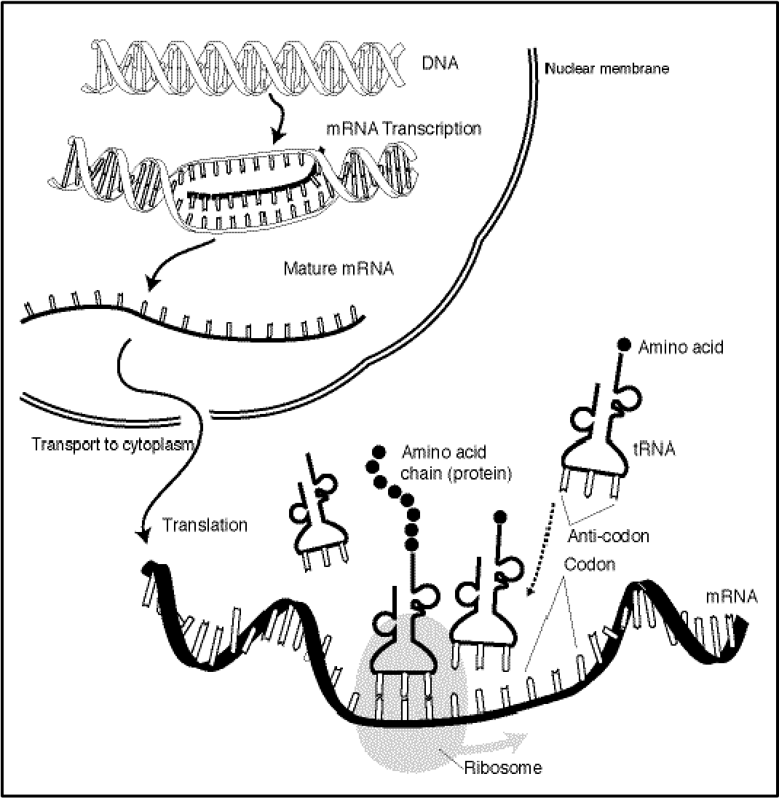
- The protein chains are then transported to other areas of the body that need them.

- WHY is TRANSLATION Important?

- Makes all the ______________that the body needs

- Without translation, proteins wound not be made and we could not replace the
proteins that are depleted or damaged

Codons and amino acids
You will need to look up the mRNA codon and amino acid that corresponds to it using a table or a wheel (see below)

Special Codons
There are 2 special codons on the mRNA.
- Start or initiation codon = ___________
  - Tells where a protein will begin
- Stop or termination codon – ___________, ___________, ___________________
  - Tells where a protein ends

C. SUMMARY of PROTEIN SYNTHESIS:
Below you will find the base sequence of a single strand of DNA. Please fill in the complimentary bases of mRNA, tRNA, and the correct amino acid sequence.

* NOTE: mRNA and tRNA never have ______ in the sequence! Always use the ________strand to code for the_____________________.

DNA T A C T T G C A T G G A A T G G T A A C G G T A A C T
code

mRNA ______________________________________________________________
code

tRNA ______________________________________________________________
anticodon

Amino __________________________________________________________________________
Acids

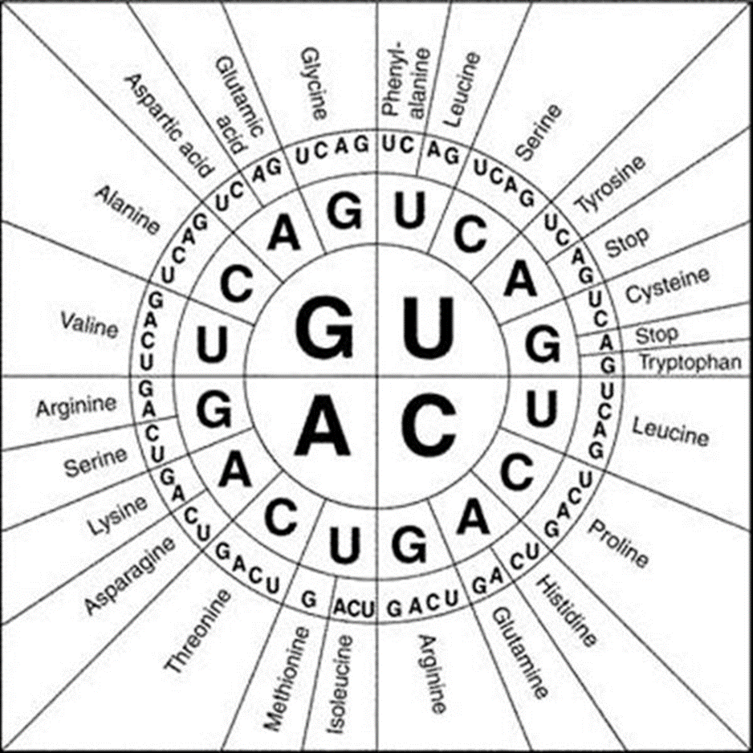

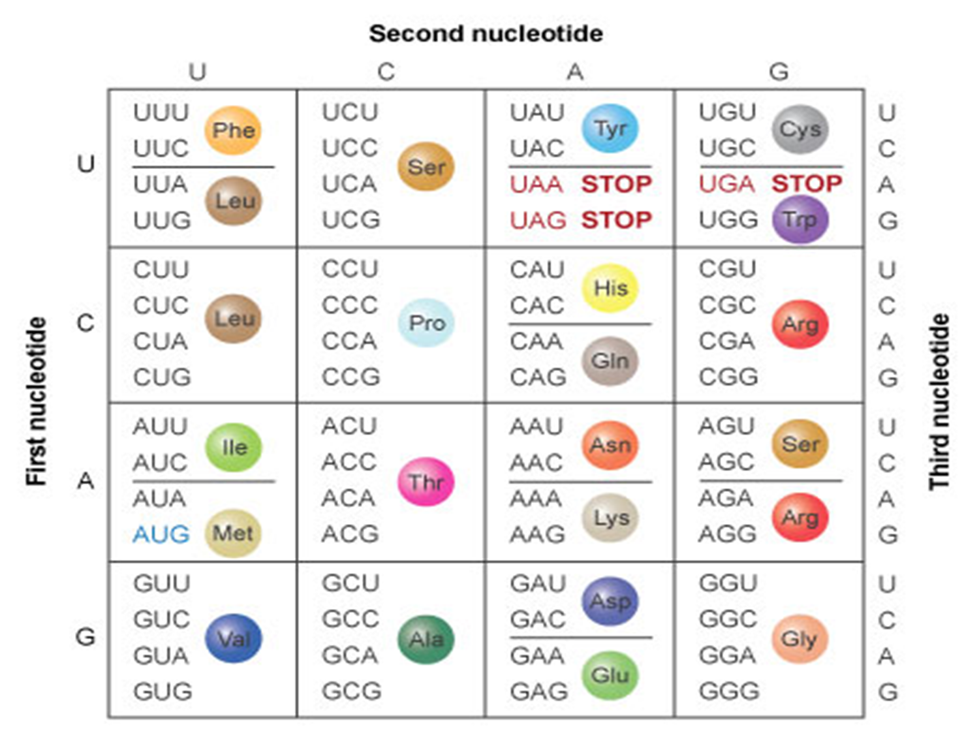

DNA & DNA Replication Worksheet

- What does DNA stand for?_________________________________________
- Where in a cell is DNA found?_______________________
- What is the difference between chromatin and chromosomes?

- How many PAIRS of chromosomes does a human have in their skin cells?________
- A segment of DNA that codes for a protein is called a ____________________.
- What are the three parts of a DNA molecule? Label the three parts of a DNA molecule in the picture provided.
  - _____________________________________
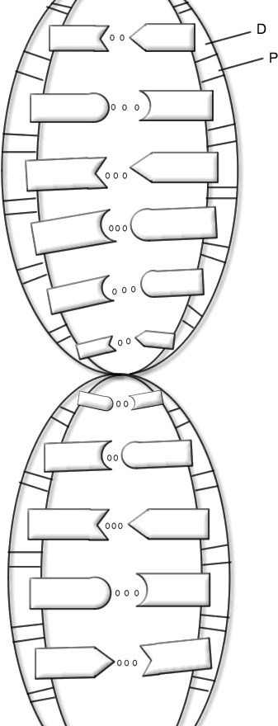
  - _____________________________________

  - _____________________________________
- What 4 bases make up DNA molecules?__________________________
- Scientifically, describe the shape of a DNA molecule.________________________________
- What type of bond holds together the nitrogen bases?____________________
  - Label the hydrogen bond in the picture
  - How many hydrogen bonds are found between A-T?_____ C-G?_____
- Who discovered DNA in 1928? ______________________________
- What scientists are credited with the “base-pairing” rules?
  - ________________________________
- What are the base pairing rules?

- Write the complementary strand to this DNA molecule on the line.
G A T C C A T G A G T T A C

_________________________
- What is the importance of the order of base pairs in a DNA molecule? (Hint: what might happen if the order of the base pairs were changed?)

- When does DNA replicate? _________________________________
- What type of replication is DNA replication? ___________________________________________ a. Why?

- During DNA replication, what causes the hydrogen bonds to break?__________________________
  - What happens after the hydrogen bonds are broken?

- After free floating nucleotides are bonded to their complement, what name is given to the newly assembled strand? ________________________________________________

- DNA synthesis can only occur (3’-5’ or 5’-3’) so a second type of DNA polymerase binds to the other template strand as the double helix opens.

- DNA ligase bonds ___________________________fragments together forming the ________________________ strand.

- What are the 2 types of pyrimidines?
  - ______________________________________
  - _____________________________________

- What are the 2 types of purines?
  - _______________________________________
  - ________________________________________

Protein Synthesis Review Worksheet

- How are DNA and mRNA alike?

- How are DNA and mRNA different? Fill in the table below.
DNA |  | mRNA
 | Shape
 | Nitrogen bases
 | Sugars
 | Location

Transcription: DNA to mRNA:

- How many strands of mRNA are transcribed from the two “unzipped” strands of DNA? __________

- If the following were part of a DNA chain, what mRNA bases would pair with it to transcribe the DNA code onto mRNA? G-G-A-T-C-G-C-C-T-T-A-G-A-A-T-C
____________________________________
- If DNA is described as a double helix, how should mRNA be described? ____________________

- How are the accuracy of DNA and mRNA codes assured? _______________________________
Translation: mRNA to PROTEIN:
- Name and describe the three types of RNA’s involved in protein synthesis?

- What is located at EACH end of a tRNA molecule? ________________________________________
- Where must an mRNA attach before protein production can begin?________________________
- How many bases are needed to specify an mRNA codon?__________
- If a strand of mRNA contain the sequence, U-A-G-C-U-A-U-C-A-A-A-U, what tRNA anticodons would be needed to translate the sequence?_____________________________
- How does mRNA get out of the nucleus? _______________________________________________
- What is the difference between an amino acid and a protein?_________________________________ __________________________________________________________________________________
- What type of bond is formed between amino acids?_____________________________

Protein Synthesis Flow Chart

Directions: Fill in the flow chart below, using the following words: Amino acids, mRNA, mRNA codon, nucleus, nuclear pore, peptide bonds, ribosome, transcription.

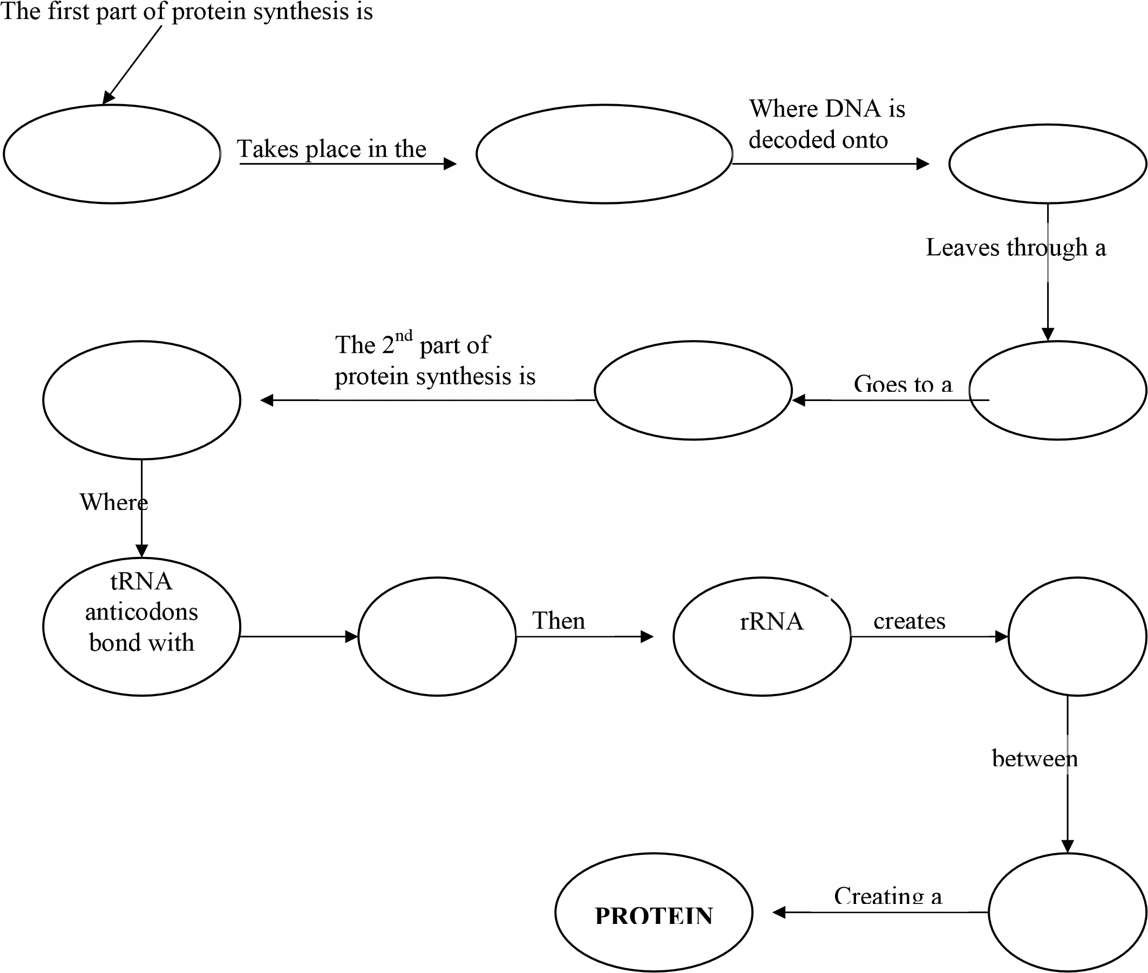

Organizing Protein Synthesis
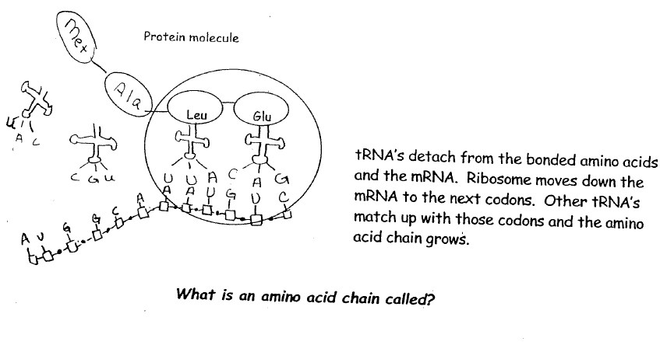
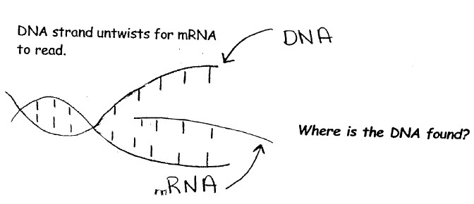
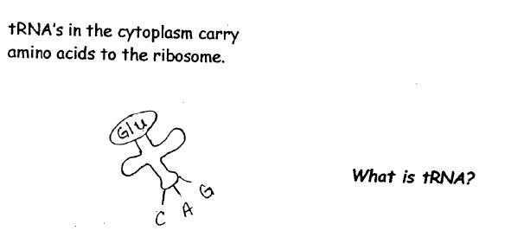
Directions: Number the following pictures (#1-6) along the left hand side in the correct order of how protein synthesis takes place. Then answer the bolded question in each of the 6 sections.

#
_______
#
_______
#
_______

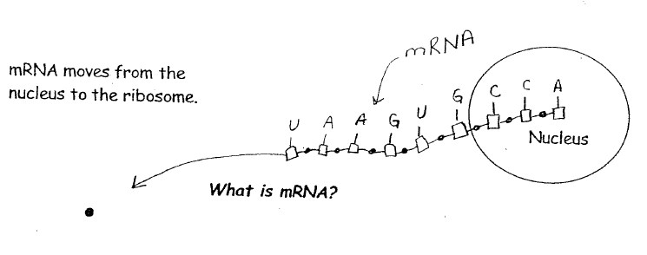
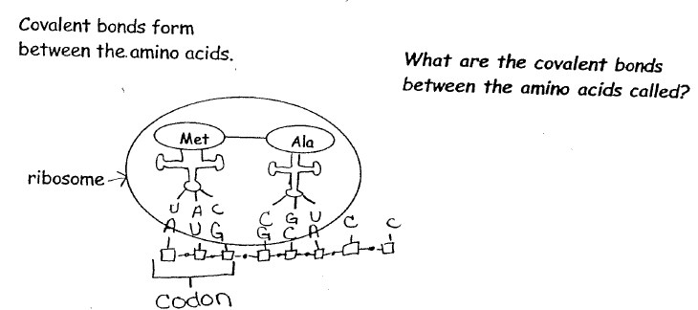
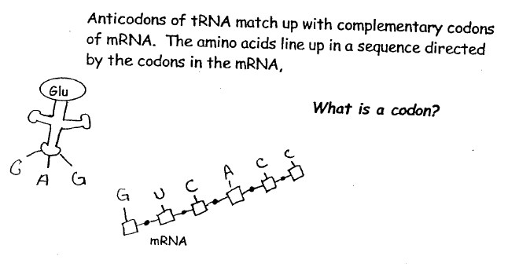

#
_______
#
_______
#
_______

Outlining the Steps of Protein Synthesis
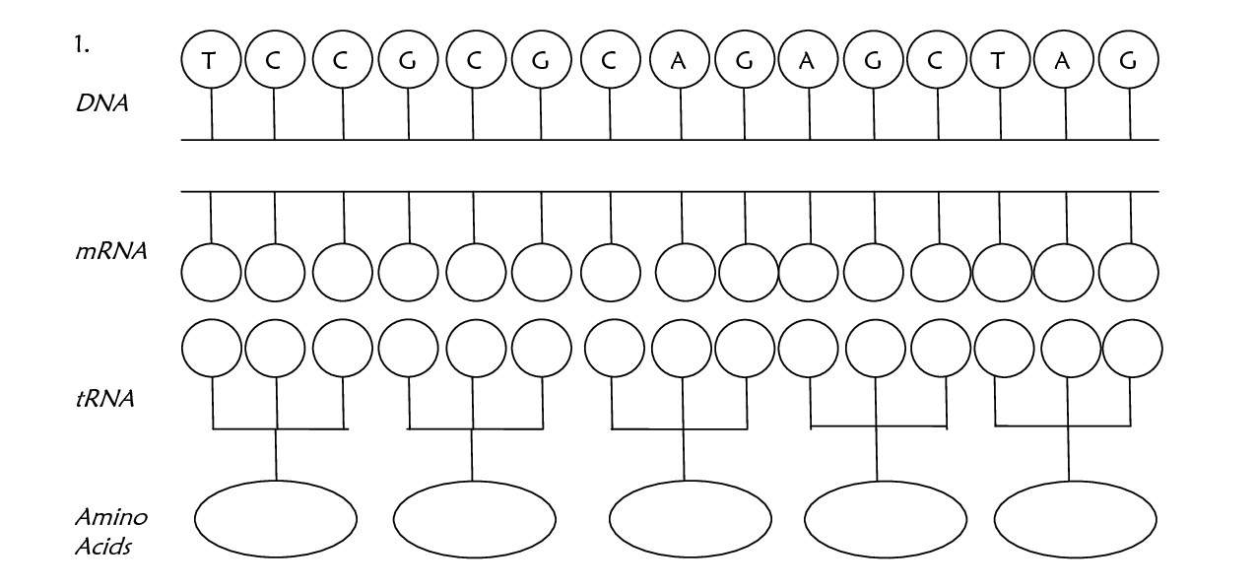
Directions: Transcribe DNA mRNA. Then determine the anticodons in tRNA & finally use your amino acid chart to determine the 5 amino acids.

Directions: Complete the following chart by comparing the 3 types of genetic material.
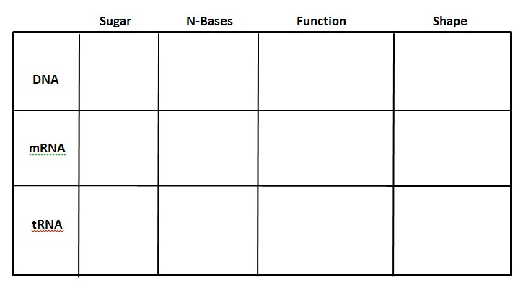
Directions: Label all of the structures in the diagram below.

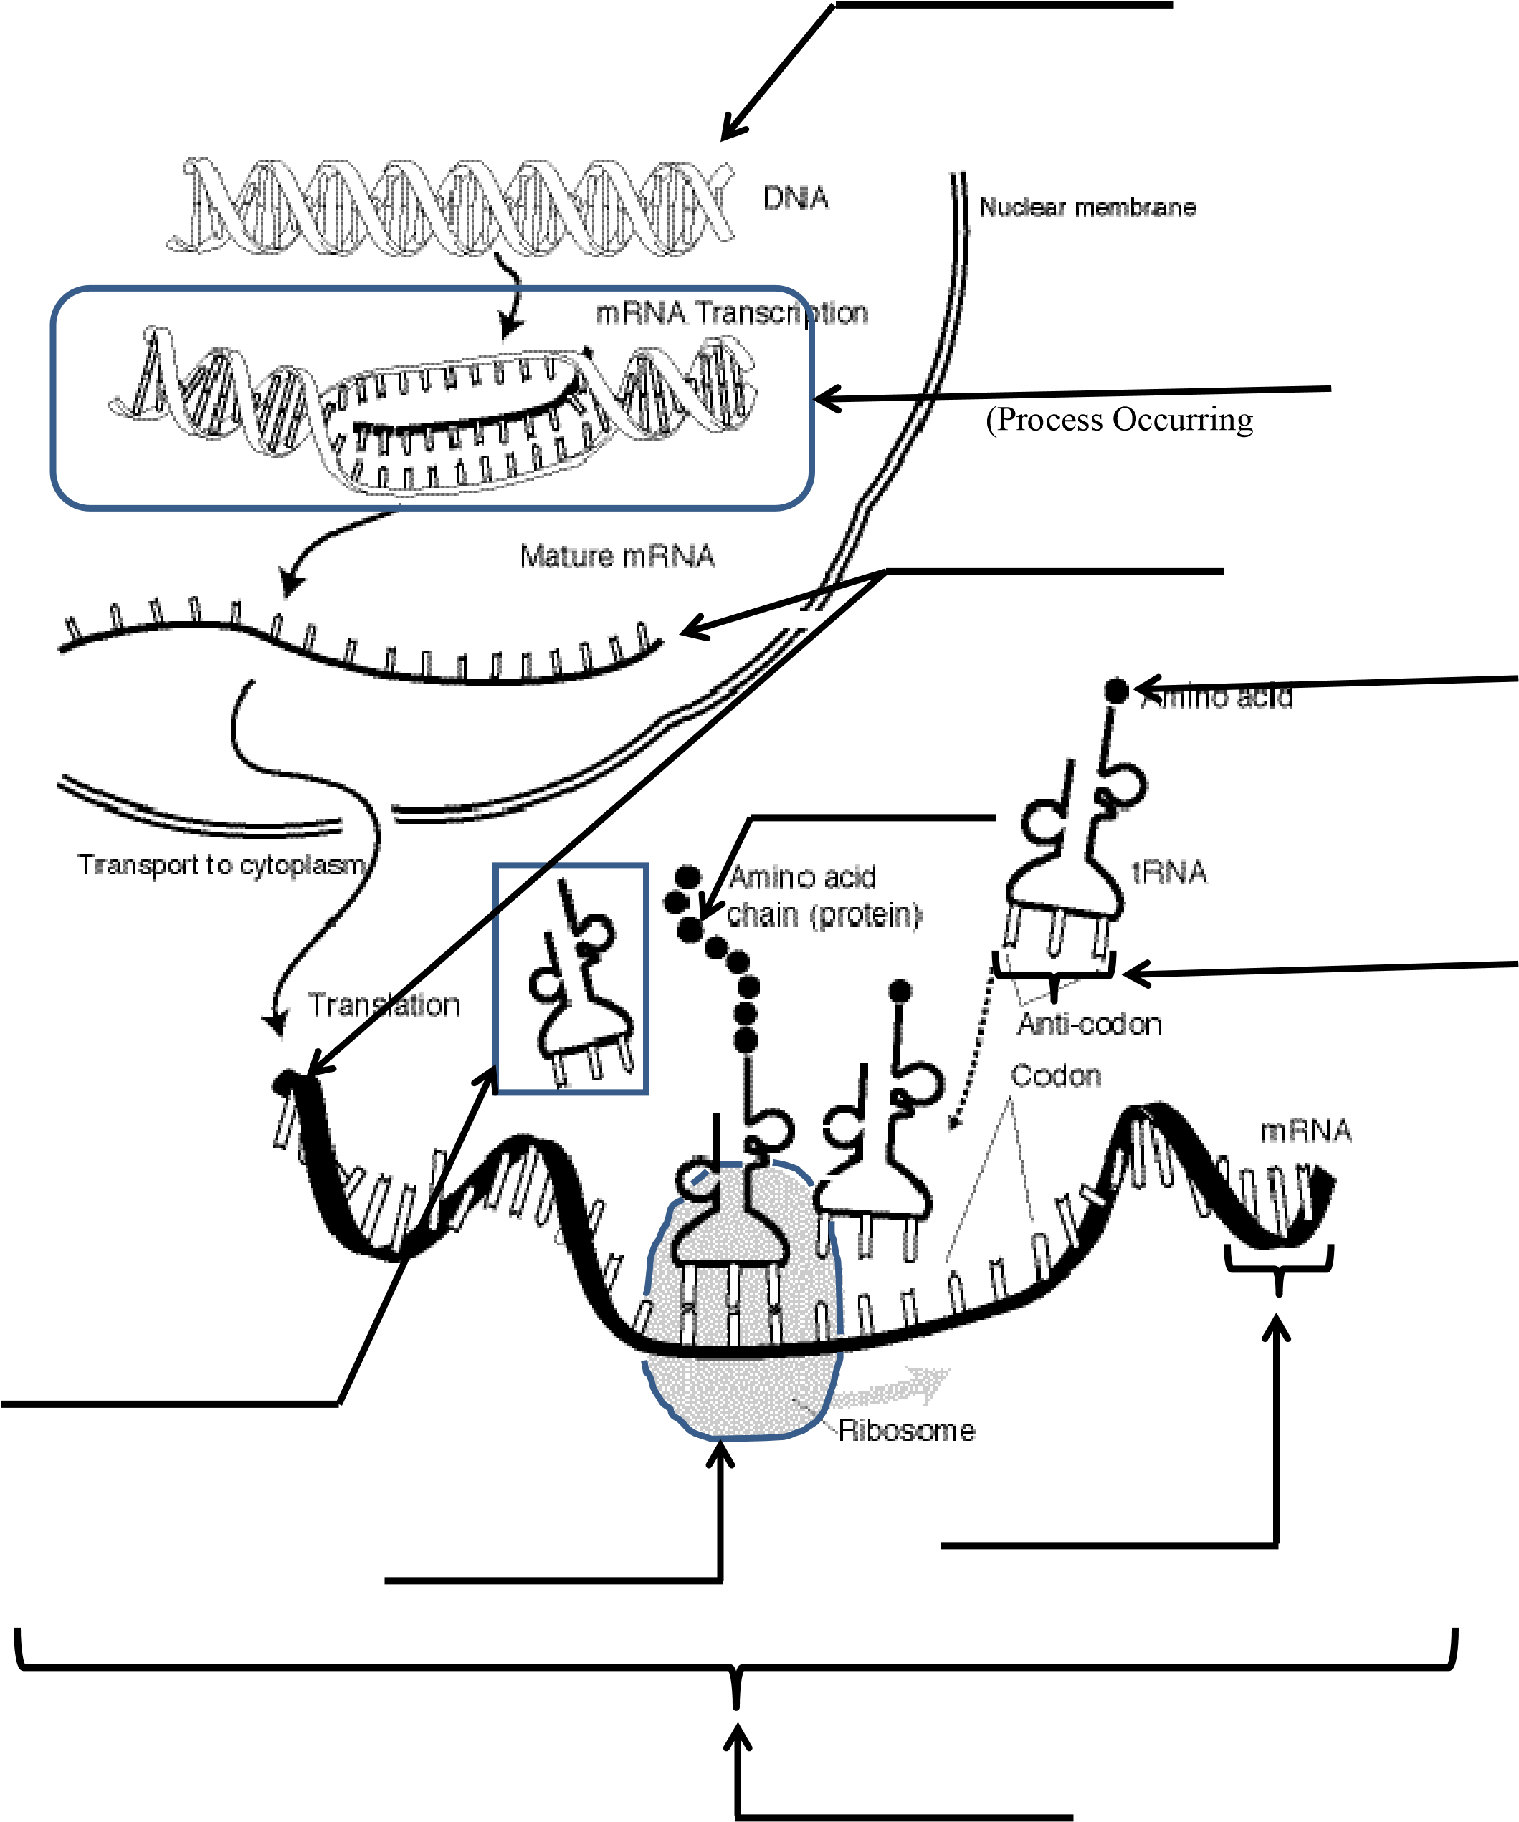

(Process Occurring

DNA & Protein Synthesis Review Worksheet

- A _________________________ is a segment of DNA that codes for a protein.
- __________________________________________ is uncoiled DNA.
- __________________________________________ is coiled DNA.
- _________________________________________ is the enzyme that runs along the parent chain of DNA and bonds free floating nucleotides to those of the parent (original) chain-- based on base pairing rules.
- ____________________________________ are short segment of DNA synthesized discontinuously in small segments in the 3’-5’ direction by DNA polymerase.

- A __________________________ is a set of three nitrogen bases representing an amino acid.
- _______________________________________ is the DNA strand that is continuously built by the addition of nucleotides to the 3’ end during replication.
- ___________________________________________ is the DNA strand that is discontinuously built into small Okazaki fragments during replication.
- __________________________________________ is the enzyme that chemically links Okazaki fragments together.
- A _______________________________ is a polymer made up of amino acids.
- During ___________________________________________________________, parental strands of DNA separate, serve as a template, and produce DNA molecules that have one strand of parental DNA and one strand of new DNA.
- _________________________is the process through which mRNA is decoded and forms a protein.
- _________________________ is the process through which DNA transfers the code to mRNA.
14) ___________________________________ is the sugar in RNA.
- _______________________________________ is the sugar in DNA.
- _______________________________ are 3 nitrogen bases that are complement to the mRNA codon.
- The order of bases in a molecule of mRNA is determined by the sequence of _________________________ in the DNA.
- What are the nitrogen bases for DNA?_______________________________
- What are the nitrogen bases for mRNA?______________________________
20) What are the 3 parts that make up a DNA nucleotide?
  - ________________________________________
  - ________________________________________
  - ________________________________________
21) What are the 3 parts that make up a mRNA nucleotide?
  - ________________________________________
  - ________________________________________
  - ________________________________________
22) What is the function of mRNA?

- What is the function of tRNA?
- What is the function of rRNA?

- Where are proteins made? ________________________________

- What scientists are credited with the “base-pairing” rules? ___________________
- What type of bonds hold together the nitrogen bases in a DNA molecule? _________
- Where in a cell can mRNA be found? __________________________
29) True or False: DNA can leave the nucleus.
- What is the difference between DNA replication and protein synthesis?
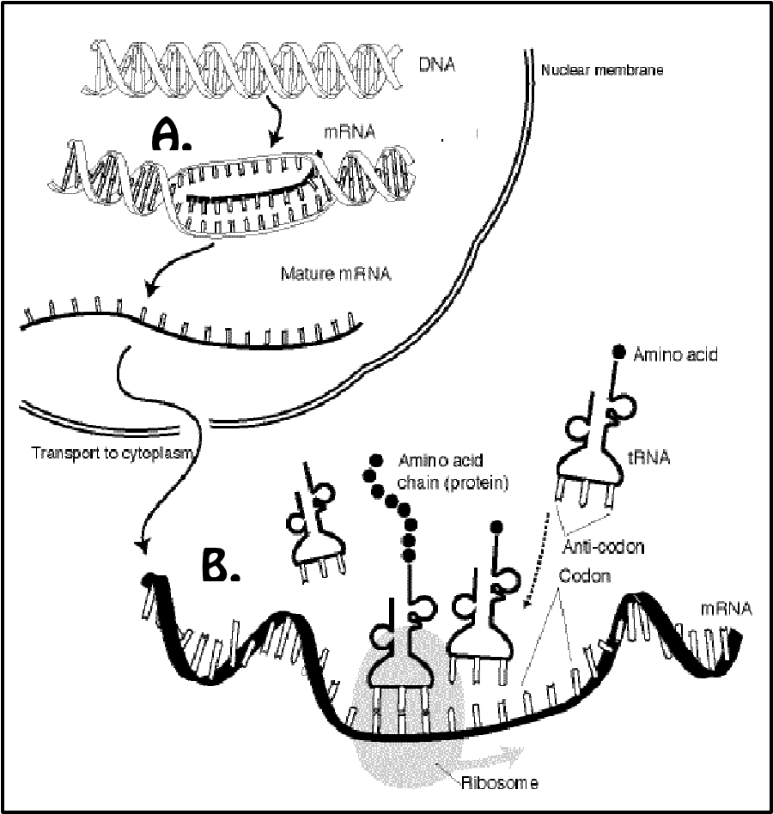

- Look at the diagram on the right.
  - What process is occurring at “A”?
_______________________________
  - What process is occurring at “B”?
_______________________________
- What was the purpose of the lysis solution used during the DNA extraction lab?

- Identify the following molecule. ______________
  - Label the 2 parts of the molecule below.
B._____________________________

A.
____________ _________

- Using the following DNA sequence, complete the process of protein synthesis. DNA strand: TAC GGA CAC TTG

mRNA codon: _____ _____ _____ _____

tRNA anticodon: _____ _____ _____ _____

Amino acids: _____ _____ _____ _____
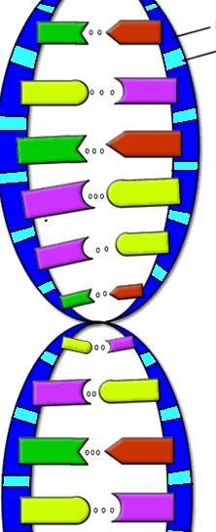
DNA & Protein Synthesis Vocabulary:

- DNA = blueprint of life (has the instructions for making an organism)

- Chromatin = uncoiled DNA

- Chromosome = coiled DNA

- Gene = a segment of DNA that codes for a protein, which in turn codes for a trait (skin tone, eye color, etc); a gene is a stretch of DNA

- Purines = adenine (A) and guanine (G)

- Pyrimidines = thymine (T) and cytosine (C)

- Nitrogen bases = A, T, C, G

- Replication = process where DNA makes a copy of itself

- Semiconservative replication = parental strands of DNA separate, serve as a template, and produce DNA molecules that have one strand of parental DNA and one strand of new DNA.

- DNA polymerase =(enzyme) runs along the parent chain of DNA and bonds free floating nucleotides to those of the parent (original) chain-- based on base pairing rules

- DNA helicase = enzymes that unwinds and unzips the parental DNA molecule

- Okazaki fragment = short segment of DNA synthesized discontinuously in small segments in the 3’5’ direction by DNA polymerase.

- DNA ligase = enzyme that chemically links Okazaki fragments together

- Leading strand = DNA strand that is continuously built by the addition of nucleotides to the 3’ end during replication

- Lagging strand = DNA strand that is discontinuously built into small Okazaki fragments during replication

- Ribose = sugar in RNA

- Uracil = nitrogen base of RNA

- RNA = Ribonucleic Acid

- mRNA = messenger RNA; Structure: single stranded; Function: Carries the DNA message from the nucleus to the ribosomes

- tRNA = transfer RNA; Structure: has an anticodon that is a complement to the mRNA codon at one end and a amino acid at the other end; Function: Carries the amino acids to the ribosomes for protein production.

- rRNA = ribosomal RNA; Structure: Apart of ribosome; Function: Creates the peptide bonds between the amino acids during protein production.

- Transcription = is the process through which DNA transfers the code to mRNA

- Codon = set of three nitrogen bases representing an amino acid

- Amino acid = building blocks of a protein

- Translation = is the process through which mRNA is decoded and forms a protein

- Ribosomes = tiny organelles where proteins are assembled

- Peptide bond = a covalent bond that holds amino acids together in a protein

- Protein = a polymer made up of amino acids

- Anticodon = 3 nitrogen bases that are complement to the mRNA codon

- Protein synthesis = forming proteins based on information in DNA and carried out by RNA

- Polypeptide chain = a chain of amino acid linked together by peptide bonds

