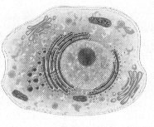
UNIT REVIEW: Cellular Structure & Function
____1) Which molecule is found in a cell’s membrane and prevents the fatty acid tails from sticking together?
a) keratin b) collagen c) protein d) cholesterol
____2) Not all substances can cross the cell membrane, for this reason, the cell membrane is said to be a) a barrier b) selectively permeable c) membrane bound d) a cell wall
____3) Provides structure and support in plant cells:
a) nuclear envelope b) a cell membrane c) cell wall d) ribosomes
____4) Microfilaments and microtubules
- contain digestive enzymes c) are sites of protein synthesis
- function in cell structure and movement d) are sites of photosynthesis

____5) The cell organelle that processes and packages lipids and proteins is the ______________.
a) mitochondria b) ribosomes c) Golgi apparatus d) ER

____6) The cell organelle that digests molecules, old organelles, and foreign substances is the _______. a) mitochondria b) smooth ER c) Golgi apparatus d) lysosome
____7) The shape of the cell depends on its _______.
a) location b) structure c) function d) size
____8) A prokaryote has __________________.
a) a nucleus b) a cell membrane c) membrane bound organelles d) All of the above
____9) The first person to observe and describe microscopic organisms and living cells was _________. a) Robert Hooke b) Rudolf Virchow c) Anton Leeuwenhoek d) Theodor Schwann
____10) The movement of PARTICLES from an area of higher concentration to an area of lower concentration
is called _____________________.
a) osmosis b) diffusion c) isotonic d) kinetic energy
____11) The osmotic effect in plants is known as ____________________.
- diffusion b) plasmolysis c) capillary action d) turgor pressure
____12) One difference between eukaryotic and prokaryotic cells is that ONLY: a) prokaryotic cells are surrounded by a cell membrane
b) prokaryotic cells have a nucleus
c) eukaryotic cells have genetic information
d) eukaryotic cells have membrane bound organelles
____13) The organelle that organizes protein synthesis is the _____________.
a) mitochondrion b) ribosome c)centriole d) lysosome
____14) After a protein is made by a ribosome, where will it most likely go next?
a) rough ER, nucleus b) rough ER, smooth ER c) rough ER, Golgi d) nucleus, lysosome
____15) The part of the cell that regulates movement of substances into and out of the cell is the _____. a) nucleus b) cell membrane c) golgi apparatus d) mitochondrion
____16) Cells that have high energy requirement generally have many _____________.
a) nuclei b) flagella c) mitochondria d) microfilaments
____17) A solution in which the concentration of dissolved substances (solutes) is HIGHER than the concentration inside the cell.
a) ionic b) isotonic c) hypotonic d) hypertonic
____18) Control center for all cell functions is called the _______________.
a) nucleus b) nucleolus c) mitochondria d) Golgi apparatus
____19) Cell walls are composed of ________________.
a) protein b) cellulose c) monosaccharides d) lipids
____20) The gelatin-like aqueous fluid that organelles are bathed in is the _________________ a) crista b) nucleolus c) cytoplasm d) centromere
____21) Organelle that converts sunlight, CO₂ and water into sugars (photosynthesis) is called a ___.
a) ribosome b) lysosome c) chloroplast d) vacuole

____22) The cell organelle that transfers energy to ATP is the ________________.
a.) mitochondrion b) smooth ER c) nucleus d) Golgi apparatus
____23) Storage (food, water) chambers within a cell are known as _____________.
a) microfilaments b) lysosomes c) vacuoles d) ribosomes

____24) Which of the following is not a principle of the cell theory?
a) All matter consists of at least one cell.
- Cells are the basic units of life.
- All cells arise from preexisting cells.
- All organisms are made of one or more cells.
____25) A cell membrane is a thin layer of lipids and ___________.
a) monosaccharides b) proteins c) chitin d) water
____26) Cell membranes are made of two phospholipid layers called a ______________.
a) bilayer b) hydrophilic c) polarity d) semi layer

____27) The cell organelle that synthesizes RNA is known as __________
a) mitochondria b) rough ER c) ribosomes d) nucleolus
____28) The organelles that assists other organelles to move from place to place in the cell are_____.
a) ribosomes b) microfilaments c) vacuoles d) chloroplasts

____29) When food is pushed out of the paramecium, (one celled protist) this process is called__.
a) osmosis b) diffusion c) exocytosis d) endocytosis

____30) Prokaryotes are organisms whose cells contain NO _____________.
a) nucleus b) cell membrane c) eukaryotes d) bilayers
____31) The movement of materials across the plasma membrane by the use of transport proteins is:
a) osmosis b) passive diffusion c) facilitated diffusion d) transport diffusion

____32) Unlike animals cells, plant cells have ______________.
a) cell membranes b) mitochondria c) cell walls d) chromosomes
____33) The loss of turgor pressure; causes plant to wilt is known as _______________
a) osmosis b) turbulence c) plasmolysis d) dynamic equilibrium
____34) Movement of molecules across the membrane by using their kinetic energy is called ________.
a) concentration gradient b) passive transport c) facilitated diffusion d) active transport
____35) Type of ER that has ribosomes attached to it:
a) smooth ER b) rough ER c) hard ER d) soft ER
____36) What are cells that contain a nucleus or nuclei called?
a) eukaryotes b) prokaryotes c) ribosomes d) nucleoli
____37) Osmosis will not occur when a cell is placed in the following solution:
a) salt water b) hypotonic c)hypertonic d) isotonic
____38) ________________ coined the word “cell” based on where monks lived.
a) Anton Leeuwenhoek b) Robert Hooke c) Theodor Schwann d) Mathias Schleiden
____39) _____ assists in the movement of chromosomes during cell division.
a) nuclear envelope b) cytoskeleton c) spindle fibers d) centrioles
____40) _____ are structures that carry out specific functions in the cell.
a) cytoskeleton b) organelles c) crista d) chloroplasts
____41) Which molecule is attached to proteins in a cell’s membrane and helps transmit chemical signals?
a) carbohydrate b) collagen c) lipid d) cholesterol

42) Determine if the animal cell is placed in a hypertonic, hypotonic, or isotonic solution by CIRCLING the correct answer above the box. Then draw a picture of this situation in the box provided showing the movement of WATER. Be sure to write what would happen to an ANIMAL CELL when placed in this solution.
a) An animal cell containing 73% water, and 27% solutes was placed in a solution containing 27% water and 73% solutes.
• What would happen to the animal cell? ___________________________________________

HYPERTONIC HYPOTONIC ISOTONIC

Label the parts of these two cells:

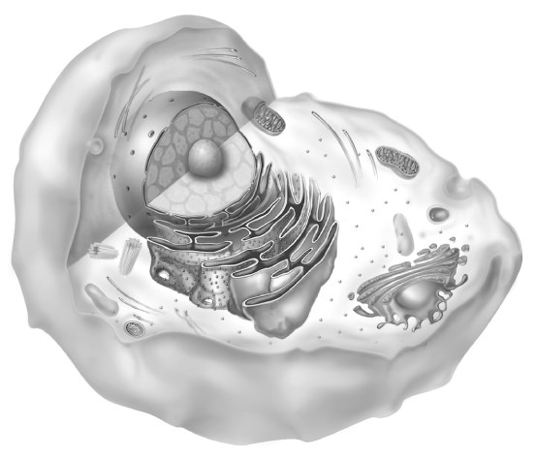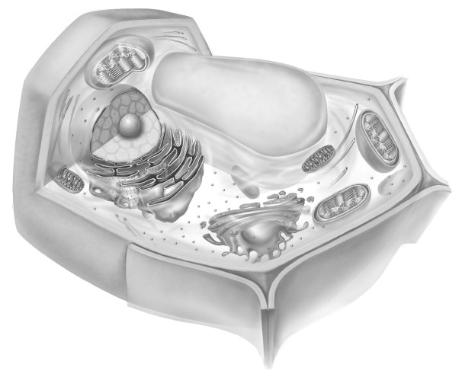

Cell A

Cell B

