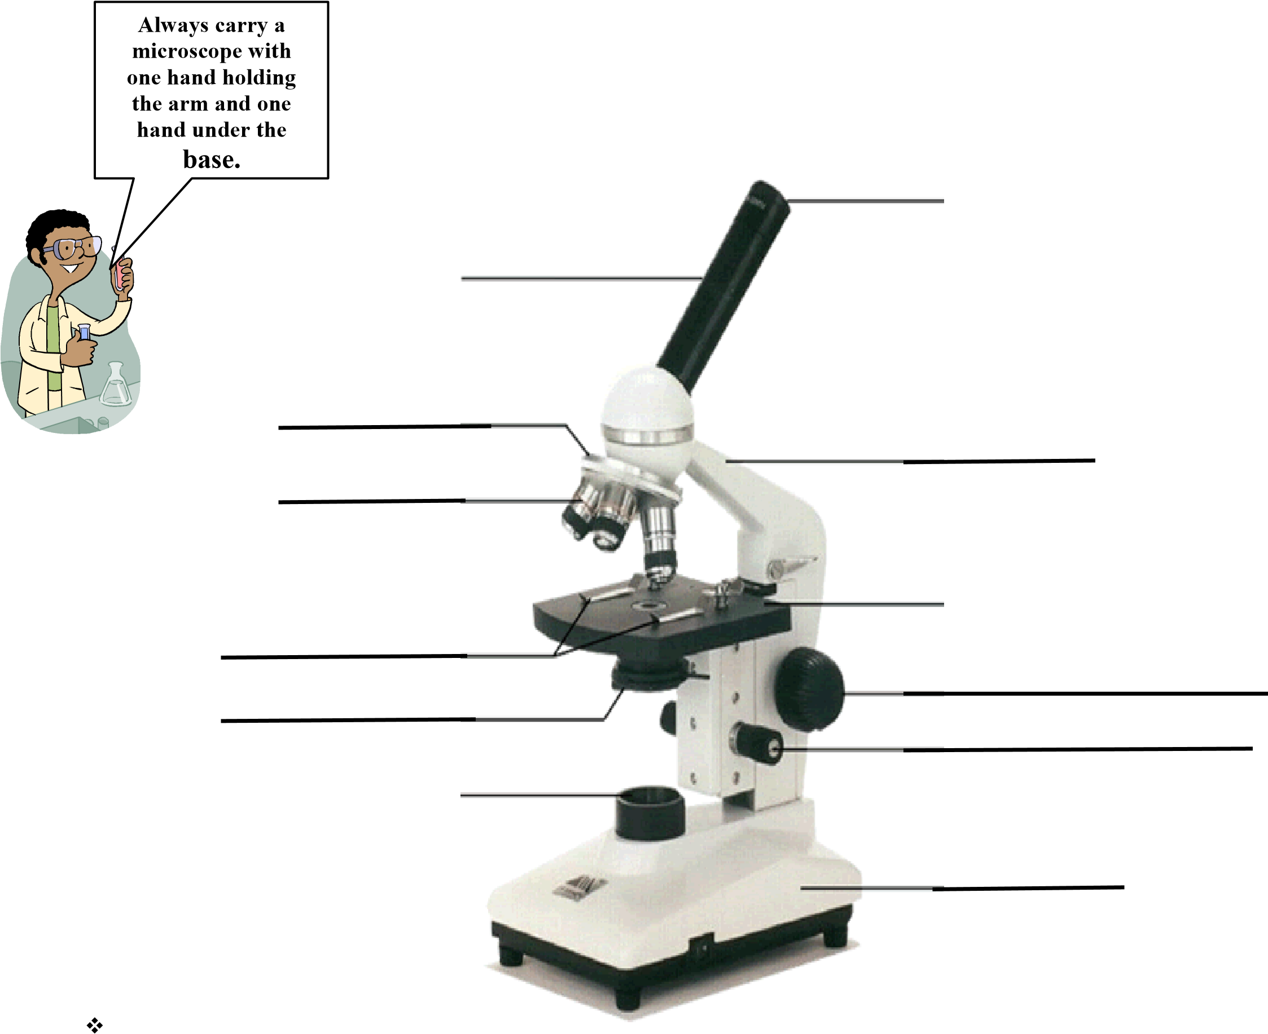
The Compound Light Microscope
8.
6.
12.
11.
10.
9.
7.
5.
4.
3.
2.
1.
Microscope Parts
Functions of microscope parts:
- Ocular =
- Body tube =
- Revolving nosepiece =
- Objective lenses =
- Stage =
- Stage clips =
- Iris diaphragm =
- Light =
- Base =
- Fine adjustment knob =
- Coarse adjustment knob =
- Arm =
Microscope Do’s and Don’ts
- Carry microscope by: _________________________________________
- Lenses should be cleaned with: _________________________________
- Coarse adjustment knob only used on __________ and ______________ power.
- When finished using scope for the day, return to ______________ objective for storage.
- When moving the slide on the stage, object moves to the _________________________ direction as seen in the ocular.
- Object viewed must be on a _____________________ and covered with a ______________________ ________________________; specimen must be ____________________.
What’s MY POWER?
- To calculate the power of magnification, multiply the power of the ocular lens by the power of the objective.
Scanning Power
- Ocular lens = 10X
- Objective = 4X
  - TOTAL magnification for SCANNING power = _____________________
Low Power
- Ocular lens = 10X
- Objective = 10X
  - TOTAL magnification for LOW power = ________________________
High Power
- Ocular lens = 10X
  - Objective = 40X
  - TOTAL magnification for HIGH power _________________________

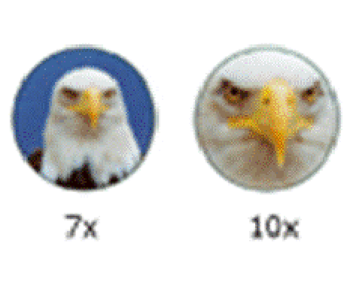 | We can see better details with  ______________ powers of magnification, but we can’t see as much of the image
- Comparing Powers of Magnification:

Which of these images would be viewed at a higher power of magnification?
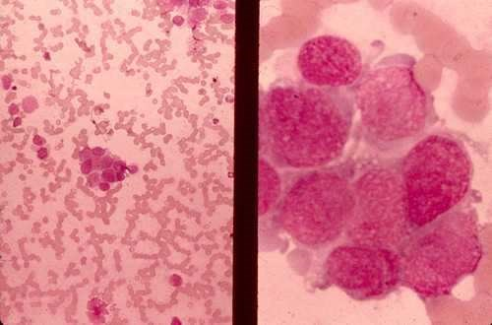

Compound Light Microscope:
- You will be using compound light microscope in several labs.
- These microscopes have a maximum magnification of _________
- So you __________ see most of the organelles like ribosomes, Golgi bodies,
lysosomes, etc.
- More powerful microscopes are needed (2,000 X plus)

Common Problem……AIR BUBBLES:
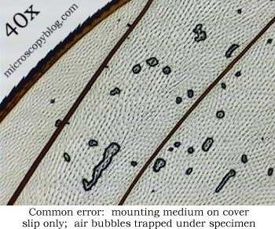

AIR
BUBBLES

How to Make a Wet-Mount Slide:
- – Get a clean slide and cover slip from your supply box.
- – Place ONE drop of water/stain in the middle of the slide. Don’t use too much or the water/stain will run off the edge and make a mess!
- – Place the edge of the cover slip on one side of the water/iodine drop.
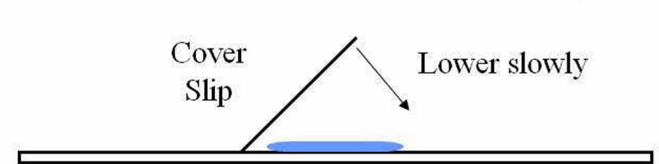
- - Slowly lower the cover slip on top of the drop.
- – Place the slide on the stage and view it first with the SCANNING power objective. Once you see the image, you can rotate the nosepiece to view the slide with the different objectives.
YOU DO NOT NEED TO USE THE STAGE CLIPS WHEN VIEWING WET-MOUNT SLIDES!
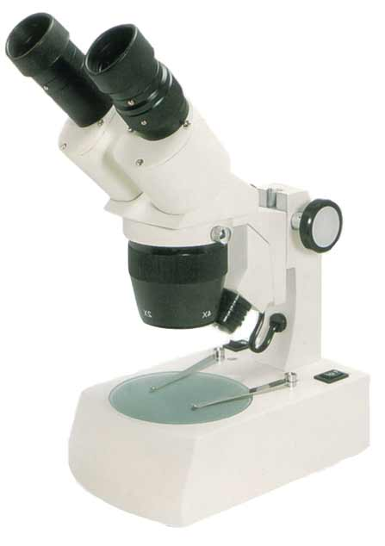
Stereo Microscope (Binocular)
- Used to view objects in ________________
- Object does not : ________________________________________________
- Object does not have to be _________________________________________
- Eyepiece magnifies ___________________
- Objective lenses are __________________________ magnification
- Object moves in ___________________________________direction.

