ORGANIC MOLECULES WORKSHEET Name:___________________________________________________Period:______Date:_________
Part 1: CARBON: Answer the following questions.
- All organic compounds contain ____________________
- In order for a carbon atom to be considered stable it needs to form ________ covalent bonds.
- Compounds that contain only hydrogen and carbon atoms are called __________________.
- The following structural formulas show four different compounds of carbon and hydrogen (hydrocarbons). Below each structural formula, write the chemical formula and label any double and triple bonds.
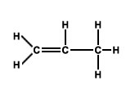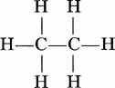

1.___________________ 2._____________________ 3.______________________

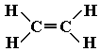

4.___________________

Part 2: CARBOHYDRATES: Answer the following questions.

- What atoms make up carbohydrates? _______________________________________________

- What is the ratio of hydrogen to oxygen atoms present in all carbohydrates? _________

- What are the three types of carbohydrates?
  - ___________________________________________________
  - ___________________________________________________
  - ___________________________________________________

Part 3: MONOSACCHARIDES & DISACCHARIDES: Answer the following questions.

- What are the monomers of carbohydrates? _____________________________________

- What is the difference between monosaccharides and disaccharides?

- What are the three examples of monosaccharides?

  - ________________________________________

  - ________________________________________

  - ________________________________________

- What are the three examples of disaccharides?

  - ________________________________________

  - ________________________________________

  - ________________________________________
- Look at the structural formulas below. These three sugars all have the same chemical formula (C₆H₁₂O₆).
  - Are the structural formulas the same? __________________
  - What do we call compounds that have the same chemical formula, but differ in their structural formulas? _______________________
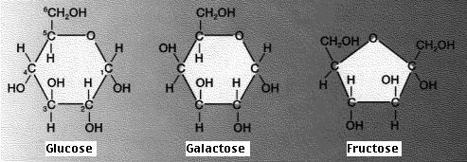

- Monosaccharides all have the same formula: C₆H₁₂O₆. How can you write this formula in the simplest form (reduced) that illustrates the proportion of elements in monosaccharides? ______________________________
- Below is an example of dehydration synthesis. In dehydration synthesis, a hydrogen atom from one molecule joins with a hydroxyl group (-OH) from another molecule to form water, leaving two molecules bonded to the same oxygen atom. For example, when glucose and fructose combine by dehydration synthesis, they form sucrose and water.

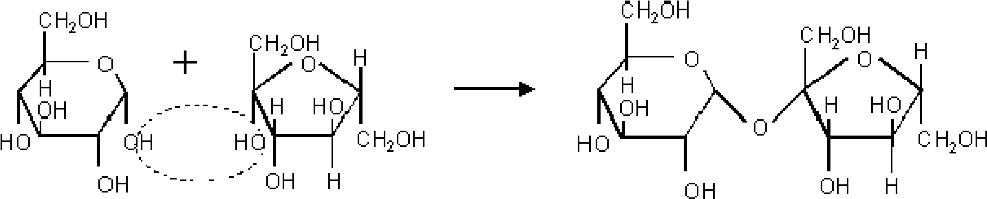 + H₂O
water

- Below is an example of hydrolysis. Complex organic molecules are broken down by the addition of the components of water – H⁺ and OH⁻.
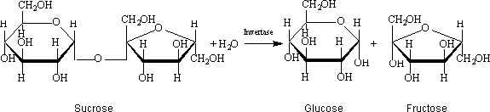
water

- What are the products of the hydrolysis reaction? ____________________________________

- What are the reactants of the dehydration synthesis reaction?________________________

- How are the reactions in #7 and #8 related?_________________________________________

_________________________________________________________________________________

- What is the chemical formula for disaccharides?__________________

- Why is the chemical formula of disaccharides not double that of the monosaccharides?

- In what life process does hydrolysis occur?______________________________________

- Look at the three reactions below. Which reaction(s) is hydrolysis taking place? ______________
  - How do you know?

- Look at the three reactions below. Which reaction(s) is dehydration synthesis taking place? _________
  - How do you know?

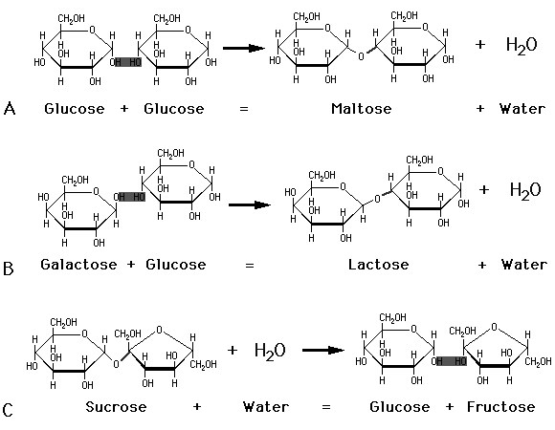

- What are the common names for sucrose and lactose? _______________________________________
- What are polysaccharides? ____________________________________________________________
- What substance would the repeating unit that makes up starch, cellulose, and glycogen?
________________________________

