Biochemistry: Enzymes

Name ______________________________ Pd. ____ Date _______________________

ENZYMES:
A specialized type of ____________________
Function in our body:
- Acts like a ________________= substance that __________________ up the rate of a
chemical reaction but it is _________ used up in the reaction.
- Enzyme(s) reduce _________________= amount of energy needed to begin a reaction
- Usually end in ______________________________.
__________________= an organic molecule ____________with the enzyme to
__________in the reaction.
- Need an active site on the enzyme
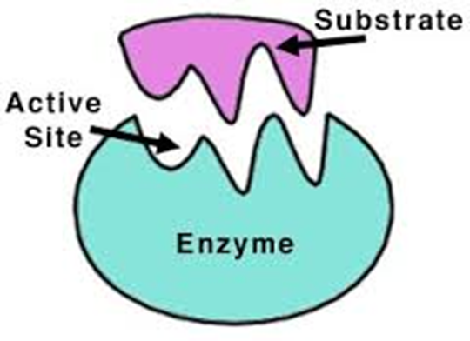
    - __________________- attracts and holds only ______________molecules called__________________.
      - “Lock-and-key” system- one “key” will fit “lock”; perfect fit
      - Induced Fit – “lock” will mold around the “Key” if fit is close enough

    - Therefore, _______________ enable molecules called ________________to undergo a chemical change to form new substances, called______________________.
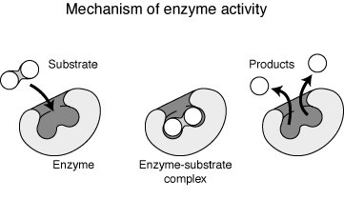

________

- Example of the ________________ of sucrose using the enzyme (________)

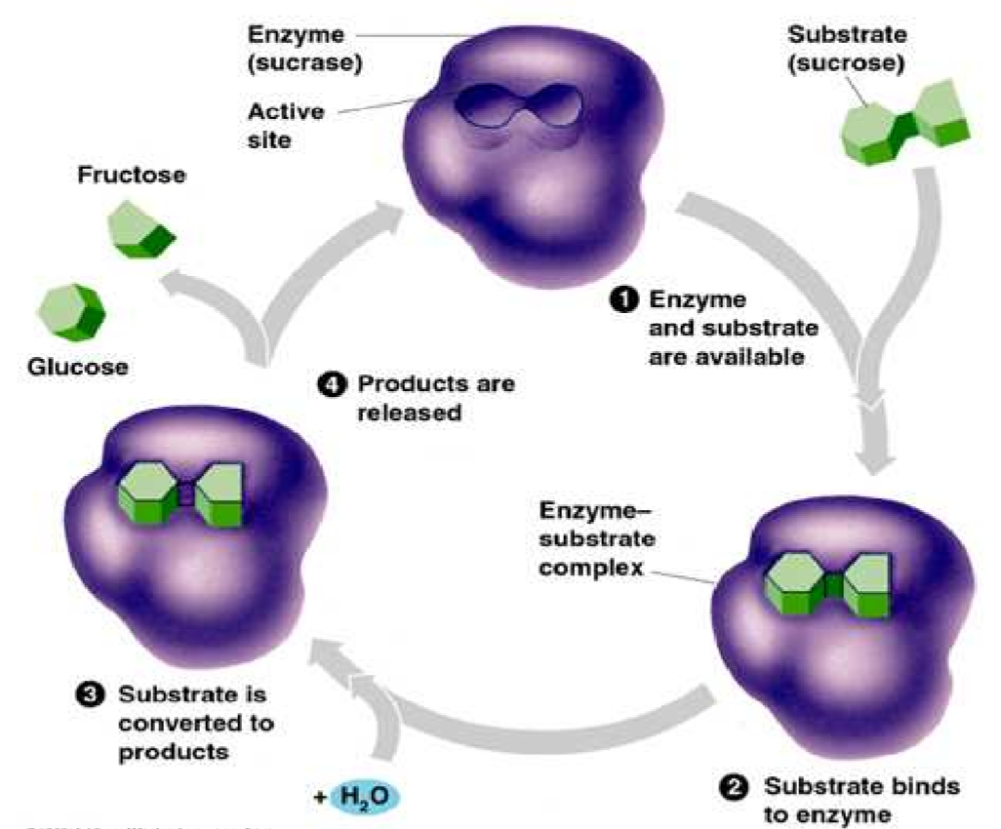

Enzyme Inhibitors
- ________________________ ______________________= a substance that
_____________the activity of an enzyme by entering the ______________in place of the
_________________whose structure is ______________ ____________________.

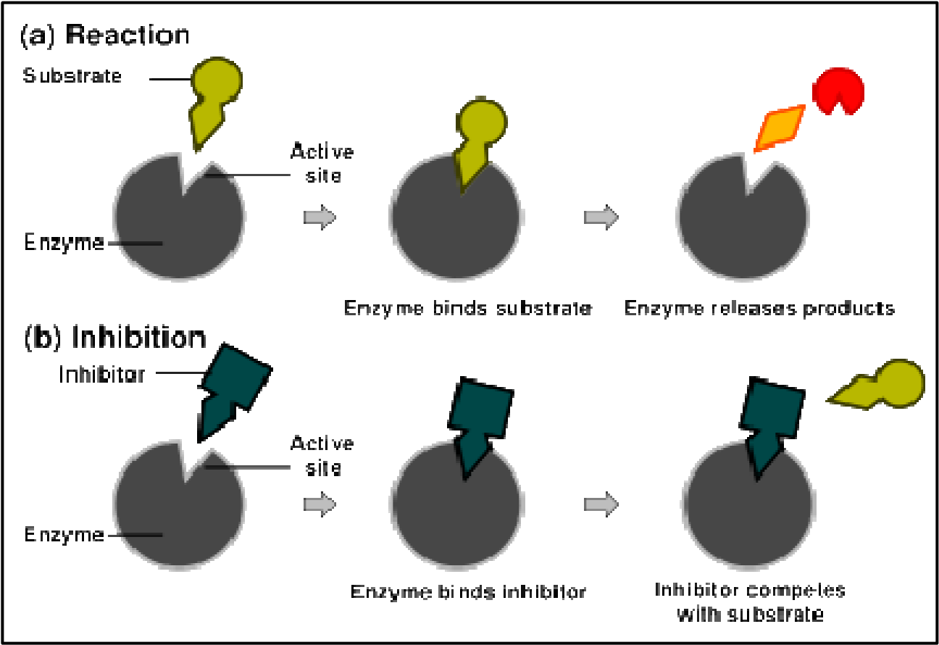

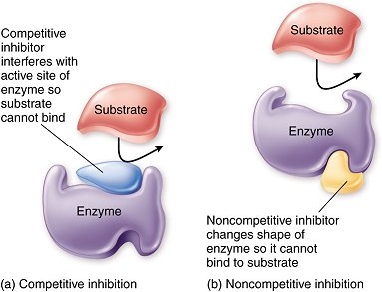
- ___________________________ inhibitors:
      - Inhibitors that do not enter the ______________ _______________, but bind to another part of the enzyme causing the enzyme to change its ____________________, which in turn alters the ___________________ ________________.

- Could not ________________without enzymes! (Almost all chemical reactions in cells
require an enzyme)
      - Speeds up the reactions in:
        - ________________________________ of food
        - ________________________________ of molecules
        - ___________________________________ of energy

- __________________________are named for the compound they work on.
    - You drop the current compound ending and replace it with _________
o For example:
o Lactose’s enzyme is ______________
o Maltose's enzyme is ______________
o Sucrose's enzyme is ______________
o ______________(in your salvia) is the enzyme for starch (amylose)

2 Factors that affect enzymes:
    - ___________________________- Too high temperatures will denature (change the shape of) the active site of the enzyme, causing the enzyme to not work properly.
    - _____________ – every enzyme has an optimum pH in which they will work. Altering the pH will cause the enzyme to not work properly.

Examples
- Cat box example
Urea + urease ___________________________ + carbon dioxide
Clean litter in cooler temps = less smell due to __________________ rate of reaction
- pH (most like 6 - 8 pH near neutral)
______________________ Juice on apple
____________________________ __________________________ (PPO) is the enzyme that reacts with oxygen to turn the apple brown

HOW DOES OUR BODY GET ENERGY FROM THE BREAKING DOWN OF MOLECULES?

_____________________________________________________
_____________________________________________________

Draw a conclusion based on each graph below.

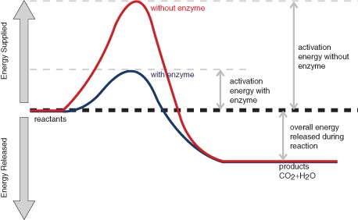

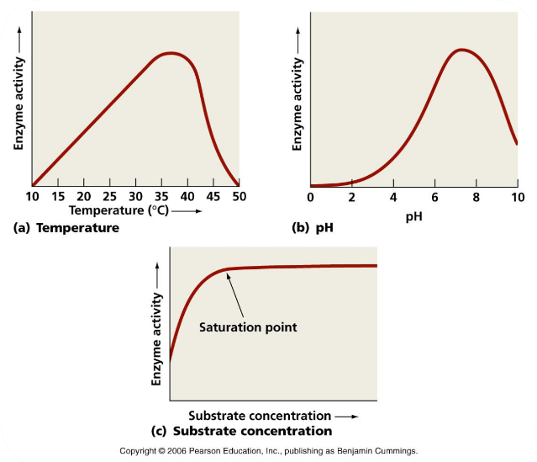
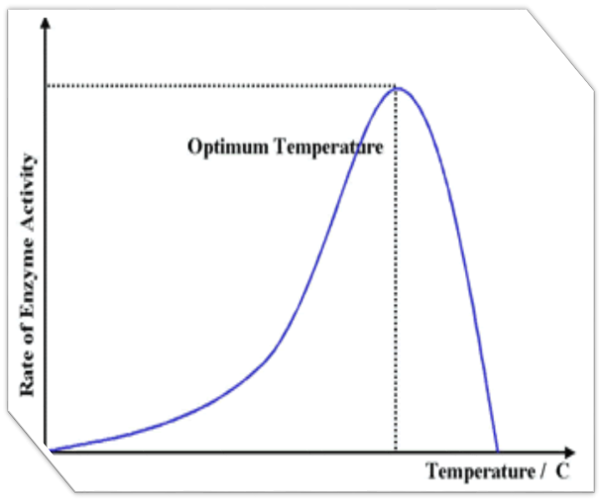

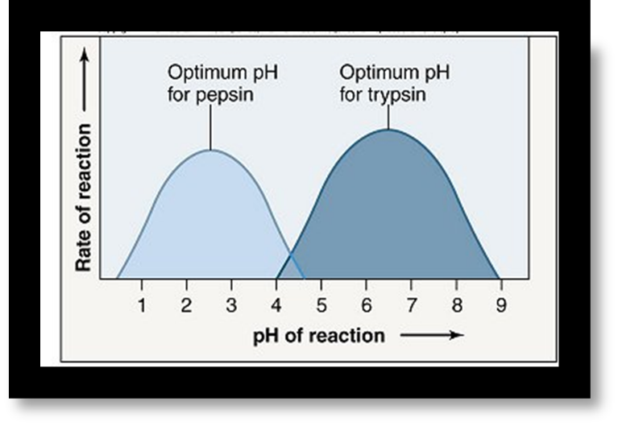
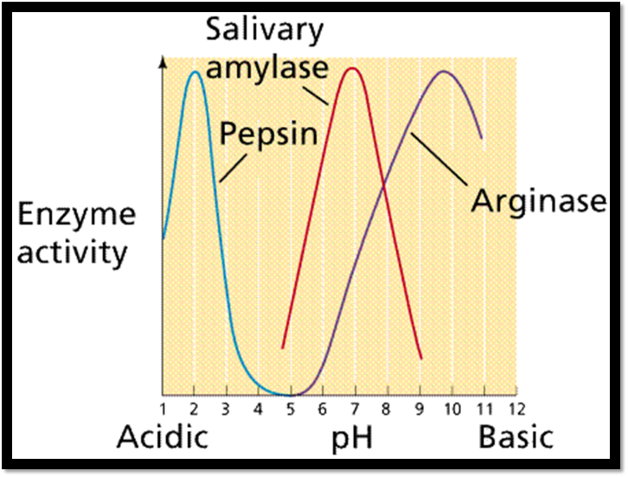

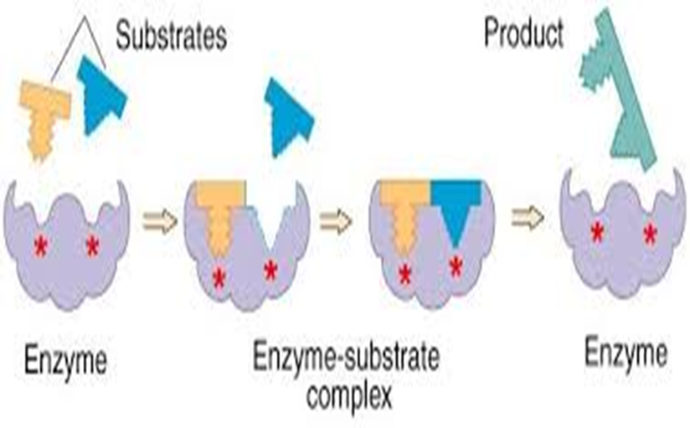

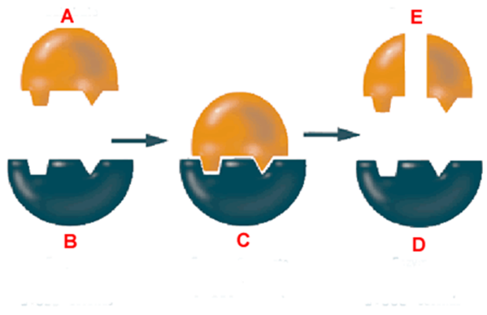
Dehydration synthesis or hydrolysis?

