Biochemistry: Nucleic Acids

Name _________________________________ Pd. _____ Date _________________

NUCLEIC ACIDS:

- Complex polymer that stores information in cells in the form of a___________.
- Monomers (basic building blocks):_________________, which consist of C, H, O, N, P
• These elements are arranged in 3 groups: ______________________________, _________________________, and a__________________________.
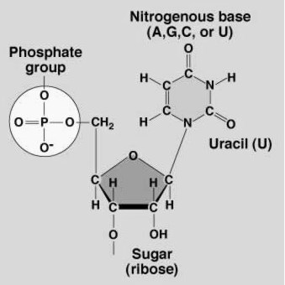

Phosphate
Group
Sugar
Nitrogen
Base

Nucleic Acid Structure
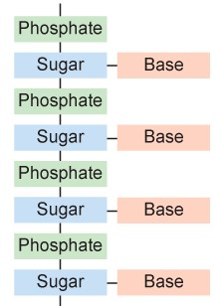
2 types of nucleic acids:

  - ______________(deoxyribonucleic acid) contains all the instructions for an organism’s development…..AKA genetic information
    - __________________________ stranded molecule

  - _____________(ribonucleic acid) forms a copy of DNA and is used for protein synthesis (production)
    - _____________________ stranded molecule

