Biochemistry: Proteins

Name _____________________________________________
PROTEINS:
- ____________________: meats, soy, cheese
- Large complex polymer composed of C, H, O, N, & sometimes S
- Monomers (basic building blocks): _____________________
        - ______different amino acids
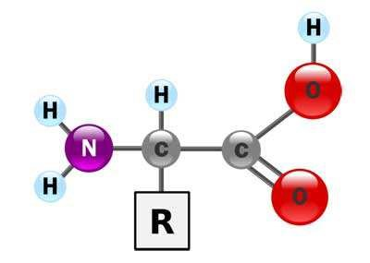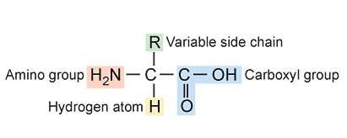
•

Example amino acids:

Structure of an amino acid:
  - Central carbon atom bonded with _____________________. The other 3 bonds are with an _______________ group (-NH₂), a ______________group
(-COOH) and a ___________________group (-R)
o The variable group makes each amino acid _____________________!
Amino acids are linked together by _________________ ___________________ to form a protein
  - Ex: 2 amino acids joined by ___________________ ______________________
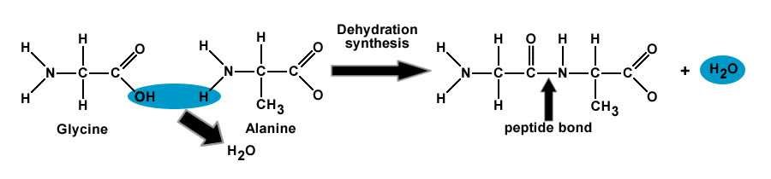
______________________= a covalent bond that joins amino acids to each other
  - Forms between the _______________ group of one amino acid and the _________________________group of the other amino acid.

Proteins- named for the _______________of amino acids that make them
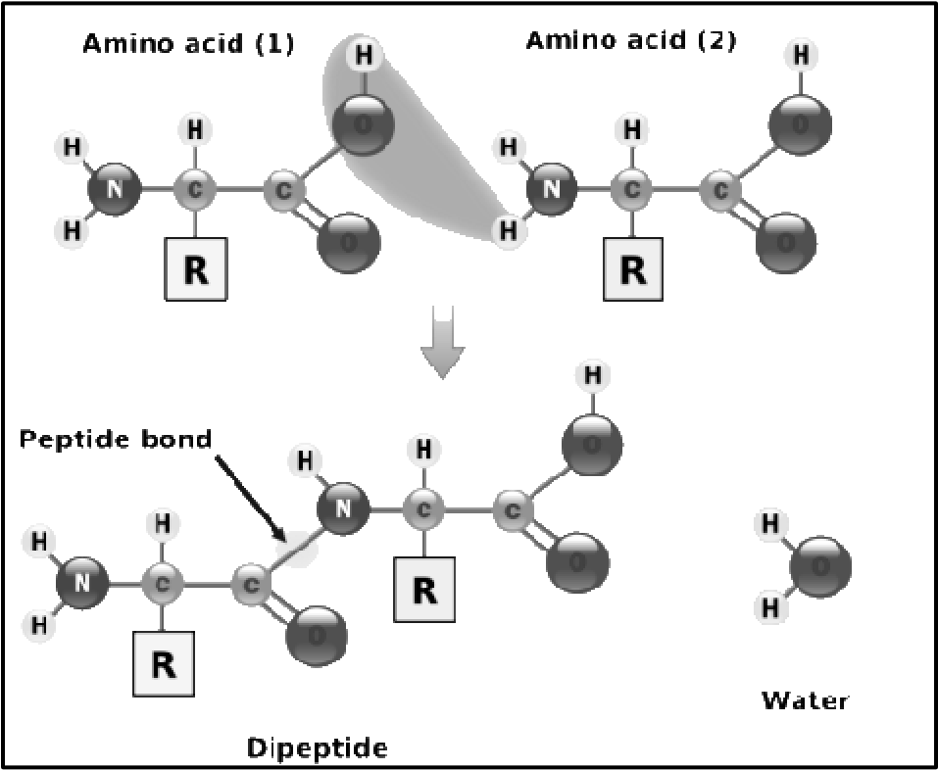
  - Ex: o two amino acids =
____________________
    - three amino acids =
____________________
    - many amino acids =
_____________________
Essential Amino Acids:
  - ______of the _____ amino acids are “essential” because they are required by the body but are _________created by it.
o As a result, it must be provided by our______. If one is missing then proper growth and repair cannot be_________________.

Types & Functions of proteins in our body:
    - ____________________________contraction (actin and myosin)
    - Transport _______________________________in the bloodstream (hemoglobin)
    - Provide _________________________________(antibodies)
    - Carry out ______________________________reactions (enzymes and hormones)
    - Collagen = _____________________ protein in animals
- Gives connective tissue ___________________________
- _______________________
  - Anti-wrinkle creams?
- Keratin
  - ________________________ protein in humans
  - Found in __________________, nails, _________________
  - Adds __________________________________
- All proteins help with ___________________ and ______________________ of cells in our diet
- Increase protein intake during rapid ___________________ years or ___________________________ repair.

What happens to PROTEINS in the body?
    - Broken down by the digestive system via HYDROLYSIS into
_______________which are then absorbed into the body through the bloodstream, where the body cells take the amino acids and makes protein for muscles.

Crash Course: You Are What You Eat
https://www.youtube.com/watch?v=H8WJ2KENlK0&list=PL3EED4C1D684D3ADF&index=3

