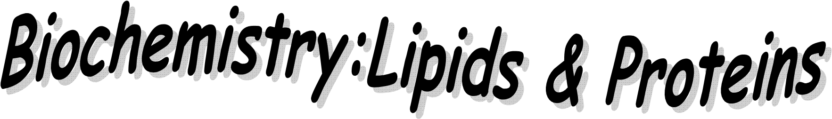

Name: ___________________________________Period: _____ Date: __________

- LIPIDS:
_______________: butter, oil, Crisco, lard
Commonly called _____________& __________
Contain __________C-H bonds and _________O atoms than______________________.
• Ex: C57H110O6
Nonpolar; therefore repels ___________ (_________________)

Functions of lipids in our body:
    - _____________energy storage (used when carbohydrates are NOT available)
    - _____________________
    - _____________body tissue (cushioning)

WHICH HAS MORE ENERGY – LIPIDS OR CARBS?

    - One gram of _________contains ______________as much __________as one gram of _________________. Therefore, __________are better ___________compounds!

Fats vs. Carbs. & Energy Storage:
    - 1 gram of Carbs. (glycogen) = about ____________ of energy
o a short term rapid energy source (sprint events)
    - 1 gram of Fats = about ___________of energy
o a long term energy source (endurance events - marathons)
    - Average human contains about 0.5 Kg of stored glycogen = ______ Kcal of energy.
    - About 16 Kg of body fat = ___________ Kcal of energy
To carry the same amount of energy [144,000 Kcal] as carbs, we would have to store 36 Kg [79.4 pounds] more glycogen to lose 1 Kg of body fat.
This means you need to burn lots of calories!

Types and Examples of Lipids:
1.____________- steroids
2._____________– bee, furniture, ear, car
3. _____________- in egg yolks, red meat
4.__________ - from animals
5. ___________– from plants
6. _________________ - cell membranes
7. __________________________ - plants

Structure of Lipids:
  - Basic building blocks: __________________+ ________________
  - Fatty Acids
o Long _____________________________with a ___________group at one end
- One fatty acid
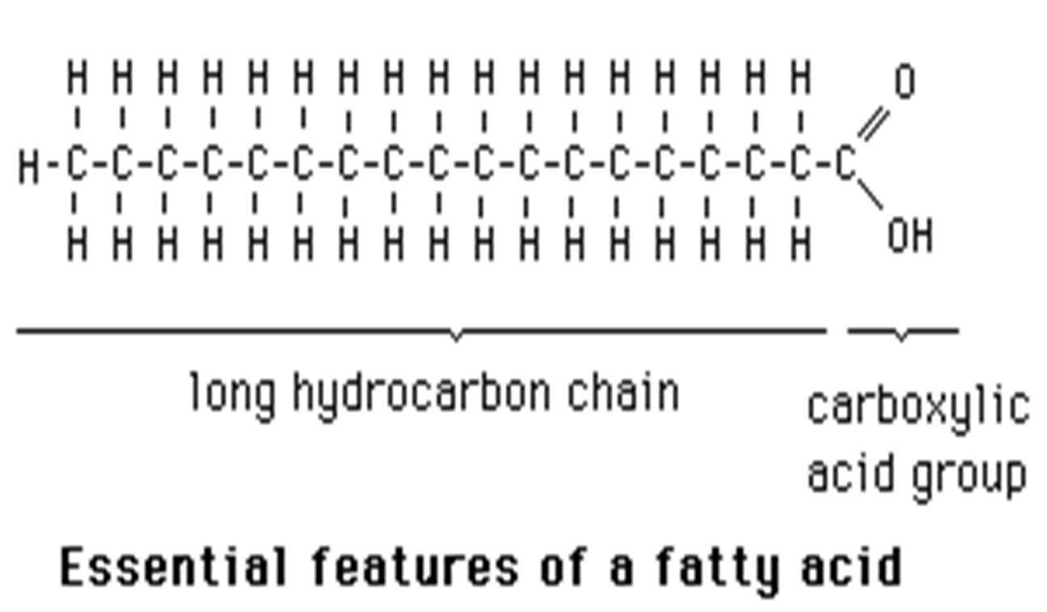

  - Glycerol and each fatty acid chain are joined to each other by __________________________________________.

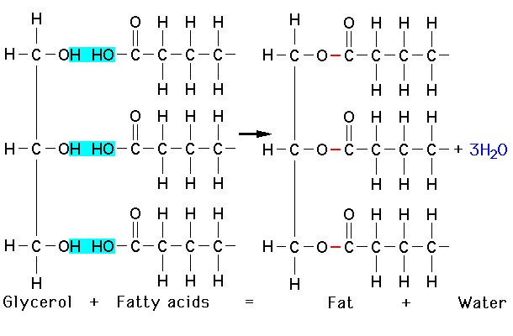

  - Structure of a lipid (1 glycerol + 3 fatty acids):
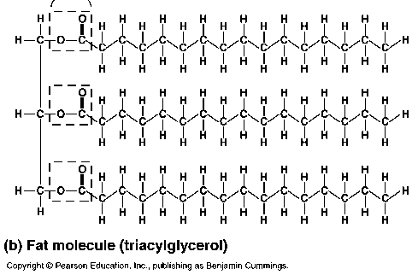

3
Fatty Acids

Glycerol

4 types of fats:
      - _____________________ = fatty acid chains of carbon with only ______________ bonds between the carbon atoms
o “_______________________”- cholesterol (heart disease)
o ___________at room temperature
Ex: _____________ , _______________________
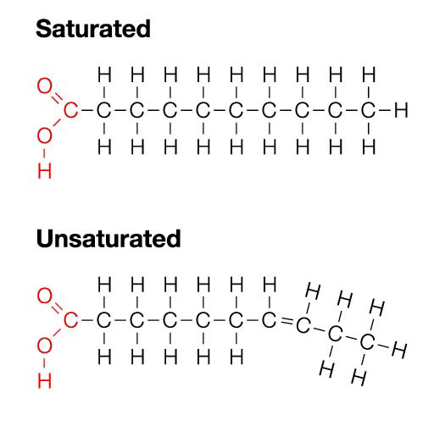
      - _____________________ = fatty acid chains of carbon with
ONE__________________ bond between the carbon atoms
o “_____________________”
o ______________at room temperature
Ex: _______________

      - _____________________________= more than one double bond between the carbon atoms in the chain
o Ex: nuts, seeds, fish, leafy greens

        - Structural formulas for saturated and polyunsaturated fatty acids:
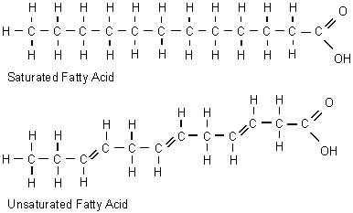
Polyunsaturated fatty acid

4. _____________________________________ (trans fat)
    - Unsaturated fats that have been artificially saturated by addition of hydrogen atoms
      - ___________________________ at room temperature
        - Margarine
        - Vegetable shortening

What happens to LIPIDS in the body?
    - Broken down by the digestive system via HYDROLYSIS into _______________ and _______________which are then absorbed into the body through the bloodstream.
    - The fatty acids can then be broken down directly to get ______________, or can be used to make glucose

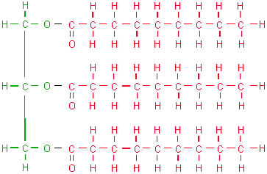
_____________________________= Majority of fat in an organism consists of this type of fat molecules
    - Derived from fats eaten in ___________or made in the body from other energy sources like carbohydrates.
    - Calories ingested in a meal and not used immediately by tissues are converted to triglycerides and transported to fat cells to be stored.
    - Storage – 3 month supply of ___________vs. glycogen’s 24 hour supply
• Hormones regulate the release of triglycerides from fat tissue so they
meet the body's needs for energy between meals.

Excess Triglycerides- Life Applications:
    - Cause plaque to build up
o ______________________ = walls of the arteries get thick and hard; fat
builds up inside the walls and slows the blood flow
          - Cause blood clots –heart attacks, strokes
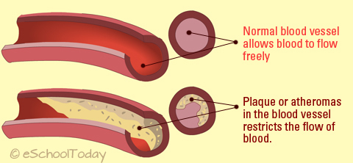
      - _____________________(high blood pressure)

________________________________ (part of cell membrane structure)
