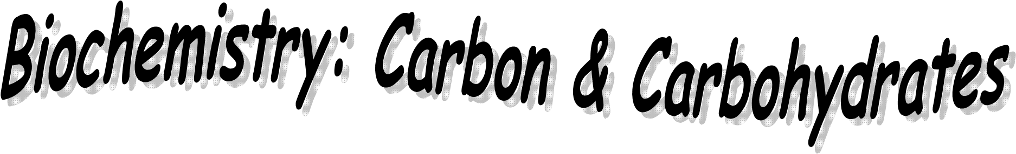
Name: ___________________________________Period: _______Date: __________


- ROLE OF CARBON IN ORGANISMS:

___________________________= compounds that contain carbon and hydrogen
        - Ex: Carbohydrates, lipids, proteins

___________________________= compounds that DO NOT contain carbon and hydrogen
        - Ex: Vitamins, minerals, water
Carbon forms ____covalent bonds to become stable
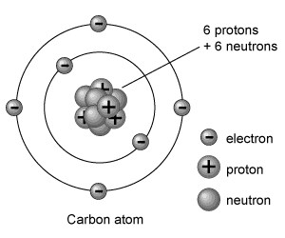
Can join with other carbons to form straight__________, branches or________________.

These structures may contain
______________carbon atoms
        - This makes many
__________________possible!

____________________= the simplest carbon compound (CH₄)

____________________= any molecule made ONLY of _______________and ______________atoms!
        - Ex: Methane
        - Methane’s ________________or chemical formula is __________
        - Methane’s________________________:
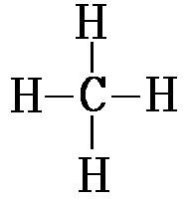
o Bonds are represented by _______________

_______________ = compounds that have the same
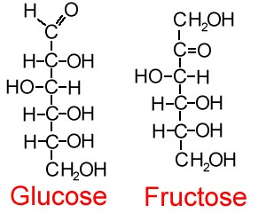
____________________but different ______________
• Ex: Glucose & Fructose
o Formula- _____________
__________________ ______________can range from
_________carbon atoms to ________________of carbon atoms
- THE DIGESTIVE SYSTEM:
The digestive system breaks down organic compounds into their building blocks
(____________________________)
Body cells take the monomers and put them together in the form the body can use
____________________= extremely large compounds made of smaller ones.

_________________= large molecule formed when many smaller molecules
(monomers) bond together, usually in __________ chains
  - Ex: Carbohydrates, proteins, lipids, nucleic acids
  - Polymers and their monomers:
POLYMERS | MONOMERS (building blocks)
Carbohydrate

Protein
Lipid
Nucleic Acid

WHAT PROCESS ALLOWS BODY CELLS TO MAKE LARGE COMPOUNDS FROM MONOMERS?

  - __________________________or Condensation reactions=
  - The _______________of _____and ______ (water) from the individual molecules so that a ____________may form between them and result in a more
____________________molecule
- This is an _______________________________________ process.
- ______________________organic molecules
- ________________________ bonds = store energy
o Humans – _______________________ production
- Plants – fruit & veggie production

Dehydration synthesis represented by an equation:
Monomer + Monomer Polymer + water
For example:
    - Amino Acid + Amino Acid ________________________________
    - Monosaccharide + Monosaccharide __________________________
    - Fatty Acids + Glycerol __________________________________

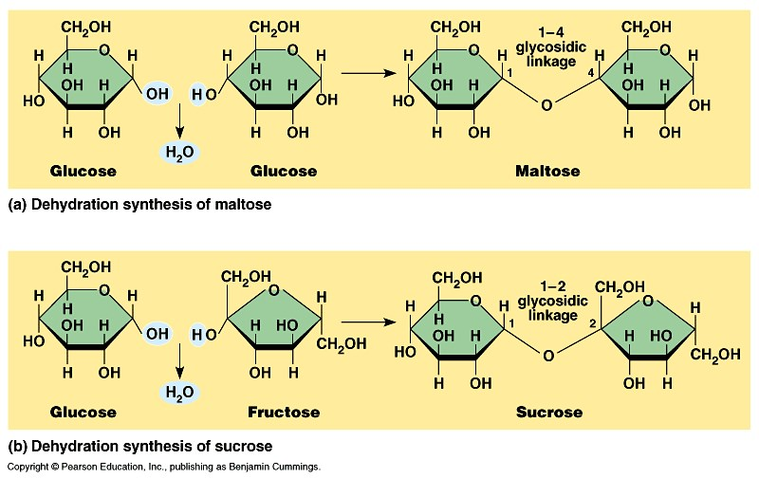2
+
H
O

+
H
2
O

WHAT PROCESS ALLOWS THE DIGESTIVE SYSTEM TO BREAKDOWN NUTRIENTS?

• ________________= (hydro =______________, Lysis =__________)
- The breaking of a large compound (polymer) into smaller compounds (monomers)
through the addition of -H and –OH (water).
- This is a ___________________________ process.
- Breaks organic molecules _____________
- Break bonds = release __________________
- Occurs during ___________________– release energy from food
Hydrolysis represented by an equation:
Polymer + water monomer + monomer
For example:
    - Protein + water _____________________________________
    - Carbohydrate + water _________________________________
    - Lipid + water _________________________________________

HYDROLYSIS OF SUCROSE:

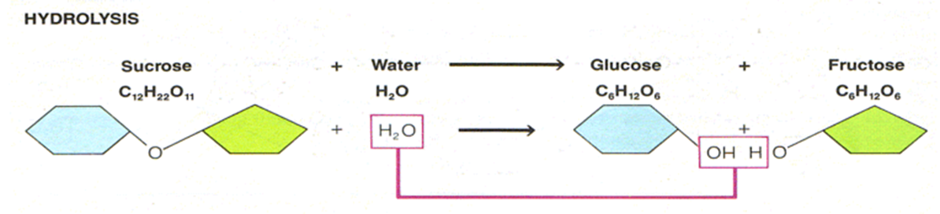

WHAT DO ATHLETES EAT THE DAY BEFORE A BIG GAME?

____________________________________________________
____________________________________________________
____________________________________________________

- CARBOHYDRATES:
Foods: pasta, bread, fruits, veggies
Compounds used for ______________and release of _________________
Made of C, H, O atoms
Reduced formula: _____________
- H:O ratio is always _________________
How do you identify a carbohydrate?
• Look at the kinds and number of atoms
- Ratio is ___Hydrogen atoms: ___Oxygen atom always!
- Rings of C, H, O (# of rings tells type of carb)
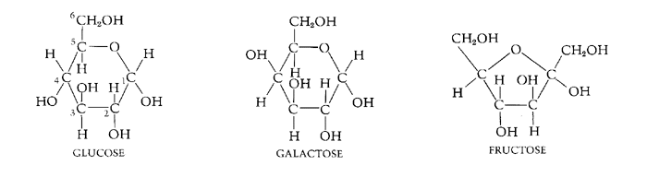

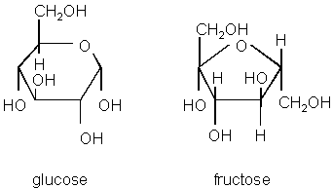
3 types of carbohydrates:

  - __________________________= C₆H₁₂O₆
  - _______________sugar (6 carbons)
  - Ex: _________________________________________
- Glucose = veggies
- Fructose = fruits
- Galactose = milk sugar
- Only form our ________can use for ______________________ _____________
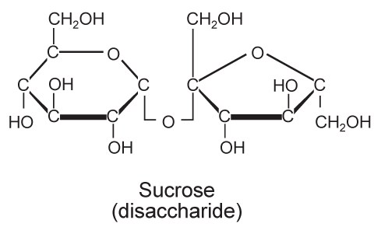
  - ___________________________= C₁₂H₂₂O₁₁
__________sugar made of 2 simple sugars (Monosaccharide + Monosaccharide)
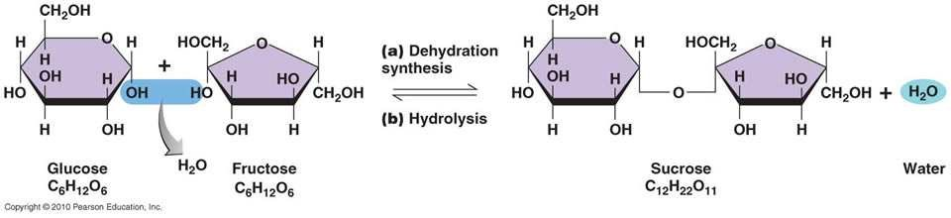
      - Combined by _____________________________ reaction

      - Used for ___________________ energy supply; not instant.
Ex: sucrose, lactose, maltose
      - ________________: (table sugar) Glucose + Fructose sucrose + H₂O
      - ________________: (milk sugar) Glucose + Galactose lactose + H₂O
• __________________: Glucose + Glucose + glucose maltose + H₂O

3. ______________________________=
More than 2 ____________________________ joined by dehydration synthesis

Ex:
  - ______________ (________________)- Plant’s energy storing molecule 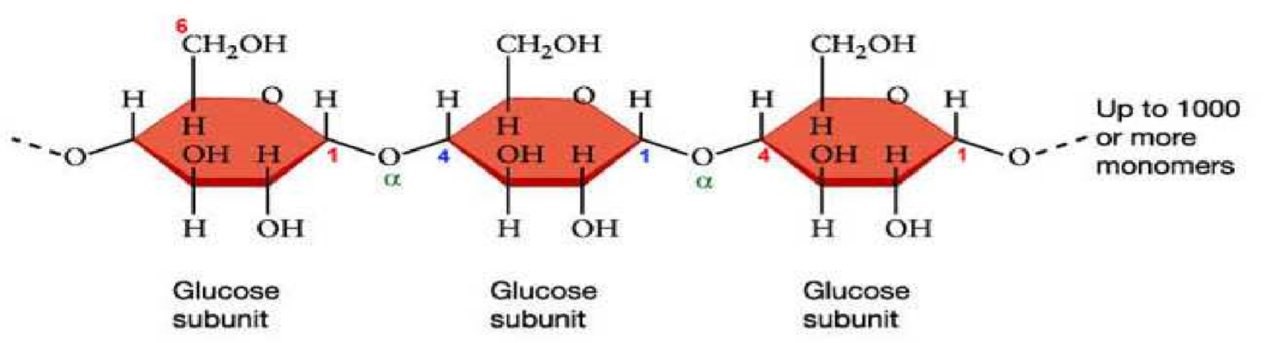
Starch

  - ______________________- Animal’s energy storing molecule
o Energy storage form of ______________________
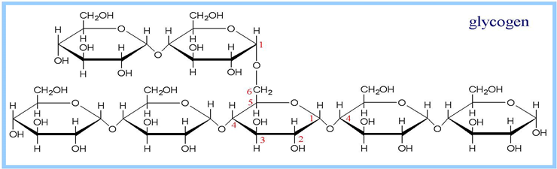
o Found in the liver and skeletal muscle
o When the body needs
____________________ between
meals/physical activity, glycogen is broken down into glucose through _____________________________
  - ________________- provides structure in plant cell walls (cannot be digested by human body)

What happens to CARBOHYDRATES in the body?
- Broken down by the digestive system via HYDROLYSIS into _______________ which are then absorbed into the body through the_____________________, where the body cells take the monosaccharides and produce _____________.
- After the immediate energy requirements of all your body's tissues have been met, the excess glucose in your blood will be converted into a storage form of carbohydrate called ____________________ (found in your muscles and liver).
- If all of your glycogen stores are full and you still have excess glucose in your bloodstream, the remaining glucose will be converted to _________.

IV. FUNCTIONAL GROUPS:

Functional groups give a molecule __________________properties

_________________: (-OH) allows molecule to be more soluble in water
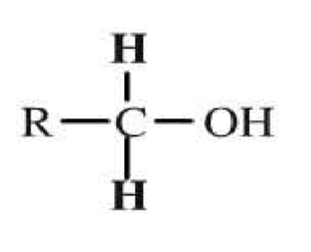
Alcohol
Group

- __________________: (-COOH) allows molecule to release H ions in water - therefore ______________!
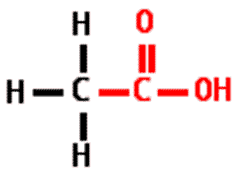
• There is a ________________ ____________between carbon and oxygen

- _________________ __________: (-NH2) allows molecule to accept ions from an acid- therefore __________!
