The Odyssey: Map of Odysseus’ Journey Name ________________________
Mrs. Godfrey Pd. _____ Due Date ___________
The war at Troy lasted ten years. Then, after Troy, it took another ten years before Odysseus would arrive in Ithaca. The path of his long journey home is shown on the map. Please write a brief description corresponding to the number on each of Odysseus’ adventures (2 pts. ea.).

Double click each place site to travel on Google Earth. Then close the text box to travel on the map. Single click to read the text information (you may have to scroll down a bit).

- Troy—

- Ismaros—

- Cape Maleia—

- Cythera—

- Land of the Lotus Eaters—

- Land of the Cyclopes—

- Aeolian Island—

- Telepylos—

- Aeaea—

- Acheron River—

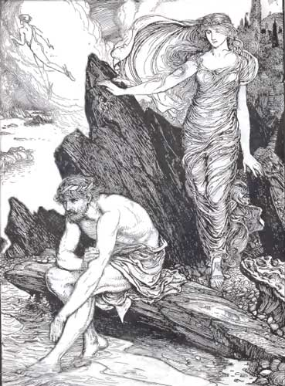
- Anthemoessa—

- Scylla—

- Charybdis—

Additional map directions (1 pt. ea.):
Label and color all bodies of water blue:
Mediterranean Sea
Aegean Sea
Ionian Sea
Black Sea
Strait of Gibraltar
Label and color (use different colors) all countries/islands:
Italy
Greece
Libya
Sicily
Thrace
Crete
modern-day Turkey
Label the following cities:
Rome
Athens

