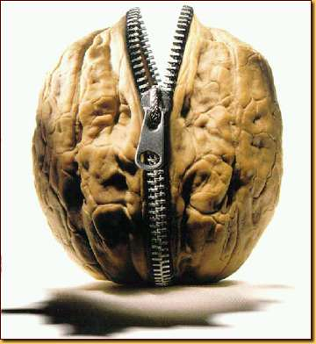
Cupid and Psyche: In a Nutshell
Picture this: Mortal girl falls in love with supernatural boy. Relationship problems ensue. Boy makes girl immortal too. They live happily ever after.
If images of Robert Pattinson and his carefully disheveled hair are flitting through your mind, guess again. We're not talking about the Twilight series, or any other teen paranormal romance novel, for that matter. We're talking about the Greco-Roman myth of "Cupid and Psyche."
This story is all about what happens when Cupid gets nicked by his own arrow and falls for a mortal girl. There's love, mystery, betrayal, passion, danger . . . Heck, there's even a bit of Beauty and the Beast and Cinderella thrown in for good measure. Come to think of it, it's kind of crazy that the story of Cupid and Psyche hasn't been made into a blockbuster Hollywood movie yet. Seriously, somebody tell Disney to check out this guide. There's a gold mine here.

Connections
Explore the ways this myth connects with the world and with other topics:
- In Edgar Allan Poe's poem "Ulalume," the speaker is walking around the woods with his soul. His soul happens to be a winged woman named Psyche. Poe's Psyche was clearly inspired by Cupid's love.
- Cupid and Psyche's romance does have a lot of similarities to Edward and Bella's in the Twilight saga.
- Venus wants her son Cupid to punish Psyche by making her fall in love with the ugliest thing around. That sounds a lot like the prank Fairy King Oberon plays on his wife, Titania, in Shakespeare's A Midsummer Night's Dream. Oberon gets his sidekick to make Titania fall in love with a donkey-headed man. Shakespeare's play was inspired in part by Apuleius's The Golden Ass, the ancient Roman novel that the story "Cupid and Psyche" appears in.

Adapted from http://www.shmoop.com/cupid-psyche/

