Dallastown Area School District

3rd Grade Science Fair

Name _______________________

Due Date ____________

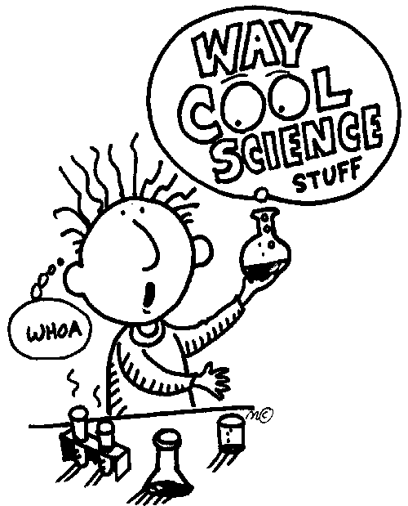

Date:

Dear Parents and Students:

It’s time to start work on our school’s Science Fair! Enclosed is important information regarding your child’s project. Ample time has been scheduled and work has been spread out so that students can complete the work at a comfortable pace.

This is a major project and will represent a portion of your child’s grade for the next grading period. The primary objective of this project is to have students approach a problem scientifically. This includes:

- Asking questions and forming hypotheses
- Creating experiments to test those hypotheses
- Organizing data and drawing conclusions
- Writing about scientific research

The project must be experimental in nature as opposed to a demonstration. In other words, students must do a test, survey, or experiment to determine the answer to their question instead of just making a model of something. We encourage students to pick topics that they are genuinely interested in, because they will be working on these projects for the next several weeks. Topics must also be original—something the students do not already know. Each student will be required to turn in the following:

- Scientific Inquiry Sheet: This is an organizer that helps students prepare their information to be put on the display board. Each of the steps on this organizer must be included on the student’s display board.

- Display: This includes taking pictures or making sketches of the experimental process, gathering materials, building, and setting up the display for presentation. In order to do well, the individual must be engaged in the project from the beginning and not wait until the last minute.

Project guidelines state that all work must be done by the student; however, assistance may be provided by teacher and parents. It is very difficult to work alone without the exchange of ideas, so we encourage you to brainstorm with your child on different ideas and possible topics your child may want to pursue. Students have been given resources for science fair topics. Please take a moment to review these with your child in order to generate topic ideas. Science Fair Proposals are due on __________________________.

I am looking forward to working with you to make this a valuable learning experience for your child. I appreciate your support on this important project. As acknowledgement and part of your child’s homework, please sign, date, and return the bottom portion of this letter by _____________________________________________________________.

Sincerely,
Science Teacher

I have reviewed the Science Fair information with my child, _________________________, and we understand the requirements for a successful Science Fair Project.

_________________________ _______________
(Parent Signature) (Date)

_________________________ _______________
(Student Signature) (Date)

What to do????
Checklist for Science Fair Project

______ Choose a project idea and have it approved by your teacher. You can find numerous project ideas on www.sciencebuddies.com

______ Purchase a display board.

______ Be sure to give yourself enough time to complete the project. Collect your data as you complete your project, so you don’t have to do it all at the end.

______ Display your project neatly and creatively on your display board. Be sure to display all aspects of the scientific method on your board (use your Scientific Method Sheet)

______ During this process and especially when your project is complete, check the grading rubric to be sure that you have completed all of the necessary steps.

