WORD AND BEYOND!

Tips and tricks for using Microsoft Word

How to insert clipart and pictures: 2
How to add Wordart: 3
How to add tables: 4
How to create columns: 5
How to create screen shots: 6
How to track changes: 7
Other topics you don’t want to miss: 9

How to insert clipart and pictures:



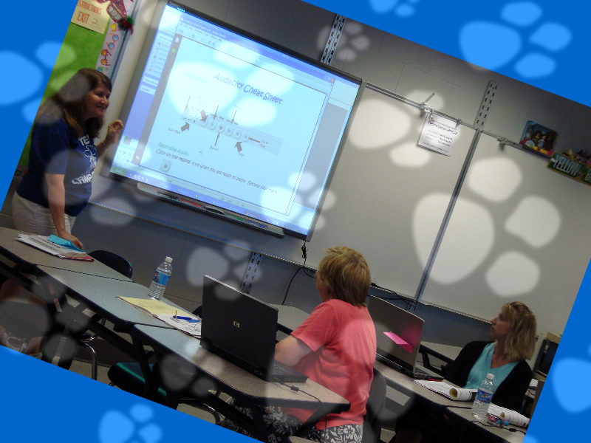


How to add Wordart:

How to add tables:

Dallastown Area School District Total Number of Staff and Students
 | LH | LS | OV | YT | DT | MS | HS | Total
Students
Faculty
Total

How to create columns:

The quick brown fox jumps over the lazy dog. The quick brown fox jumps over the lazy dog. The quick brown fox jumps over the lazy dog. The quick brown fox jumps over the lazy dog. The quick brown fox jumps over the lazy dog. The quick brown fox jumps over the lazy dog. The quick brown fox jumps over the lazy dog. The quick brown fox jumps over the lazy dog. The quick brown fox jumps over the lazy dog. The quick brown fox jumps over the lazy dog.
The quick brown fox jumps over the lazy dog. The quick brown fox jumps over the lazy dog. The

How to create screen shots:
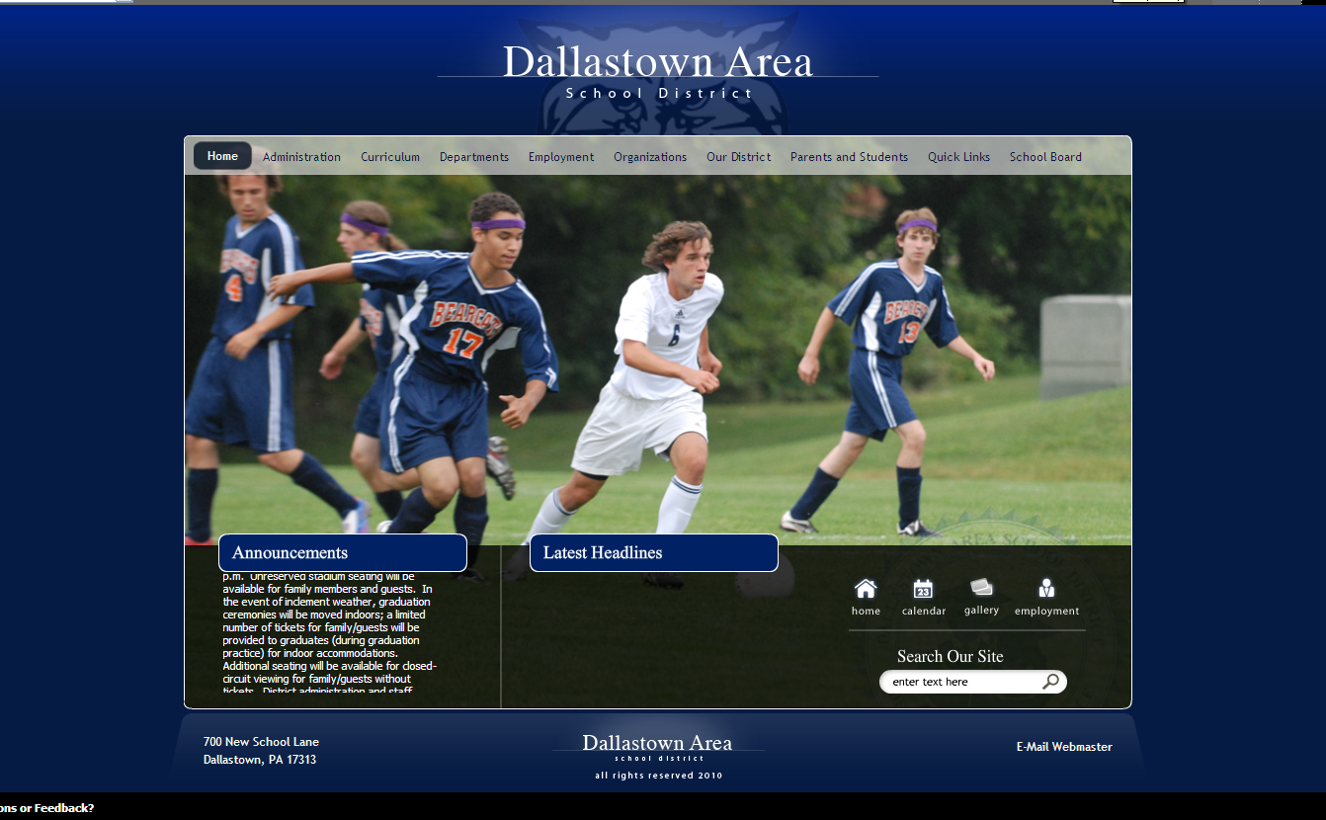

How to track changes:

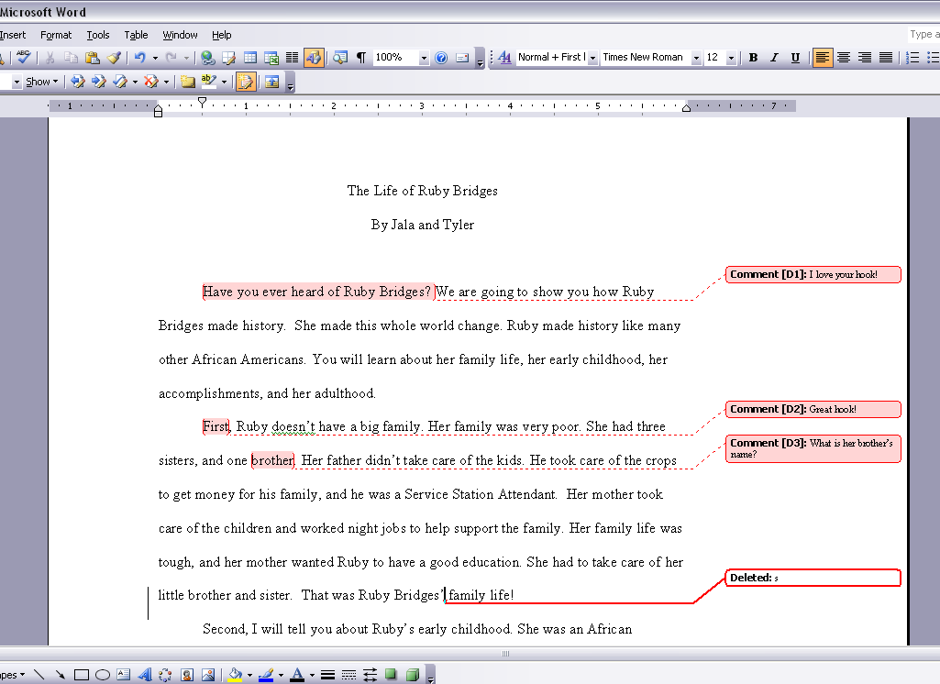

Other topics you don’t want to miss:

How to…

add drop caps

add borders, shading, and background

copy and paste Excel documents and make them look GOOD

use the table of contents template

use tabs

use shortcuts

